Risk Assessment of Organochlorine Pesticides in Water, Sediment and Fish from the Halda River, Bangladesh

A thesis submitted to the Department of Fisheries in partial fulfillment of the
requirements for the degree of Master of Science (MS) in Fisheries Management from
the University of Dhaka, Bangladesh

Submitted By
Examination roll: 2431202  Registration number: 2019-117-144 | MS session: 2023-24  Registration session: 2019-20

Fisheries Management Branch
Department of Fisheries
Faculty of Biological Sciences
University of Dhaka, Dhaka-1000
Submission Date: 27.02.2023

Declaration by Student
I hereby declare that the thesis entitled "Risk Assessment of Organochlorine Pesticides in Water, Sediment and Fish from the Halda River, Bangladesh" submitted to the Department of Fisheries, University of Dhaka for the degree of Master of Science (MS) is based on self- investigation, carried out under the supervision of Dr. Md. Habibullah-Al-Mamun, Professor, Department of Fisheries, University of Dhaka, Dhaka-1000, Bangladesh.
I also declare that this or any part of this work has not been submitted for any other degree anywhere. All sources of knowledge used have been duly acknowledged.

Author,

…………………………………………..
Name: Md. Ashikur Rahman
Examination roll: 2431202
MS session: 2023-24
Registration number: 2019-117-144
Fisheries Management, Department of Fisheries, Faculty of Biological Sciences
University of Dhaka, Dhaka-1000, Bangladesh

Approval Sheet
We certify that the research work embodied in this thesis entitled "Abundance and Characteristics of Microplastics in Different Fish Species from the Halda River in Bangladesh" submitted by Md. Ashikur Rahman, roll number: 2431202, registration number: 2019-117-144, MS session: 2023-2024 has been carried out under our supervision.
This is further to certify that it is an original work and suitable for the partial fulfillment of the degree of Master of Science (MS) in Fisheries Management from the Department of Fisheries, University of Dhaka.
We wish every success in hir life.

…………………………………….
(Signature of Co-supervisor)
Shiek Muzahidul Islam
Scientific officer (SO)
Institute of Food Science and Technology (IFST)
Bangladesh Council of Scientific and Industrial Research (BCSIR)
Dhaka-1205, Bangladesh
…………………………………….
(Signature of Supervisor)
Dr. Md. Habibullah-Al-Mamun
Professor
Department of Fisheries
Faculty of Biological Sciences
University of Dhaka
Dhaka-1000, Bangladesh

Acknowledgements
First and foremost, I express my deepest gratitude to the Almighty Allah for His boundless kindness and for granting me the health, strength, and ability to complete this research work successfully and on time.
I would like to sincerely thank my esteemed supervisor, Dr. Md. Habibullah-Al-Mamun, Professor, Department of Fisheries, University of Dhaka, for his invaluable academic guidance, continuous support, insightful suggestions, and constant encouragement throughout this research and the successful completion of this dissertation.
I am equally grateful to my co-supervisor, Sheikh Muzahidul Islam, Scientific Officer (SO), Institute of Food Science and Technology (IFST), Bangladesh Council of Scientific and Industrial Research (BCSIR), Dhaka, for his valuable guidance, support, and constructive suggestions throughout this research work. I would also like to acknowledge the significant contribution of my former co-supervisor, Md. Nurul Huda Bhuiyan, former Principal Scientific Officer, BCSIR, Dhaka, for his valuable guidance, cooperation, and support during the earlier stages of this research.
Special thanks are extended to Monzur Morshed Ahmed, Director, Institute of Food Science and Technology (IFST), BCSIR, Dhaka, for granting permission to conduct the laboratory analysis. I am also sincerely grateful to Md. Rizvi Ahmed, Junior Technician, IFST, BCSIR, Dhaka, for his valuable assistance during the sample extraction process.
I am grateful to Md. Shoukat Ali, Senior Upazila Fisheries Officer, Hathazari, Chattogram, for granting permission for sample collection from the Halda River. I am also thankful to Md. Tofazzel Hossain Fahim, Senior Upazila Fisheries Officer, Raozan, Chattogram, for his kind cooperation and support throughout the sampling period.
I would also like to express my sincere appreciation to Udoy Das, Mohammed Ayoun, and Sabrina Akter, MS students, Chittagong Veterinary and Animal Sciences University, Chattogram, and Pranab Datta, MS student, Department of Fisheries, University of Dhaka, for their valuable assistance and contributions during sample collection and throughout the research work.

Abstract
The Halda River is an ecologically important tidal river in Bangladesh and a major natural spawning ground for Indian major carps. Despite extensive research on physicochemical conditions and heavy-metal contamination, information on persistent organochlorine pesticide (OCP) residues in the river's water, sediment and fish remains limited. This study assessed the occurrence, distribution and potential ecological and human-health risks of selected OCPs in the Halda River. Water and surface-sediment samples were collected from eleven sampling stations representing upstream, midstream and downstream reaches, while three economically important carp species; Rui (Labeo rohita), Catla (Catla catla) and Mrigal (Cirrhinus cirrhosus), were sampled from the three river zones. Target OCP residues were quantified by gas chromatography with electron-capture detection, and concentration patterns were evaluated using descriptive statistics and spatial comparisons. Ecological risk was assessed using water-column risk quotients and sediment-quality guideline approaches, whereas potential human-health risks were estimated using hazard indices and incremental lifetime cancer-risk metrics for relevant exposure pathways. The results reported in Chapter 3 showed a clear longitudinal enrichment of OCP contamination. In water, mean total OCP concentration increased from 43.95 ± 28.80 µg/L in the upstream zone to 54.91 ± 11.17 µg/L in the midstream zone and 79.73 ± 16.20 µg/L downstream, with a significant zone effect (F(2,90) = 27.85, p < 0.001). The DDT group was the dominant class in water, whereas surface sediment showed an even stronger DDT signature, with p,p′-DDT and p,p′-DDD together accounting for approximately 68% of the reported sediment OCP burden. Sediment contamination also increased significantly downstream (78.72 ± 48.92, 99.38 ± 29.23 and 161.32 ± 49.32 µg/kg for upstream, midstream and downstream, respectively; F(2,90) = 30.51, p < 0.001). In fish muscle, mean total OCP concentration increased from 13.40 ± 10.26 µg/kg wet weight upstream to 20.86 ± 9.03 µg/kg midstream and 36.53 ± 7.97 µg/kg downstream, with significant effects of both river zone and species (p < 0.001). Risk assessment indicated a marked contrast between ecological and estimated human-health risks. Water-column risk quotients identified p,p′-DDT and p,p′-DDD as major ecological-risk drivers, while sediment-quality comparisons indicated frequent guideline exceedance for DDT-related residues. The cumulative ecological pressure increased toward the downstream reach, particularly around Kalurghat, with an additional localized hotspot at Nazirhat. By contrast, the overall non-carcinogenic hazard indices for fish consumption, direct water exposure and sediment contact remained below unity under the adopted exposure assumptions. However, adult fish-consumption cancer-risk estimates increased toward downstream reaches and exceeded the upper end of the screening range reported in the thesis at some locations, indicating that dietary exposure warrants continued attention. Overall, the findings demonstrate persistent and spatially heterogeneous OCP contamination in the Halda River, with the strongest ecological concern associated with DDT-related residues and downstream sediment accumulation. Continued multi-matrix monitoring, source investigation and targeted pollution-control measures are therefore warranted.
Keywords: organochlorine pesticides; Halda River; water; sediment; fish; ecological risk; human-health risk; GC-ECD; DDT; Bangladesh.

Table of Contents

Declaration by Student 2
Approval Sheet 3
Acknowledgements 4
Abstract 5
Table of Contents 7
List of Figures 12
List of Tables 16
List of Abbreviations 18
Chapter-1: Introduction 19
1.1 Background 19
1.2 Importance of the Halda River 21
1.2.1 Hydrology and Physical Setting 21
1.2.2 The Natural Carp Spawning Ground and Spawn Collection Tradition 22
1.2.3 Socio-Economic and Ecological Value 22
1.3 Sources and Environmental Behavior of OCPs 23
1.3.1 Point and Non-Point Sources 23
1.3.2 Environmental Fate and Transport Processes 24
1.3.3 Persistence, Degradation and Metabolite Formation 24
1.4 Types of OCPs and Their Characteristics 25
1.4.1 The DDT Group (o,p′- and p,p′- isomers of DDT, DDD and DDE) 25
1.4.2 The HCH Group (α-, β-, γ- and δ-HCH) 26
1.4.3 The Cyclodiene Group (Aldrin, Dieldrin, Heptachlor, and Heptachlor epoxide)
1.4.4 Summary of Physicochemical Properties 30
1.4.5 Rationale for Selecting These Fifteen OCP Congeners 31
1.5 Bioaccumulation and Biomagnification 31
1.6 Toxicity of OCPs on Riverine Life 32
1.7 Human Health Impact 34
1.8 Pollution and Contamination Concerns in Aquatic Systems 35
1.9 Regulatory Status and Policy Framework 37
1.10 Previous Studies in Bangladesh and Similar Rivers 38
1.11 Research Gap 39
1.12 Aim and Objectives of the Study 40
1.13 Significance of the Study 41
1.14 Rationale and Justification of the Study 42
1.15 Scope and Limitations 43
1.16 Organization of the Thesis 44
Chapter-2: Materials and Methods 45
2.1 Description of the Study Area: The Halda River 45
2.2 Sampling Design and Site Selection 46
2.3 Sample Collection 49
2.3.1 Water Sample Collection 50
2.3.2 Sediment Sample Collection 50
2.3.3 Fish Sample Collection 51
2.4 Description of Collected Samples 52
2.4.1 Taxonomic Classification and Morphological Characteristics of the Study Species 53
2.5 Sample Preservation and Transportation 56
2.6 Reagents and Materials 56
2.7 Sample Preparation and Extraction of OCPs 57
2.7.1 Extraction of Fish Samples 58
2.7.2 Extraction of Sediment Samples 59
2.7.1 Extraction of Water Samples 60
2.8 Extract Clean-up 62
2.9 Instrumental Analysis 63
2.9.1 GC Calibration Standards 64
2.9.2 Calibration Factor and Sample Quantification 64
2.10 Quality Assurance and Quality Control (QA/QC) 66
2.11 Data Analysis and Risk Assessment Approach 66
2.11.1 Health Risk Assessment for Fish 66
2.11.2 Health risk assessment for surface water 68
2.11.3 Health risk assessment for sediment 70
2.11.4 Ecological risk assessment 73
Chapter-3: Results 76
3.1 Concentration and Distribution of OCPs in Fish 76
3.1.1 Spatial (Zone-wise) and Species-wise Variation 78
3.1.2 Human Health Risk from Fish Consumption 80
3.2 Concentration and Distribution of OCPs in Water 82
3.2.1 Spatial (Zone-wise and Site-wise) Variation 84
3.3.2 Human Health Risk from Exposure to River Water 87
3.2.3 Ecological Risk to Aquatic Life 90
3.3 Concentration and Distribution of OCPs in Sediment 94
3.3.1 Spatial (Zone-wise and Site-wise) Variation 96
3.3.2 Human Health Risk from Direct Sediment Contact 99
3.3.3 Ecological Risk of OCPs in Sediment 102
Chapter-4: Discussion 107
4.1 Overview 107
4.2 Congener Profile and Implied Contamination History 107
4.3 Inter-Compartmental Partitioning 108
4.4 Spatial Gradient and Anthropogenic Pressure 109
4.5 Ecological versus Human-Health Risk 109
4.6 Comparison with Previous Studies 111
4.7 Limitations 112
4.8 Synthesis 112
Chapter-5: Conclusions and Recommendations 114
5.1 Conclusions 114
5.2 Recommendations 115
5.3 Limitations and Future Research 116
Chapter – 6: References 118

List of Figures
Figure No. | Figure Caption | Page No.
1.1 | Chemical structures of the six DDT-group OCPs (∑DDTs) quantified in this study.
1.2 | Chemical structures of the four HCH-group OCPs (∑HCHs) quantified in this study.
1.3 | Simplified schematic structures of the two cyclodiene OCPs (Aldrin and Dieldrin) quantified in this study.
1.4 | Simplified schematic structures of the two cyclodiene OCPs (Heptachlor and Heptachlor epoxide) quantified in this study.
2.1 | Sampling Zones and Locations of the Study.
2.2 | Sediment Sample Collection.
2.3 | Fish Sample.
2.4 | Labeo rohita (Hamilton, 1822).
2.5 | Catla catla (Hamilton, 1822).
2.6 | Cirrhinus cirrhosus (Hamilton, 1822).
2.7 | Transportation and preservation.
2.8 | Reagents and materials.
2.9 | Fish sample preparation.
2.10 | Fish sample extraction flowchart.
2.11 | Sediment sample extraction flowchart.
2.12 | Water sample extraction flowchart
2.13 | Weighing of 10g homoginized sample
2.14 | Adding 30 mL n-hexane to the sample
2.15 | Shaking and Vortexing
2.16 | Transferring the mixture into a conical flask
2.17 | Adding 5g of anhydrous sodium sulfate on the filter paper
2.18 | Setting conical flasks on a reciprocal mechanical shaker
2.19 | Extract filtering through the Whatman filter paper
2.20 | Drawing the filtered extract into the syringe
2.21 | Passing the filtrate through a 0.22 µm syringe filter into a 2mL GC vial
2.22 | Ready water sample vial for GC analysis
2.23 | Instrumental analysis
3.1 | Mean concentration (± SD) (a) and detection frequency (b) of the 14 target OCPs in fish muscle, pooled across zones and species (n = 27)
3.2 | Relative contribution (%) of the three OCP chemical classes to the total ΣOCP burden in fish muscle
3.3 | Mean ± SD total OCP concentration (ΣOCP, µg/kg ww) in fish muscle by zone and species
3.4 | Heat map of mean OCP concentration (µg/kg ww) across the nine zone × species combinations, showing which compounds and locations drive the overall contamination pattern
3.5 | Non-carcinogenic Hazard Index (HI = ΣTHQ) for adult and child fish consumers (a) by zone and (b) by species
3.6 | Compound-wise contribution to the target hazard quotient (THQ) for (a) adult and (b) child consumers, by zone, by species and overall
3.7 | Mean (± SD) concentration of individual OCPs in Halda River water, pooled across all sites
3.8 | Relative contribution (%) of the three OCP chemical classes to the total ΣOCP concentration in water
3.9 | Mean ± SD total OCP concentration (ΣOCP, µg/L) in water at the eleven sampling sites, arranged from up-stream to down-stream and coloured by zone
3.10 | Heat map of the mean concentration (µg/L, n = 3 per site) of the seven detected OCPs at the eleven sampling sites, arranged up-stream to down-stream
3.11 | Non-carcinogenic Hazard Index (HI = ΣTHQ, ingestion + dermal) for adult and child receptors exposed to Halda River water, by zone.
3.12 | Incremental lifetime cancer risk (CR, ingestion + dermal) for adult and child receptors by zone (log scale)
3.13 | Compound-wise contribution to the adult Target Hazard Quotient (THQ, ingestion + dermal), by zone
3.14 | Ecological risk quotients of the seven detected OCPs based on river-wide mean and maximum concentrations (log scale)
3.15 | Cumulative ecological risk (ΣRQ, mean-concentration basis) of the OCP mixture by zone, decomposed by compound.
3.16 | Mean concentration (+1 SD) (a) and detection frequency (b) of the 14 target OCPs in Halda River surface sediment, pooled across all sites and zones
3.17 | Relative contribution (%) of the three OCP chemical classes to the total ΣOCP burden in sediment
3.18 | Mean ± SD total OCP concentration (ΣOCP, µg/kg) in sediment at the eleven sampling sites (a) and by zone (b)
3.19 | Heat map of mean OCP concentration (µg/kg, n = 3 per site) at each of the eleven sampling sites, arranged up-stream to down-stream
3.20 | Non-carcinogenic Hazard Index (left) and incremental lifetime Cancer Risk (right) from combined incidental ingestion and dermal contact with sediment, for adult and child receptors by zone (logarithmic axes)
3.21 | Compound-wise contribution to the adult Target Hazard Quotient (THQ) from sediment contact, by zone. Aldrin is the dominant contributor at every zone
3.22 | Ecological risk quotients of the seven detected OCPs based on river-wide mean and maximum concentrations (log scale)
3.23 | Cumulative ecological risk (ΣRQ, mean-concentration basis) of the OCP mixture by zone, decomposed by compound

List of Tables
Table No. | Table Caption | Page No.
1.1 | Approximate physicochemical properties of the fourteen OCP congeners examined in this study
2.1 | Water and sediment sampling stations along the Halda River, grouped by stream segment
2.2 | Fish species collected from each stream segment of the Halda River for OCP residue analysis
2.3 | Exposure parameters used in the risk calculation
2.4 | Oral reference doses (RfD) and cancer slope factors (CSF) applied
2.5 | Exposure parameters used in the water-exposure risk calculation
2.6 | Oral reference doses (RfD), cancer slope factors (CSF) and dermal permeability coefficients (Kp) applied
2.7 | Exposure parameters used in the sediment human-health risk calculation
2.8 | Oral reference doses (RfD), cancer slope factors (CSF) and dermal absorption fractions (ABS) applied
2.9 | Sediment quality guidelines (µg/kg dry weight) used for the ecological risk screening.
3.1 | Descriptive statistics for individual OCPs in fish muscle (µg/kg ww, n = 27)
3.2 | Two-way analysis of variance of ΣOCP concentration (µg/kg ww) in fish muscle by zone and species (fixed effects, balanced design, n = 3 per cell, N = 27).
3.3 | Hazard Index (HI) and incremental lifetime Cancer Risk (CR) by zone and species, for adult and child consumers
3.4 | Descriptive statistics for individual OCPs in Halda River water (µg/L, n = 33).
3.5 | Mean ± SD ΣOCP concentration (µg/L) by zone and by sampling site.
3.6 | Two-way analysis of variance of water OCP concentration (µg/L) by zone and compound class (fixed effects, proportional design, N = 99 class-sum observations)
3.7 | Hazard Index (HI) and incremental lifetime Cancer Risk (CR) from water exposure by zone and site, for adult and child receptors (ingestion + dermal pathways)
3.8 | Ecological risk quotients (RQ = MEC/PNEC) of detected OCPs in Halda River water based on river-wide mean and maximum concentrations, with risk classification.
3.9 | Site-wise ecological risk quotients (mean-concentration basis) and cumulative mixture risk (ΣRQ) for detected OCPs in Halda River water.
3.10 | Descriptive statistics for individual OCPs in surface sediment (µg/kg, n = 33).
3.11 | Mean ± SD concentration (µg/kg, n = 3) of OCP classes and ΣOCP at each sampling site.
3.12 | Two-way analysis of variance of sediment OCP concentration (µg/kg) by zone and compound class (fixed effects, proportional design, N = 99 class-sum observations).
3.13 | Hazard Index (HI, ingestion + dermal) and incremental lifetime Cancer Risk (CR) from sediment contact by site, zone and overall, for adult and child receptors.
3.14 | Ecological risk quotients (RQ = C/TEL; RQ-PEL = C/PEL), risk class and guideline tier for each detected compound, by zone and overall.
3.15 | Mean PEL-quotient (mPEL-Q), number of compounds exceeding TEL and PEL, and the corresponding empirical probability of sediment toxicity each site and zone.
4.1 | Relative contribution (%) of OCP compound classes to ΣOCP in the three environmental compartments of the Halda River.
4.2 | Summary comparison of ecological and human-health risk indicators for OCPs in the Halda River (river-wide mean values).

List of Abbreviations
Abbreviation | Full form
AF | Dermal adherence factor
ANOVA | Analysis of variance
APHA | American Public Health Association
BCSIR | Bangladesh Council of Scientific and Industrial Research
BDL | Below detection limit
CCME | Canadian Council of Ministers of the Environment
CDI | Chronic daily intake
CF | Conversion factor
CR | Incremental lifetime cancer risk
CSF | Cancer slope factor
DDT | Dichlorodiphenyltrichloroethane
DDD | Dichlorodiphenyldichloroethane
DDE | Dichlorodiphenyldichloroethylene
EDI | Estimated daily intake
EF | Exposure frequency
EPA | Environmental Protection Agency
GC-ECD | Gas chromatography with electron-capture detection
GIS | Geographic Information System
GPS | Global Positioning System
HCH | Hexachlorocyclohexane
HI | Hazard Index
IFST | Institute of Food Science and Technology
IR | Ingestion rate
IRIS | Integrated Risk Information System
Kow | Octanol–water partition coefficient
LADD | Lifetime average daily dose
LEL | Lowest effect level
MEC | Measured environmental concentration
MW | Molecular weight
OCP | Organochlorine pesticide
PEL | Probable effect level
PEC | Probable effect concentration
PNEC | Predicted no-effect concentration
QA/QC | Quality assurance/quality control
RfD | Reference dose
RQ | Risk quotient
RSD | Relative standard deviation
SA | Skin surface area
SD | Standard deviation
SEL | Severe effect level
TEC | Threshold effect concentration
TEL | Threshold effect level
THQ | Target hazard quotient
UNEP | United Nations Environment Programme
USEPA | United States Environmental Protection Agency
WHO | World Health Organization

Chapter-1: Introduction

1.1 Background
Chemical pesticides have played a decisive role in shaping the trajectory of modern agriculture. In a country like Bangladesh, where cultivable land is limited and population pressure on that land is among the highest in the world, the ability to protect a standing crop from insects, weeds and vector-borne disease has always carried consequences well beyond the field itself. When the Green Revolution package, comprising high-yielding variety (HYV) seeds, chemical fertilizer, assured irrigation and synthetic pesticide, was introduced into Bangladeshi agriculture during the mid-1960s, it promised, and to a large extent delivered, a marked rise in cereal output, particularly rice (S. Rahman, 2013). What is less often discussed is that this same package also opened the door to a category of environmental contamination that the country's river systems are still contending with today.
Organochlorine pesticides, commonly abbreviated as OCPs, were among the very first synthetic insecticides adopted at scale in Bangladesh, and indeed across most of South Asia, following their introduction in the years immediately after the Second World War. Compounds such as DDT, the various isomers of HCH (technical BHC), aldrin, dieldrin and heptachlor were prized for a combination of properties that, in hindsight, are precisely what made them so problematic: they killed a broad spectrum of insect pests effectively, they were inexpensive to manufacture, and a single application remained active in the field for weeks or months rather than days. It is this last property, environmental persistence, that eventually forced their withdrawal. The use of organochlorine insecticides (with the sole exception of heptachlor) for both agricultural and public-health purposes was formally banned in Bangladesh by late 1993, although existing stocks were permitted to be used out and a limited emergency allowance for DDT in plague-vector control was granted in 1994 (Matin et al., 1998). More than three decades have now passed since that ban, yet OCPs have not disappeared from Bangladesh's environment. Surveys of surface and irrigation water conducted across the country in the years immediately following the ban already detected residues of DDT, heptachlor, lindane and dieldrin in a subset of the sampled sites, even though the majority of samples were found to be free of contamination at that time (Matin et al., 1998). Later work extended this picture: a survey of irrigated surface water from twenty-two districts of Bangladesh reported DDT contamination at several locations, with concentrations reaching as high as 8.29 µg/L at one site and its degradation product DDE detected at up to 4.06 µg/L (Md. K. Alam, 2013). Findings of this kind point to a simple but important fact, namely that a legal ban on the manufacture and sale of a chemical does not, by itself, remove that chemical from soils, sediments and water bodies where it has already accumulated over decades of use, nor does it guarantee that illegal or informal use has entirely stopped. It is this persistence, long after the regulatory door has closed, that makes the continued monitoring of OCPs in Bangladeshi rivers a matter of ongoing rather than merely historical interest.
The regulatory story of pesticides in Bangladesh did not end with the 1993 organochlorine ban, and it is worth situating that ban within the broader arc of pesticide policy in the country to appreciate how the present situation came about. Between 1996 and 2007 a further twenty-one pesticides were partially or completely withdrawn by the national regulator, culminating in the removal of all WHO Class I (highly and extremely hazardous) pesticides from agricultural use in 2000, a step that was followed, notably, by a substantial and well-documented fall in pesticide-related suicide mortality nationwide without any corresponding drop in agricultural output (F. R. Chowdhury et al., 2018). That later round of bans targeted mainly organophosphate and carbamate compounds rather than organochlorines, since by the year 2000 organochlorines had already been off the market for the better part of a decade, but the episode is a useful reminder that Bangladesh's pesticide regulatory system has, over time, shown itself willing to act decisively once sufficient evidence of harm accumulates. Whether a similar degree of decisiveness has been applied to monitoring what remains of the earlier organochlorine generation in the country's rivers and sediments is a separate question, and one that this thesis speaks to directly.
The Halda River, the subject of the present study, sits at the intersection of two concerns that rarely overlap so directly: it is simultaneously one of Bangladesh's most ecologically important freshwater systems, being the only river in the world where the major Indian carps spawn naturally, and it is a river whose catchment has, over the past few decades, come under increasing agricultural, urban and industrial pressure. Whether and to what extent OCP residues have accumulated in its water, its bed sediment and its fish, the very organisms whose reproduction the river is famous for supporting, has not previously been examined in any systematic way, even though the river's heavy-metal burden has attracted a fair amount of scientific attention in recent years (M. A. Islam et al., 2020; Kamal et al., 2024a). The present thesis was undertaken to help close that gap.

1.2 Importance of the Halda River

1.2.1 Hydrology and Physical Setting
The Halda originates in the low hill ranges near Ramgarh in Manikchhari and Khagrachari, flows in a broadly south-westerly direction through Fatikchhari, Nazirhat, Bhujpur, Hathazari and Raozan, and finally joins the Karnaphuli River at Kalurghat on the outskirts of Chattogram city. Along this course it behaves as a tidal river for a considerable stretch of its lower and middle reaches, meaning that its water level and, to some extent, its flow direction are influenced twice daily by the tide entering from the Bay of Bengal through the Karnaphuli estuary (A. Akter & Ali, 2012). This tidal influence, combined with the freshwater discharge the river receives from its hilly upper catchment during the pre-monsoon and monsoon months, produces a distinctive hydrological regime that few other rivers in Bangladesh, or indeed anywhere, replicate.
It is precisely this combination, a sudden surge of fresh, turbulent, oxygen-rich hill water meeting a tidal saline front, typically triggered by the first heavy nor'wester rains of late March through May and continuing into the monsoon, that is understood to provide the physical cue for the natural spawning of Indian Major Carp in the Halda (Tsai et al., 1981). No comparable combination of hydrological conditions has been documented to occur naturally, in a similarly reliable and exploitable fashion, on any other river.

1.2.2 The Natural Carp Spawning Ground and Spawn Collection Tradition
Local fishing communities along the Halda have collected naturally spawned eggs of Rui (Labeo rohita), Catla (Catla catla), Mrigal (Cirrhinus cirrhosus) and Kalibaus (Labeo calbasu) for well over a hundred years, using simple hapa nets and, more recently, small collection boats stationed at known spawning bends of the river during the brief windows, sometimes lasting only a few hours, when a spawning "tide" occurs (Kamal et al., 2024a). This is not a minor or purely traditional activity confined to a handful of households. Fertilised eggs collected from the Halda are hatched in riverside hatcheries and the resulting fry are distributed to fish farms across Bangladesh, making the river a genetic source of considerable importance to national aquaculture, since it supplies naturally spawned, comparatively pure-line brood stock at a time when many hatchery-bred carp populations elsewhere in the country show signs of inbreeding depression and reduced growth performance. Government and academic institutions, including the Bangladesh Fisheries Research Institute and the University of Chittagong, have taken an active interest in the river for precisely this reason, and the river's principal spawning zones, among them Napiter Ghona, Horekrishno-Mohajoner Tek and West Binajuri in the downstream reach used as sampling stations in the present study, have been the subject of repeated water-quality and, more recently, contamination monitoring exercises (Kamal et al., 2024a).

1.2.3 Socio-Economic and Ecological Value
Beyond its role in carp genetics, the Halda sustains the everyday livelihoods of a considerable number of fishing and spawn-collecting households settled along its banks. Its water is drawn for irrigation of the surrounding floodplain and, in places, for domestic use, and its channel and adjoining wetlands support a diversity of fish, crustacean and bird life typical of a healthy lowland tidal river. Few rivers of comparable size in Bangladesh can claim to combine this degree of biological productivity with a function as specific and internationally unusual as natural carp spawning, and it is largely for this reason that the Halda has, at various points, been proposed as a candidate for formal ecological protection status.
None of this ecological value has insulated the river from the pressures typically associated with a rapidly developing catchment. In the upstream hill tracts, expanding tea cultivation and mixed agriculture bring with them fertilizer and pesticide runoff during the very months, the pre-monsoon period, when spawning is expected to occur. Further downstream, the towns of Nazirhat and Hathazari have grown considerably over the past two decades, adding domestic sewage and small-scale industrial effluent to the river's load. Closest to the confluence with the Karnaphuli, the Kalurghat area hosts an established industrial belt, tanneries, dyeing units, brickfields and mills among them, whose discharges have already been linked to elevated heavy-metal concentrations in the river's water and sediment at exactly the stations, Chayar Char and Kalurghat, that form part of the downstream sampling scheme used in this study (M. A. Islam et al., 2020; Kamal et al., 2024a).
What has received comparatively little attention in this body of work is the organic contaminant load of the river, and OCPs in particular. Given that the spawning grounds lie precisely in the stretch of river exposed to the greatest combination of agricultural and industrial pressure, a gap of this kind is difficult to justify on scientific grounds alone, let alone from a fisheries-management or food-safety perspective, and it is this gap that the present thesis sets out to address.

1.3 Sources and Environmental Behavior of OCPs

1.3.1 Point and Non-Point Sources
OCPs reach river systems such as the Halda through a mixture of diffuse (non-point) and localised (point) pathways. In an agriculturally dominated catchment, non-point sources tend to dominate the overall load: surface runoff and soil erosion following rainfall on treated cropland and tea gardens, gradual leaching of residues through the soil profile into shallow groundwater that eventually discharges to the river, spray drift during application, and atmospheric deposition of pesticide volatilised from soils elsewhere in the region and subsequently washed out by rain all contribute (Carolin et al., 2023). Point sources, while generally smaller in volume, can be locally significant, and include effluent from pesticide formulation, storage or repackaging facilities, improper disposal of expired stock and empty containers directly into drains or watercourses, and, in urbanising stretches of a catchment, general industrial and municipal wastewater outfalls that may carry legacy contamination even where the discharging industry itself has no current connection to pesticide manufacture.

1.3.2 Environmental Fate and Transport Processes
Once an OCP molecule enters the aquatic environment, what happens to it next is governed overwhelmingly by its physicochemical properties, above all its octanol-water partition coefficient (Kow), a measure of how strongly the compound prefers a fatty, non-aqueous phase over water. Every one of the fifteen congeners examined in this study has a log Kow value above 3.5 (see Table 1.1 in Section 1.4.5), meaning that only a small proportion of the total mass present in a river reach at any given moment remains truly dissolved in the water column. The remainder rapidly sorbs onto suspended particulate matter, algae, and organic detritus, and, as these particles settle, is transferred into the bed sediment. Bed sediment therefore functions not merely as a passive record of past contamination but as an active secondary source, capable of releasing OCPs back into the overlying water during flood-driven resuspension, dredging, or the disturbance caused by bottom-feeding fish and other benthic organisms (Kuranchie-Mensah et al., 2012). This partitioning behaviour, water to particulate to sediment and, under the right conditions, back again, is one of the main reasons OCP contamination in a river can persist and remain biologically available for years or decades after the last direct input has ceased.
Uptake by biota proceeds from both of these reservoirs. Fish and other aquatic organisms absorb dissolved-phase OCPs passively across gill membranes during respiration, while bottom-dwelling and detritus-feeding species take up an additional, often larger, fraction through direct ingestion of contaminated sediment and associated organic matter (Katagi, 2010). It is this combination of gill uptake and dietary ingestion that sets the stage for the bioaccumulation and biomagnification processes discussed at length in Section 1.5.

1.3.3 Persistence, Degradation and Metabolite Formation
Not every OCP behaves identically once in the environment, and the differences between them are informative in their own right. p,p′-DDT, for instance, is transformed under the anaerobic (oxygen-poor) conditions typical of buried river sediment into p,p′-DDD, whereas under the more oxygen-rich conditions found near the sediment-water interface or in the water column itself it tends instead toward p,p′-DDE (Aislabie et al., 1997). Because of this, the relative proportions of DDT and its two principal metabolites recovered in an environmental sample are commonly used by researchers as a rough indicator of whether the contamination is recent (dominated by the parent DDT) or historical and weathered (dominated by DDD and DDE) (Carolin et al., 2023). A broadly similar logic applies to the cyclodiene group: aldrin is readily epoxidised, both by sunlight and by microbial and enzymatic action within organisms, to dieldrin, while heptachlor undergoes an analogous transformation to heptachlor epoxide (Jorgenson, 2001). In practice this means that dieldrin and heptachlor epoxide are frequently detected in river sediment and fish tissue even in catchments where the parent aldrin or heptachlor has not been applied for many years, a pattern that is itself a useful diagnostic when interpreting monitoring data of the kind generated in this study (Fenner et al., 2013; Nowell et al., 1999).
Climatic and seasonal factors specific to Bangladesh add a further layer of complexity to this picture. The tropical monsoon climate, with its intense pre-monsoon and monsoon rainfall concentrated into a few months of the year, produces pronounced pulses of surface runoff capable of mobilising OCP residues that may have been bound to agricultural soils for a considerable time, while the relatively high ambient temperature throughout much of the year tends to accelerate volatilisation losses from soil compared with what would be observed in temperate settings (Harner et al., 2001; Naseem et al., 2023). Although capturing full seasonal dynamics is ideal for understanding long-term transport and transformation processes, sampling was restricted to May to evaluate peak pre-monsoon contamination loads and early runoff dynamics in the Halda River.

1.4 Types of OCPs and Their Characteristics
The fourteen OCP analytes quantified in this study were classified into three major chemical groups based on their structural characteristics: the DDT group, HCH group, Cyclodiene group, comprising aldrin, dieldrin, heptachlor, and heptachlor epoxide. Each is described below, together with its chemical structure, principal historical use, and the properties that determine its environmental and toxicological behaviour.

1.4.1 The DDT Group (o,p′- and p,p′- isomers of DDT, DDD and DDE)
Dichlorodiphenyltrichloroethane, universally known by its acronym DDT, together with its two major environmental breakdown products DDD (dichlorodiphenyldichloroethane) and DDE (dichlorodiphenyldichloroethylene), make up the ∑DDTs group of six congeners considered in this thesis: o,p′-DDT, p,p′-DDT, o,p′-DDD, p,p′-DDD, o,p′-DDE and p,p′-DDE. All six share a common diphenylmethane skeleton, two chlorine-substituted benzene rings joined through a central aliphatic carbon that carries either a trichloromethyl group (in DDT), a dichloromethyl group (in DDD), or is instead doubly bonded to a dichloromethylene group (in DDE, which lacks the saturated central carbon-hydrogen bond present in the other two). The o,p′ and p,p′ prefixes simply indicate whether the chlorine atom on the second ring sits in the ortho or the para position relative to the first ring's chlorine substituent. DDT was, without much exaggeration, the single most consequential insecticide of the twentieth century: it is credited with dramatically reducing malaria mortality in numerous countries during the mid-1900s and was used just as widely in general agriculture, before mounting evidence of its persistence and its effect on wildlife, most famously bird eggshell thinning, led to its progressive withdrawal from the 1970s and 1980s onward, including in Bangladesh (Carolin et al., 2023).
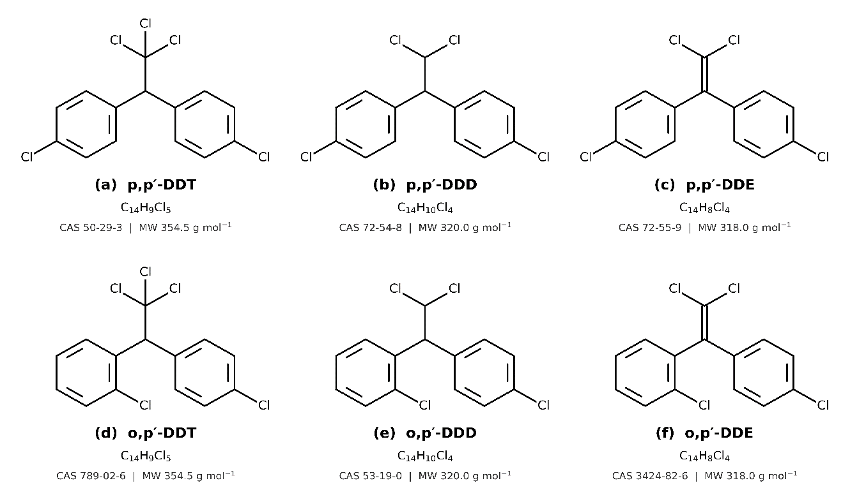
Figure 1.1: Chemical structures of the six DDT-group OCPs (∑DDTs) quantified in this study.

1.4.2 The HCH Group (α-, β-, γ- and δ-HCH)
Hexachlorocyclohexane, sometimes still referred to by its older name benzene hexachloride (BHC), is a fully chlorinated cyclohexane ring with the molecular formula C6H6Cl6. Technical-grade HCH, as historically manufactured and applied, is actually a mixture of several stereoisomers that differ from one another only in the three-dimensional (axial or equatorial) arrangement of the six ring-bound chlorine atoms, not in the underlying connectivity of the molecule (Lal et al., 2010). Of these, four isomers, alpha, beta, gamma and delta, are of the greatest environmental and toxicological interest and together constitute the ∑HCHs group examined here. It is worth noting that only the gamma isomer, marketed and still occasionally referred to under the trade name Lindane, possesses meaningful insecticidal activity; the alpha, beta and delta isomers are essentially inert by-products generated as a matter of chemistry during the industrial synthesis of technical HCH, yet they persist in the environment just as readily, and in the case of beta-HCH, arguably more readily, than the active gamma form (Carolin et al., 2023). Because beta-HCH, with all six chlorines in the more thermodynamically stable equatorial orientation, tends to be the slowest of the four isomers to degrade, its relative dominance in an environmental sample is often taken as a sign of older,weathered contamination, whereas a comparatively higher proportion of gamma-HCH points toward more recent input (Nagata et al., 2005; Willett et al., 1998).
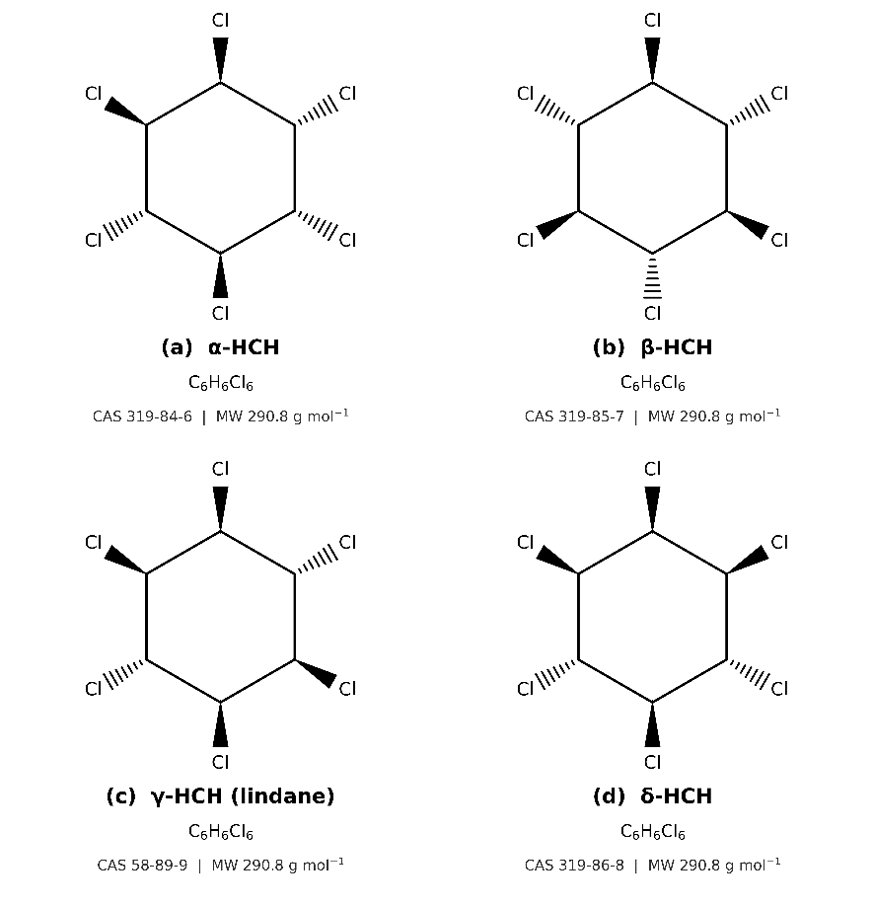
Figure 1.2: Chemical structures of the four HCH-group OCPs (∑HCHs) quantified in this study
1.4.3 The DRN Group (Aldrin and Dieldrin)
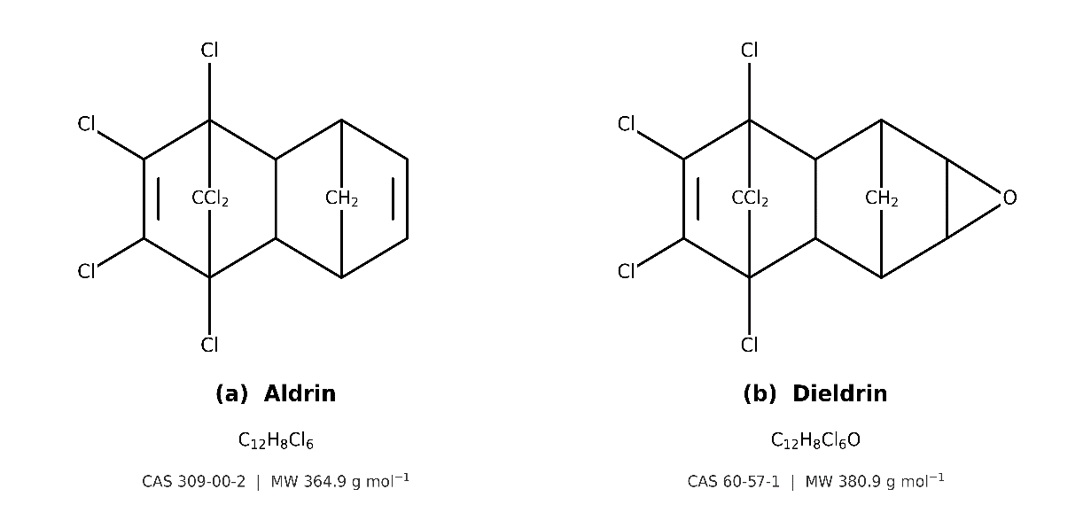
Aldrin and dieldrin are persistent organochlorine insecticides of the cyclodiene group. Aldrin was historically used mainly as a broad-spectrum soil insecticide, whereas dieldrin was employed against agricultural and structural insect pests. Aldrin undergoes epoxidation and can be transformed into dieldrin in biological systems and through environmental processes. Therefore, dieldrin residues may occur even where historical pesticide use primarily involved aldrin (Pang et al., 2022; Tsiantas et al., 2021). Both compounds exhibit high environmental persistence and strong affinity for organic matter and lipids, promoting their retention in soil and sediment and accumulation in biological tissues. Their persistence allows residues to remain detectable long after their original application, making them important contaminants in aquatic ecosystems and food-chain exposure assessments (Carolin et al., 2023; WHO, 1989). The aldrin-dieldrin transformation is important for environmental interpretation because detection of dieldrin does not necessarily indicate recent dieldrin application; it may instead reflect the transformation and redistribution of historically applied aldrin (Carolin et al., 2023; Taiwo, 2019). In Bangladesh, Matin et al. (1998) reported that the use of organochlorine insecticides, except heptachlor, for agricultural and public-health purposes had been banned by late 1993, although existing stocks could still be used. Their survey of surface and groundwater collected during 1992-1995 detected several OCP residues, including dieldrin, in some water samples. Given their persistence, transformation, and bioaccumulation potential, aldrin and dieldrin remain relevant indicators of historical cyclodiene contamination in aquatic environments, including the Halda River.
Figure 1.3: Simplified schematic structures of the two cyclodiene OCPs (Aldrin and Dieldrin) quantified in this study

Figure 0.4: Simplified schematic structures of the two cyclodiene OCPs (Heptachlor and Heptachlor epoxide) quantified in this study..Figure 0.5: Simplified schematic structures of the two cyclodiene OCPs (Aldrin and Dieldrin) quantified in this study.

Figure 0.6: Simplified schematic structures of the two cyclodiene OCPs (Heptachlor and Heptachlor epoxide) quantified in this study..

Figure 0.7: Sampling Zones and Locations of the StudyFigure 0.8: Simplified schematic structures of the two cyclodiene OCPs (Heptachlor and Heptachlor epoxide) quantified in this study..Figure 0.9: Simplified schematic structures of the two cyclodiene OCPs (Aldrin and Dieldrin) quantified in this study.

Figure 0.10: Simplified schematic structures of the two cyclodiene OCPs (Heptachlor and Heptachlor epoxide) quantified in this study..Figure 0.11: Simplified schematic structures of the two cyclodiene OCPs (Aldrin and Dieldrin) quantified in this study.

1.4.4 The HPT Group (Heptachlor and Heptachlor Epoxide)
Heptachlor is a persistent cyclodiene organochlorine insecticide historically used primarily for controlling soil insects and termites, as well as in certain agricultural applications. Following environmental release, heptachlor can undergo biological transformation to heptachlor epoxide, a persistent metabolite that may remain in soil and water for prolonged periods. Both compounds have strong affinities for organic matter and lipids, while heptachlor epoxide can accumulate in fish and other aquatic organisms (Henderson et al., 1959). The persistence and transformation of these compounds are important in aquatic contamination because residues can be transferred among water, sediment, and aquatic biota. Detection of heptachlor epoxide therefore does not necessarily indicate recent application of heptachlor; rather, it may reflect the environmental transformation and redistribution of historically applied heptachlor (Carolin et al., 2023; Nowell et al., 1999; WHO, 1992). In Bangladesh, Matin et al. (1998) reported that the use of organochlorine insecticides, except heptachlor, for agricultural and public-health purposes had been banned by late 1993, although existing stocks could still be used. Their investigation of surface and groundwater samples collected during 1992-1995 detected heptachlor residues in some water samples and noted that its use remained permitted for specific purposes at that time (Matin et al., 1998). Given their persistence, transformation, and bioaccumulation potential, heptachlor and heptachlor epoxide are important analytes for assessing historical cyclodiene contamination in aquatic systems. Their occurrence in the Halda River may indicate the persistence and environmental redistribution of historical heptachlor residues.
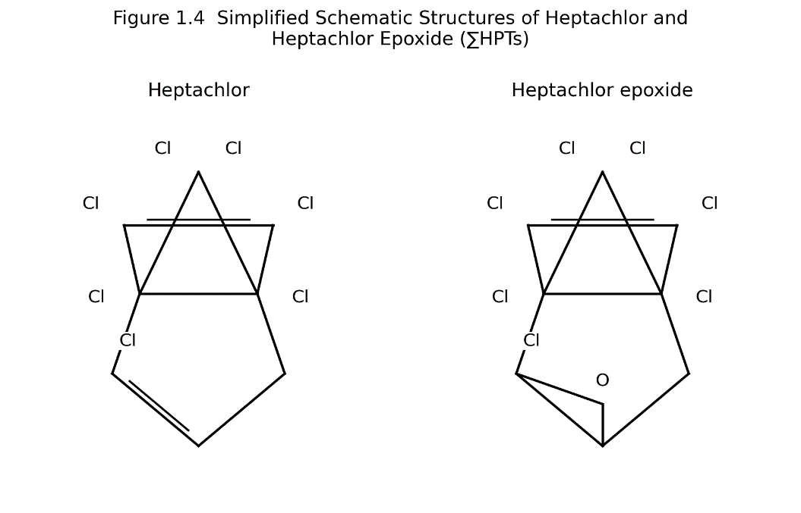
Figure 1.4: Simplified schematic structures of the two cyclodiene OCPs (Heptachlor and Heptachlor epoxide) quantified in this study

1.4.4 Summary of Physicochemical Properties
Table 1.1 brings together, for ease of reference, the principal physicochemical properties of all fifteen congeners discussed above. These values, compiled from the wider OCP literature (Carolin et al., 2023; N. J. Chowdhury et al., 2024), are provided as approximate, order-of-magnitude figures rather than precise constants, since reported values for log Kow and water solubility do vary somewhat between sources depending on the experimental method used to derive them; they are nonetheless useful in explaining, for example, why the DDT-group compounds, with the highest log Kow values in the table, would be expected to show the strongest affinity for sediment and fish lipid of the four groups, while the HCH isomers, with comparatively lower log Kow and higher water solubility, would be expected to remain more evenly distributed between the water column and the particulate/biotic phases.
Table 1.1: Approximate physicochemical properties of the fourteen OCP congeners examined in this study.
Compound | Group | Molecular Formula | MW (g/mol) | log Kow | Water Solubility (mg/L, 20-25 °C)
o,p'-DDT | DDTs | C14H9Cl5 | 354.5 | ~6.79 | ~0.085
p,p'-DDT | DDTs | C14H9Cl5 | 354.5 | ~6.91 | ~0.025
o,p'-DDD | DDTs | C14H10Cl4 | 320.0 | ~5.87 | ~0.10
p,p'-DDD | DDTs | C14H10Cl4 | 320.0 | ~6.02 | ~0.09
o,p'-DDE | DDTs | C14H8Cl4 | 318.0 | ~6.00 | ~0.14
p,p'-DDE | DDTs | C14H8Cl4 | 318.0 | ~6.51 | ~0.04
α-HCH | HCHs | C6H6Cl6 | 290.8 | ~3.80 | ~2.0
β-HCH | HCHs | C6H6Cl6 | 290.8 | ~3.78 | ~0.24
γ-HCH (Lindane) | HCHs | C6H6Cl6 | 290.8 | ~3.72 | ~7.3
δ-HCH | HCHs | C6H6Cl6 | 290.8 | ~4.14 | ~2.1
Aldrin | DRNs | C12H8Cl6 | 364.9 | ~6.50 | ~0.027
Dieldrin | DRNs | C12H8Cl6O | 380.9 | ~5.40 | ~0.14
Heptachlor | HPTs | C10H5Cl7 | 373.3 | ~5.44 | ~0.18
Heptachlor epoxide | HPTs | C10H5Cl7O | 389.3 | ~5.00 | ~0.35

1.4.5 Rationale for Selecting These Fifteen OCP Congeners
The particular set of fifteen congeners analysed in this thesis was not chosen arbitrarily. Taken together, ∑DDTs, ∑HCHs, ∑DRNs and ∑HPTs represent the OCP families most consistently reported, and most consistently detected, in monitoring studies of South Asian and, more specifically, Bangladeshi river systems, including the Meghna, the Buriganga and its neighbouring rivers around Dhaka, and irrigation water sampled across the wider country (M. Akter et al., 2026; Md. K. Alam, 2013; Hasan, 2021). Restricting the analysis to these fifteen compounds, rather than attempting to screen for the much larger universe of pesticides that has been used in Bangladesh over the decades, keeps the analytical method (described in Chapter Two) both tractable and directly comparable with the existing body of Bangladeshi and regional OCP literature, which is itself an important consideration given how thin that literature currently is for the Halda River specifically. It also ensures that the parent compounds and their principal environmental transformation products, DDT alongside DDD and DDE, aldrin alongside dieldrin, heptachlor alongside heptachlor epoxide, are captured together, which, as discussed in Section 1.3.3, is essential to correctly interpreting whether any contamination detected reflects recent input or long-weathered residues.

1.5 Bioaccumulation and Biomagnification
Bioaccumulation is the term used to describe the net build-up of a chemical within the tissues of a single organism over its lifetime, a process that occurs whenever the rate at which the organism takes up the chemical, through its gills, its skin, or its diet, exceeds the rate at which it can metabolise or excrete it (Streit, 1998). For a class of compounds as lipophilic and metabolically resistant as the OCPs, this balance is heavily tilted toward accumulation rather than elimination. Once absorbed, OCP molecules partition preferentially into lipid-rich tissue, muscle, liver and, in the case of egg-bearing females, the developing ova, where they can remain for months or years with only slow turnover (Antu et al., 2026).
Biomagnification is a related but distinct phenomenon, describing the tendency of OCP concentrations to increase at each successive step of a food chain rather than simply within a single organism. Phytoplankton and other primary producers take up trace amounts of dissolved and particulate OCPs from the water column; zooplankton and small invertebrates that graze on this primary production accumulate correspondingly higher concentrations in their own, smaller body mass; and fish that prey on these invertebrates, particularly larger, longer-lived, higher-trophic-level species, can end up carrying body burdens many times higher than the ambient environmental concentration would on its own suggest (Antu et al., 2026; Ray & Shaju, 2023). This is the essential reason why trace, sub-microgram-per-litre concentrations of OCPs in river water, of the kind that might otherwise be dismissed as negligible, can nonetheless translate into biologically meaningful, and potentially toxicologically significant, residue levels in the muscle tissue of the very fish that people go on to eat.
Within the Halda River's fish community, and specifically among the three carp species examined in this study, feeding ecology is expected to play a considerable role in determining how much OCP residue each species accumulates. Mrigal is predominantly a bottom-feeding, detritivorous species that forages directly on the river bed, precisely the compartment identified in Section 1.3.2 as the principal long-term reservoir of hydrophobic contaminants such as OCPs, and would on that basis be expected to show comparatively higher residue burdens than Catla, which feeds mainly at the water surface on plankton, or Rui, which occupies an intermediate, water-column feeding niche (Kuranchie-Mensah et al., 2012). Whether this expectation holds true for the Halda's carp populations specifically is one of the questions the present study is designed to answer.

1.6 Toxicity of OCPs on Riverine Life
The toxic effects of OCPs on fish and other aquatic organisms span a wide range, from immediate, acute poisoning at high exposure concentrations to subtle, chronic effects that only become apparent over an organism's lifetime or across generations (Uotila & Kömives, 1996). At the level of acute toxicity, the cyclodienes (aldrin, dieldrin, endrin) and DDT act principally on the nervous system, DDT by interfering with the normal opening and closing of voltage-gated sodium channels in nerve cell membranes, and the cyclodienes by blocking GABA-gated chloride channels, in both cases producing a state of nervous hyperexcitability that manifests as tremors, loss of coordination, convulsions and, at sufficiently high doses, death (Narahashi, 1996; Zhorov & Dong, 2017). Even at sub-lethal acute concentrations, exposed fish frequently show impaired swimming performance and loss of equilibrium, together with visible damage to the delicate gill epithelium that compromises respiratory function (Soloneski & Larramendy, 2012).
It is chronic, low-level exposure, however, that is of greater practical relevance to a river such as the Halda, where OCP residues, if present at all, would be expected to occur at trace rather than acutely toxic concentrations. A number of OCPs, DDT and its metabolite DDE prominent among them, along with dieldrin, are recognised endocrine-disrupting chemicals, meaning they are capable of mimicking, blocking or otherwise interfering with the action of natural steroid hormones within an exposed organism. In fish, this endocrine-disrupting activity has been linked in the wider literature to reduced fecundity, skewed sex-hormone ratios and, in some documented cases, intersex conditions, impaired gonadal development, and elevated rates of embryo and larval mortality and deformity (Antu et al., 2026; Carolin et al., 2023). Given that the entire ecological and economic significance of the Halda River rests on the successful natural spawning and subsequent larval survival of its carp populations, even a chronic, sub-lethal level of OCP contamination in the river's spawning-ground reaches carries a disproportionate significance relative to what the same concentration might mean in a river without this specific reproductive function.
The effects of OCP contamination are, of course, not confined to fish alone. Zooplankton, benthic macroinvertebrates and other lower trophic-level organisms that form the base of the river's food web are similarly susceptible to both acute and chronic OCP toxicity, and disruption at this level can, in principle, propagate upward through the food chain in ways that are difficult to detect through fish-focused monitoring alone (Antu et al., 2026). This broader ecological dimension, while outside the direct scope of the present study, is worth bearing in mind when interpreting the fish- and sediment-based findings presented in later chapters.
Beyond the endocrine and neurological effects already described, a growing body of laboratory and field evidence points to genotoxic and histopathological consequences of chronic OCP exposure in fish. Studies examining fish from OCP-contaminated water bodies have reported elevated frequencies of micronuclei and other nuclear abnormalities in erythrocytes, an indicator of DNA damage, along with structural changes in the liver, kidney and gill tissue visible under histological examination, including hepatocyte vacuolation, necrotic foci and gill lamellar fusion, changes that, while not always immediately fatal, are consistent with a chronically stressed and compromised physiological state (Jayaraj et al., 2016). It is this kind of sub-lethal, tissue-level damage, rather than outright mortality, that is generally expected to characterise fish populations exposed to the trace-level OCP contamination typical of a river like the Halda, and it underscores why residue concentration alone, while the principal focus of the present study, does not tell the complete story of a contaminant's biological impact.

1.7 Human Health Impact
For the human population living along the Halda and, more broadly, for consumers of Bangladeshi freshwater fish elsewhere in the country, dietary consumption of contaminated fish represents by far the most significant pathway of exposure to OCPs, a conclusion that follows directly from the biomagnification process described above and is reinforced by the comparatively high per-capita fish consumption typical of Bangladesh (Hasan, 2021; Ray & Shaju, 2023). The health consequences associated with chronic dietary OCP exposure are wide-ranging and, in several instances, well established through decades of toxicological and epidemiological research.
Endocrine disruption has already been mentioned in the context of fish reproduction, and the same basic mechanism, interference with natural hormone signalling, operates in humans, where several OCPs act as weak xenoestrogens or anti-androgens. Reproductive and developmental effects follow from this, including associations reported in the literature between OCP exposure and reduced fertility, pregnancy loss, and impaired neurodevelopment in children exposed prenatally or during early infancy, a period during which the developing nervous system is particularly vulnerable (Hussein et al., 2022). Beyond the reproductive and developmental axis, chronic OCP exposure has been linked to immunotoxic effects, to liver and kidney damage, and to neurological outcomes extending as far as an association with Parkinson's disease in some epidemiological studies; several OCPs, DDT and its metabolites, aldrin, dieldrin and heptachlor among them, are additionally classified by international regulatory and research bodies as probable or possible human carcinogens (Carolin et al., 2023; Hussein et al., 2022; Ray & Shaju, 2023).
Certain groups within the population bear a disproportionate share of this risk. Children, owing to their smaller body mass, higher food intake relative to body weight, and the particular vulnerability of the developing nervous and endocrine systems, are generally considered more sensitive to a given dose of OCP than adults (National Research Council (U.S.), 1993). Pregnant and lactating women represent a second group of concern, both because of the risk of transplacental and lactational transfer of accumulated OCPs to the foetus or infant, and because fish is often specifically recommended as a source of dietary protein during pregnancy (Wahlang, 2018). Fishing and spawn-collecting households along the Halda itself, whose diets are likely to draw more heavily and more directly on locally caught fish than the national average, constitute a third, geographically specific group whose exposure this study is, in part, intended to help characterise.
Because these health effects depend heavily on the dose received and the duration of exposure, and because OCPs accumulate in body fat over a lifetime rather than being cleared quickly, translating a measured environmental concentration into a meaningful statement about human health risk requires a structured, quantitative approach. Indices such as the Estimated Daily Intake (EDI), the Target Hazard Quotient (THQ), the cumulative Hazard Index (HI) and, where appropriate, an estimate of incremental cancer risk (CR), calculated from measured OCP residues in edible fish tissue together with local fish consumption rates and standard body-weight assumptions, have become the accepted means of doing so in the environmental health literature (Hasan, 2021; M. A. Islam et al., 2020). This framework is adopted in the results and discussion chapters of the present thesis to interpret the OCP concentrations measured in Rui, Catla and Mrigal from the Halda River in terms of their practical significance for the people who eat them.

1.8 Pollution and Contamination Concerns in Aquatic Systems
The pressures bearing down on the Halda River are, in broad outline, not unique to it. Freshwater systems across South Asia face a broadly similar combination of agricultural intensification, rapid and often poorly planned urbanisation, and industrial growth, and Bangladesh's own river network, dense, heavily used and running through one of the most densely populated landscapes on Earth, illustrates these pressures about as clearly as any country's does (Carolin et al., 2023; M. A. Islam et al., 2020). What sets OCPs apart from many of the other pollutants affecting these rivers, heavy metals included, is the sheer length of time over which contamination introduced decades ago can remain detectable. Where a nutrient or an easily biodegradable organic pollutant might be expected to clear from a river system within weeks of the input stopping, OCP residues bound to sediment can, and demonstrably do, persist for thirty years or more after the compounds in question were formally banned (Gardes et al., 2021).
Other Bangladeshi rivers offer a useful point of comparison. OCP residues have been reported in the water and fish of the Buriganga, Turag, Balu, Sitalakhya, Bangshai and Dhaleswari rivers surrounding Dhaka, with compounds including Aldrin, p,p′-DDE and Eldrine ketone detected across these systems (Hasan, 2021). More recently, a systematic survey of the Meghna River, one of Bangladesh's principal transboundary rivers, using liquid-liquid extraction coupled with GC-ECD, reported detectable concentrations of 4,4′-DDE, 4,4′-DDD, endrin aldehyde, trans-chlordane and methoxychlor across ten sampling locations, with the highest levels recorded near sites of concentrated industrial and agricultural activity (Akter et al., 2026). Taken together, these studies establish that OCP contamination is neither a hypothetical concern nor a purely historical artefact in Bangladesh's rivers; it is a measurable, ongoing feature of the country's aquatic environment, and one whose severity appears, unsurprisingly, to track the intensity of agricultural and industrial land use in a given catchment.
Set against this regional backdrop, the near-total absence of published, dedicated OCP monitoring data for the Halda River stands out as a genuine gap. The river has, as noted earlier, attracted a reasonable body of research attention with respect to heavy metals and general water-quality parameters (Bhuyan & Bakar, 2017; M. A. Islam et al., 2020; Kamal et al., 2024b), yet its organic contaminant status, and OCPs specifically, remains essentially uncharacterised. Given the river's singular ecological function and the documented pattern of OCP persistence in comparable Bangladeshi rivers, this is not a gap that can be assumed away, and closing it, at least partially, is the central purpose of this thesis.
It is also worth stepping back briefly to note that OCP contamination is not, in any sense, a problem unique to Bangladesh or even to South Asia. The same properties that allow these compounds to persist in a local river sediment for decades also allow them to travel: volatilisation followed by atmospheric transport has carried OCPs, DDT and HCH isomers in particular, over thousands of kilometres from their original point of application, to the extent that measurable residues have been documented in the tissue of Arctic marine mammals and in polar ice, environments with no history of agricultural pesticide use whatsoever (Bidleman, 1988). This global mobility was, in fact, one of the principal arguments used to justify the Stockholm Convention's international, rather than purely national, approach to eliminating these compounds (United Nations Environment Programme, 2001). Set against that global backdrop, a river-specific study of the kind undertaken here contributes a small but concrete data point to what is, in the end, a genuinely worldwide environmental accounting exercise.

1.9 Regulatory Status and Policy Framework
The international regulatory response to organochlorine pesticides crystallised most decisively with the adoption of the Stockholm Convention on Persistent Organic Pollutants in 2001, under which twelve chemicals or chemical groups, nine of them organochlorine pesticides including DDT, aldrin, dieldrin, endrin, heptachlor and HCH-related compounds, were designated for elimination or, in the specific case of DDT, restricted use limited to disease-vector control under strict conditions (UNEP, 2001). Bangladesh is a signatory to the Convention and has, as described in Section 1.1, pursued its own parallel domestic regulatory track, banning organochlorine insecticides (heptachlor excepted) for agricultural and public-health use by late 1993 (Matin et al., 1998), well ahead of the Stockholm Convention itself, largely in response to accumulating evidence of environmental persistence and human health risk gathered through the 1980s and early 1990s.
In practice, however, a formal ban is only as effective as the monitoring and enforcement infrastructure that stands behind it, and this is where the picture becomes more complicated. Bangladesh's pesticide regulatory apparatus has historically been oriented toward registering and controlling currently used products, organophosphates, carbamates, pyrethroids and neonicotinoids among the classes that have effectively replaced OCPs in contemporary agriculture, rather than toward the ongoing, systematic monitoring of legacy contamination from compounds that were withdrawn a generation ago. Routine national surveillance of OCP residues in river water, sediment or fish is not, at present, a standard feature of the country's environmental monitoring programme, which means that the scientific literature, individual academic studies of the kind cited throughout this chapter, currently carries most of the burden of documenting where legacy OCP contamination remains and at what levels. Studies such as the present one, focused on a river of acknowledged national importance, therefore serve a purpose that extends beyond academic interest alone, contributing directly to the evidence base that would be needed to inform any future, more systematic monitoring or remediation effort targeting the Halda specifically.

1.10 Previous Studies in Bangladesh and Similar Rivers
Previous studies in Bangladesh show that river contamination is a serious and continuing environmental problem, especially in urban and agriculturally influenced waterways. Research has reported organochlorine pesticide residues in river water and fish from several contaminated rivers surrounding Dhaka, indicating that persistent pesticide pollution is not limited to a single location but is distributed across multiple river systems (Hasan, 2021). In addition, broader reviews of Bangladeshi river water quality have shown that many rivers are under severe pressure from industrial discharge, sewage, agricultural runoff, and other anthropogenic activities, with several urban rivers in critical condition (Kormoker et al., 2023; Uddin & Jeong, 2021).
Studies from Bangladesh also suggest that contamination commonly affects more than one environmental compartment at the same time. Pollutants are often found in water, sediment, and aquatic biota, which indicates that river contamination is not only a surface-water issue but also a sediment and food-web issue (Ga, 2016). This is particularly important for persistent compounds such as OCPs, because they can remain in sediments for long periods and continue to influence aquatic organisms even when direct use has declined (Jayaraj et al., 2016; WHO, 2006).
Similar findings from other river systems support the need for integrated monitoring in Bangladesh. Studies in large freshwater rivers have shown that persistent pollutants can accumulate in sediments and fish, creating long-term ecological and human health concerns through bioaccumulation and dietary exposure(Akoto et al., 2016). Reviews of polluted rivers in Bangladesh further confirm that river systems such as the Buriganga, Turag, Balu, Sitalakhya, and others have experienced intense contamination over the last decades, highlighting the vulnerability of Bangladeshi rivers to persistent chemical stress (H. Rahman et al., 2020; Uddin & Jeong, 2021).
However, despite these useful findings, comprehensive risk-based studies on OCPs in the Halda River are still limited. Most earlier studies have focused on general water quality, heavy metals, or selected contaminated rivers around Dhaka, while fewer studies have assessed OCPs simultaneously in water, sediment, and fish from an ecologically important breeding river like the Halda. This limitation creates a clear research gap and supports the need for the present study.

1.11 Research Gap
Although the Halda River is recognized as one of the most important freshwater ecosystems in Bangladesh, the available literature shows that most environmental studies in this river have focused on heavy metals and basic water quality rather than on organochlorine pesticides (OCPs) specifically (Dey et al., 2021; Hossain et al., 2021; Karim et al., 2026). Previous investigations have documented contamination risks in both water and sediments of the Halda River, and sme have identified considerable ecological concerns associated with metal pollution (Hossain et al., 2021; M. A. Islam et al., 2020). However, comparable integrated evidence on OCP contamination in water, sediment, and fish from the Halda River is still limited.
A further limitation in the existing literature is that many studies examine only a single environmental matrix, such as water or sediment, without linking these compartments to fish contamination and food-web transfer. This is important because OCPs are persistent and hydrophobic compounds that can partition among water, sediments, and aquatic organisms over time (Bayen et al., 2019; Jayaraj et al., 2016; Nowell et al., 1999). Without a multi-matrix approach, it is difficult to determine whether sediments are acting as a sink, whether fish are accumulating residues, or how contamination may move through the aquatic ecosystem. As a result, a complete understanding of OCP behavior in the Halda River remains incomplete.
In addition, ecological and human health risk assessments are often not treated together in earlier river contamination studies. For a river such as the Halda, which is both a natural breeding ground for major carp species and an important source of fish for local consumption, this is a major gap (M. A. Islam et al., 2020). The absence of combined ecological and dietary risk evaluation limits the practical value of previous findings for river management, fisheries protection, and public health planning. Risk-based evidence is especially necessary where contaminant exposure may affect fish reproduction, sediment quality, and human food safety simultaneously.
There is also a need for more site-specific and up-to-date data on pesticide contamination in the Halda River. Contamination patterns in river systems can vary by sampling location depending on land use, runoff, industrial discharge, and seasonal hydrology. Therefore, a study focused on OCPs across different environmental compartments is necessary to identify current contamination status and possible exposure pathways in this ecologically sensitive river.
Accordingly, the present study addresses these gaps by investigating OCP residues in water, sediment, and fish from the Halda River and by evaluating the associated ecological and human health risks. This approach will provide new evidence that can support environmental management and pollution control in one of Bangladesh’s most important freshwater ecosystems.

1.12 Aim and Objectives of the Study
The aim of this study is to assess the contamination status and potential ecological and human health risks of organochlorine pesticides (OCPs) in water, sediment, and fish from the Halda River, Bangladesh. This aim is consistent with previous OCP research that emphasizes the importance of evaluating persistent pollutants across environmental compartments and linking concentration data with risk assessment (Jayaraj et al., 2016; Mörner et al., 2002).
The specific objectives of the study are to:
- Determine the presence and concentration levels of selected OCPs in water, sediment, and fish samples collected from the Halda River.
- Examine the distribution pattern of OCPs among water, sediment, and fish to understand their environmental behavior and possible accumulation pathways.
- Evaluate the ecological risk associated with OCP contamination in the Halda River ecosystem.
- Assess the potential human health risks arising from fish consumption contaminated with OCP residues.
- Identify spatial variation in OCP contamination across different sampling sites of the Halda River.
- Provide scientific evidence that may support environmental management, pollution control, and river conservation efforts in this important freshwater ecosystem.

1.13 Significance of the Study
This study is significant because it addresses a critical environmental issue in one of Bangladesh’s most important freshwater ecosystems. The Halda River is ecologically valuable as a natural breeding ground for major carp species, and any contamination in this river may directly affect fish reproduction, aquatic biodiversity, and the long-term sustainability of fisheries (M. A. Islam et al., 2020; Kamal et al., 2024b; Karim et al., 2026). By focusing on organochlorine pesticides (OCPs), the study provides evidence on a class of persistent pollutants that can remain in the environment and continue to pose risks long after their use has declined (Jayaraj et al., 2016; Taiwo, 2019).
The study is also important from a public health perspective because fish from the Halda River may be consumed by local communities. OCPs can accumulate in fish tissues and may be transferred to humans through dietary exposure, creating possible health risks over time (Hussein et al., 2022; Tongo et al., 2019). In this context, the findings will help determine whether contamination levels in fish are within acceptable limits and whether the river may pose a food safety concern for nearby populations.
From an ecological standpoint, the study will contribute to understanding how OCPs behave across water, sediment, and fish in a river ecosystem. Sediment can act as both a sink and a secondary source of contamination, while fish can reflect the degree of bioaccumulation and food-web transfer (Griboff et al., 2018; Miličić et al., 2026). Therefore, an integrated assessment of these compartments will provide a more complete picture of pollutant distribution and environmental risk than studies based on water alone.
The study also has practical value for environmental management and policy. Bangladesh faces increasing pressure from agriculture, urbanization, and industrial activity, all of which can contribute to river pollution (Hoque et al., 2021; M. S. Islam et al., 2023). The results of this research may support pollution monitoring, fisheries protection, and river conservation efforts in the Halda basin. In addition, the findings may help government agencies and local stakeholders design better strategies for reducing contaminant inputs and protecting a river system that is vital to both biodiversity and livelihoods.
Overall, this study will fill an important knowledge gap by providing current, site-specific evidence on OCP contamination and associated risks in the Halda River. Its findings are expected to be useful for researchers, environmental managers, fisheries authorities, and public health stakeholders concerned with protecting aquatic ecosystems and food safety in Bangladesh.

1.14 Rationale and Justification of the Study
Bringing together the threads laid out in the preceding sections, the case for undertaking this study rests on four considerations taken jointly rather than on any single one alone. First, the Halda River performs an ecological function, natural carp spawning, that is found nowhere else, which means that any degradation of its water or sediment quality carries consequences that cannot simply be offset by looking to another river. Second, the catchment surrounding the river has demonstrably come under increasing agricultural, urban and industrial pressure over the past two decades, precisely the kind of pressure that, elsewhere in Bangladesh and the wider region, has been shown to correlate with measurable OCP contamination. Third, the physicochemical and toxicological properties of OCPs, their persistence, their tendency to bioaccumulate and biomagnify, and their documented toxicity to both aquatic organisms and human consumers, are sufficiently well established in the wider literature that ignoring the possibility of their presence in a river like the Halda would be difficult to defend on scientific grounds. Fourth, and most directly, there is at present no published, systematic OCP contamination data for the Halda River, in contrast to the comparatively well-studied heavy-metal situation, leaving a clear and specific gap for this thesis to address.
Taken together, these four points justify a dedicated, spatially resolved assessment of fifteen OCP congeners across the water, sediment and fish compartments of the Halda River, structured around the river's upstream, midstream and downstream reaches so as to capture any spatial gradient associated with the varying land-use pressures described in Section 1.2.4. The findings are intended not merely to fill an academic gap but to provide a baseline against which future monitoring, and any fisheries-management or conservation decisions concerning the river, can be measured.

1.15 Scope and Limitations
This study is focused on the assessment of organochlorine pesticides (OCPs) in water, sediment, and fish from the Halda River, Bangladesh. The scope of the research includes the determination of OCP contamination levels, the examination of their distribution among environmental compartments, and the evaluation of ecological and human health risks associated with exposure. Since OCPs are persistent organic pollutants that can accumulate in aquatic ecosystems and food webs, an integrated assessment of water, sediment, and fish is necessary to understand their environmental behavior and potential impacts (Coat et al., 2011; Jayaraj et al., 2016).
The study is limited to selected sampling sites within the Halda River and therefore represents the contamination status of the chosen locations rather than the entire river basin. Spatial variation in pollutant concentrations may occur depending on land use, local runoff, and human activity, so the results should be interpreted in the context of the sampled areas. In addition, the study primarily addresses selected OCP compounds and does not cover all possible pesticide classes or other emerging contaminants that may also be present in the river system.
Another limitation is that the study is based on measurements taken during the sampling period and may not fully capture seasonal variation in OCP concentrations. Environmental contamination can fluctuate due to rainfall, river flow, agricultural activity, and sediment disturbance, which may influence pollutant distribution over time (Jayaraj et al., 2016). Therefore, the findings provide an important snapshot of current contamination conditions but may not represent year-round variability.
The study also focuses on risk estimation using concentration data and standard risk assessment approaches. While this provides useful information on potential ecological and health threats, actual exposure and risk may vary depending on fish consumption patterns, local dietary habits, and environmental conditions. In addition, as with most deterministic risk assessments, the results depend on the assumptions and input parameters used in the analysis, which may introduce some uncertainty into the final risk estimates (Birungi et al., 2025). Despite these limitations, the study offers valuable baseline information for understanding OCP contamination in the Halda River and for supporting future research and management actions.

1.16 Organization of the Thesis
The remainder of this thesis is organised into four further chapters. Chapter Two, Materials and Methods, describes the study area in full, the sampling design adopted across the eleven water and sediment stations and three fish-collection zones, and the laboratory procedures used for sample extraction, clean-up and instrumental analysis of the fifteen target OCPs. Chapter Three, Results, presents the measured OCP concentrations in water, sediment and fish, organised by stream segment and by species. Chapter Four, Discussion, interprets these results in light of the sources, environmental behaviour and toxicological significance of OCPs discussed in this chapter, situates the findings relative to comparable studies from the Halda and other Bangladeshi rivers, and applies the human health risk-assessment framework introduced in Section 1.7. Chapter Five, Conclusion and Recommendations, summarises the principal findings of the study and offers recommendations for river management, further monitoring, and future research.

Chapter-2: Materials and Methods

2.1 Description of the Study Area: The Halda River
The Halda River is a unique tidal, hill-fed watercourse located in southeastern Bangladesh, widely recognized as an irreplaceable ecological treasure and the sole natural breeding ground in the world for several important Indian major carp species, including Rui (Labeo rohita), Catla (Catla catla) and Mrigal (Cirrhinus cirrhosus) (Kabir et al., 2015; Tsai et al., 1981). Following the Sangu and the Karnaphuli, it ranks as Chattogram’s third-largest river and stands out as one of the few major systems flowing entirely within the territorial borders of Bangladesh.
The Halda River originates in the Ramgarh hill ranges of Manikchhari and Khagrachari, flows through Manikchhari, Fatikchhari, Hathazari and Raozan Upazilas, and ultimately joins the Karnaphuli River near Kalurghat, Chattogram. (Akter & Ali, 2012; Kamal et al., 2024b). Beyond its status as a vital biodiversity corridor, the river is deeply intertwined with the regional economy and local livelihoods. Natural carp eggs harvested from its waters are used to produce high-value fry that supply hatcheries and aquaculture operations across the nation, making a substantial contribution to Bangladesh's GDP while simultaneously providing indispensable ecosystem services such as municipal drinking water for millions in Chattogram, agricultural irrigation, inland navigation, and waste assimilation (Bhuyan et al., 2018). Its hydrology is influenced by tidal fluctuations, freshwater discharge, rainfall, and monsoonal runoff. Seasonal changes in water level, flow velocity, turbidity, temperature, and other physicochemical conditions create favourable environmental conditions for the natural spawning of major carps, particularly during the pre-monsoon and monsoon periods (Tsai et al., 1981).
Despite its ecological significance, the Halda basin has increasingly been subjected to anthropogenic pressure from agricultural runoff, tea-garden and cropland pesticide application, brickfields, tanneries, and industrial effluents discharged from the Kalurghat industrial belt near the river's confluence with the Karnaphuli, all of which have been documented to elevate contaminant loads in the river's water and sediment (Alam et al., 2026; Hossain et al., 2021; Islam et al., 2020). For the purpose of this study, an approximately 60 km stretch of the Halda River was demarcated into three hydrologically and geographically distinct zones:
- Upstream (Kazirhat to Nazirhat): The least urbanised reach, bordered largely by hill-toe agricultural land and tea gardens, representing the zone of maximum non-point agrochemical inflow.
- Midstream (Nazirhat to Hathazari): A transitional reach receiving mixed agricultural and domestic-settlement runoff.
- Downstream (Hathazari to the Halda–Karnaphuli confluence): The reach encompassing the river's principal natural carp breeding and spawning grounds, and also the zone most exposed to industrial and urban discharge near Kalurghat (Kamal et al., 2024b).
Because the downstream reach constitutes the ecologically critical spawning and nursery habitat for the carp population and is simultaneously the most anthropogenically stressed segment of the river, a proportionally greater number of sampling stations was allocated to this zone, consistent with the sampling rationale adopted in previous Halda River pollution-monitoring studies that intensified station density around the breeding grounds (Hossain et al., 2021; Islam et al., 2020; Kamal et al., 2024b).

2.2 Sampling Design and Site Selection
A stratified, zone-based sampling design was adopted to assess the spatial variation of pesticide contamination along the approximately 60 km study reach of the Halda River. Based on the geographical and environmental characteristics described above, the study area was divided into three major zones: upstream, midstream, and downstream. A total of eleven (11) fixed sampling stations were selected along the river, with three stations in the upstream zone, three in the midstream zone, and five in the downstream zone. The distribution of sampling stations was determined by considering several factors, including accessibility of the sites, surrounding land-use patterns, proximity to potential pollution sources, and the ecological importance of the area for carp breeding and spawning.
During site selection, particular attention was given to locations potentially influenced by both point and non-point sources of contamination. These included agricultural drainage channels, areas with intensive agricultural activities, human settlements, and industrial or other discharge points. The selected stations were therefore intended to represent the major environmental and anthropogenic characteristics of different sections of the river. Greater sampling coverage was provided in the downstream zone because of its ecological significance as a carp breeding area and its relatively greater exposure to urban and industrial activities. The overall approach to station selection was also informed by the site-selection rationale applied in previous water- and sediment-quality studies conducted in the Halda River (Islam et al., 2020; Kamal et al., 2024b).
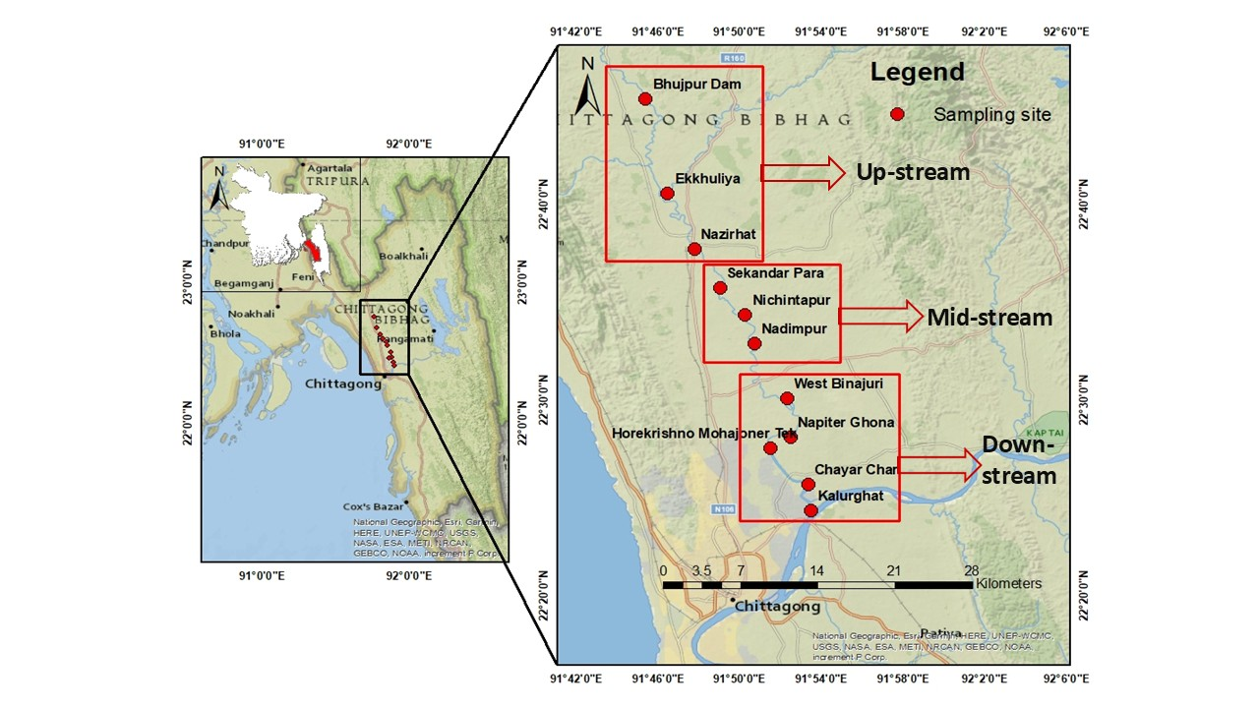
The geographic position of each station was recorded in the field using a handheld Global Positioning System (GPS) receiver, following the practice adopted in prior Halda River studies (Islam et al., 2020), and station coordinates were used to prepare a sampling-location map of the river using GIS software (ArcGIS). The eleven sampling stations, grouped by stream segment, are presented in Table 2.
Figure 2.1: Sampling Zones and Locations of the Study

Figure 0.2:Sediment Sample CollectionFigure 0.3: Sampling Zones and Locations of the Study

Figure 0.4:Sediment Sample Collection

Figure 0.5:Fish SampleFigure 0.6:Sediment Sample CollectionFigure 0.7: Sampling Zones and Locations of the Study

Figure 0.8:Sediment Sample CollectionFigure 0.9: Sampling Zones and Locations of the Study

Table 2.1: Water and sediment sampling stations along the Halda River, grouped by stream segment.
Stream | Sampling Station | Sampling Location |  | Samples Collected
Stream | Sampling Station | Latitude | Longitude | Samples Collected
Upstream | Bhujpur Dam | 22°45'22.34"N | 91°45'22.64"E | Water, Sediment
Upstream | Ekkhuliya | 22°40'32.58"N | 91°46'26.89"E | Water, Sediment
Upstream | Nazirhat | 22°37'41.51"N | 91°47'45.36"E | Water, Sediment
Midstream | Sekandar Para | 22°35'42.77"N | 91°49'00.60"E | Water, Sediment
Midstream | Nichintapur | 22°34'20.47"N | 91°50'14.28"E | Water, Sediment
Midstream | Nadimpur | 22°32'51.55"N | 91°50'41.10"E | Water, Sediment
Downstream | West Binajuri | 22°30'02.65"N | 91°52'18.75"E | Water, Sediment
Downstream | Napiter Ghona | 22°28'04.62"N | 91°52'27.12"E | Water, Sediment
Downstream | Horekrishno–Mohajoner Tek | 22°27'30.58"N | 91°51'28.68"E | Water, Sediment
Downstream | Chayar Char | 22°25'38.86"N | 91°53'18.82"E | Water, Sediment
Downstream | Kalurghat | 22°24'18.53"N | 91°53'27.93"E | Water, Sediment

2.3 Sample Collection
Field operations were meticulously structured to capture the multi-compartment dynamics of organochlorine pesticide (OCP) contamination within the river system. At each of the eleven designated monitoring stations, surface water and bottom sediment samples were gathered concurrently. To evaluate bioaccumulation pathways and establish a direct comparative framework for OCP distribution across water, sediment, and living matrices, fish samples were collected across the three primary stream segments (upstream, midstream, and downstream). Formal authorization for sample collection throughout the study area was granted by the Senior Upazila Fisheries Officer of Hathazari Upazila, Md. Shawkat Ali. Field logistics were tailored strictly to the geomorphology of the basin: sampling across the lower 25-kilometer reach was conducted from a small motorized boat launched from Kalurghat to navigate deep-water channels and tidal zones. For the remaining upstream segments where direct aquatic navigation was constrained, terrestrial routes and vehicular transport were deployed to reach designated monitoring stations, enabling the systematic retrieval of surface water and bottom sediment samples from the banks.

2.3.1 Water Sample Collection
Surface water grab samples were collected from approximately 15–30 cm below the water surface at each of the eleven stations, at channel where accessible, using pre-cleaned bottles of 1 L capacity, following the standard grab-sampling protocol described in APHA (2017) and adopted in Bangladeshi river OCP surveys (Akter et al., 2026; Hasan, 2021). . Prior to sample collection, bottles were rinsed three times with the ambient river water at the sampling point. Triplicate water samples were collected at each station to account for micro-spatial heterogeneity and to allow calculation of analytical means and standard deviations. Immediately after collection, bottles were capped to prevent sorption or leaching of organochlorine compounds into or from the cap liner. The capped bottles were then placed individually in black polyethylene bags to protect the samples from direct exposure to sunlight and minimize potential photodegradation of light-sensitive organochlorine pesticide residues, labelled with the station code, date, time, and sampling depth, and placed in an insulated ice box containing ice before transportation to the laboratory under chilled conditions (U.S. EPA, 1995).

2.3.2 Sediment Sample Collection
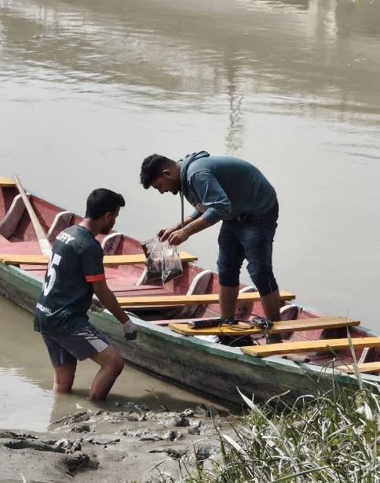
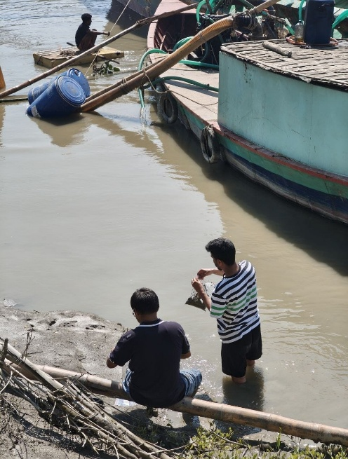
Surface sediment (top 0-5 cm layer, the layer in which recently deposited, hydrophobic organic contaminants such as OCPs preferentially accumulate) was collected entirely by hand at each of the eleven stations, using a stainless-steel hand trowel, in line with the manual sediment-sampling approach commonly adopted for river OCP monitoring (Birungi et al., 2025; M. A. Islam et al., 2020; Kuranchie-Mensah et al., 2012). In the deeper mid-channel stretches of the lower 25 km reach, sediment was collected by hand using the trowel from the boat, reaching down to the riverbed at each station; at the shallower upstream stations, sediment was collected by hand directly from the exposed riverbank. At each station, sediment was collected by hand from three sub-locations and homogenised in the field to form a single composite sample, minimising the effect of local micro-heterogeneity in grain size and organic content. Visible debris, pebbles, roots and plant material were removed on-site. Each composite sediment sample was placed inside a labelled, resealable zipper polythene bag; the sealed zipper bag was then placed inside a further opaque black polythene bag to protect the sample from light. The double-bagged samples were placed into a rigid insulated storage box and transported to the laboratory under cold, dark conditions to retard microbial degradation and photodegradation of pesticide residues prior to extraction (U.S. EPA, 1995).
Figure 2.2: Sediment Sample Collection

Figure 0.10:Fish SampleFigure 0.11:Sediment Sample Collection

Figure 0.12:Fish Sample

Figure 0.13: Labeo rohita (Hamilton, 1822)Figure 0.14:Fish SampleFigure 0.15:Sediment Sample Collection

Figure 0.16:Fish SampleFigure 0.17:Sediment Sample Collection

2.3.3 Fish Sample Collection
Three economically and ecologically important carp species that are also naturally spawned in the Halda River; Rui (Labeo rohita), Catla (Catla catla), and Mrigal (Cirrhinus cirrhosus) were collected from each of the three stream segments (upstream, midstream and downstream) with the assistance of local fishermen, using cast nets and gill nets, immediately after capture, in a manner consistent with fish-sampling protocols used in comparable OCP bioaccumulation studies on Bangladeshi rivers (Hasan, 2021). Three individual specimens (biological replicates) of each species of comparable size/age class were collected from each stream segment, giving a total of 3 species × 3 streams × 3 replicates = 27 fish samples for the study. Fish were euthanised on-site by icing in accordance with standard humane field-handling practice, sealed in labelled polyethylene bags, and transported to the laboratory in an ice-packed cooler box under cold-chain conditions (~4 °C) to minimise lipid degradation and pesticide loss prior to dissection (Hasan, 2021).

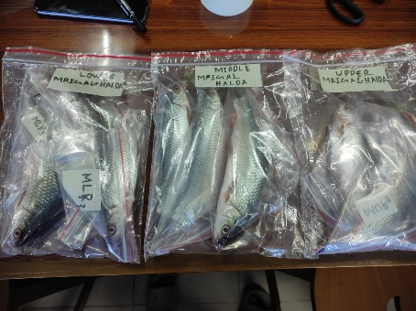
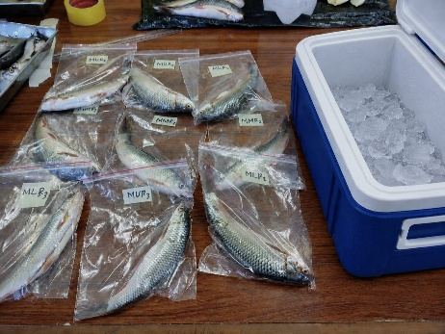
2.4 Description of Collected Samples
Figure 2.3: Fish Sample

Figure 0.18: Labeo rohita (Hamilton, 1822)Figure 0.19:Fish Sample

Figure 0.20: Labeo rohita (Hamilton, 1822)

Figure 0.21:Gibelion catla (Hamilton, 1822)Figure 0.22: Labeo rohita (Hamilton, 1822)Figure 0.23:Fish Sample

Figure 0.24: Labeo rohita (Hamilton, 1822)Figure 0.25:Fish Sample
A summary of the biological (fish) samples collected for OCP analysis is presented in Table 3. All three species belong to the family Cyprinidae (Indian Major Carps) and occupy distinct trophic niches within the water column; surface, mid-water and bottom feeding, which was considered relevant to potential differences in OCP bioaccumulation pathways among species.
Table 2.2: Fish species collected from each stream segment of the Halda River for OCP residue analysis.
Common Name | Scientific Name | Family | Trophic Guild | No. of Replicates per Stream | Total Individuals
Rui | Labeo rohita | Cyprinidae | Column feeder / herbivore-omnivore | 3 | 9
Catla | Catla catla | Cyprinidae | Surface feeder / planktivore | 3 | 9
Mrigal | Cirrhinus cirrhosus | Cyprinidae | Bottom feeder / detritivore | 3 | 9

In total, the study analysed 27 fish samples (3 species × 3 stream segments × 3 replicates), 33 water samples (11 stations × 3 replicates), and 11 composite sediment samples (one composite per station), giving a combined sample size of 71 environmental samples for OCP residue quantification.

2.4.1 Taxonomic Classification and Morphological Characteristics of the Study Species

2.4.1.1 Rui (Labeo rohita)
Rank | Taxon
Kingdom | Animalia
Phylum | Chordata
Class | Actinopterygii
Order | Cypriniformes
Family | Cyprinidae
Genus | Labeo
Species | Labeo rohita (Hamilton, 1822)
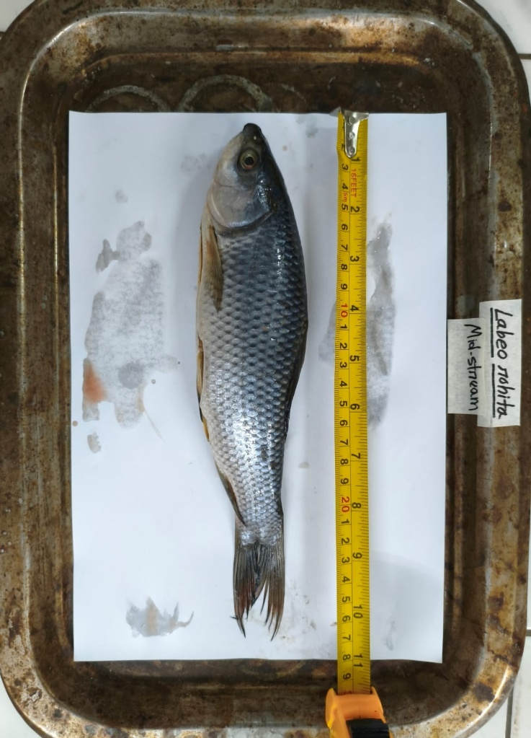
Key characteristics:
Figure 2.4: Labeo rohita (Hamilton, 1822).
- Body elongated, laterally compressed and streamlined, with a bluish-grey to silvery back and silvery-white flanks; a reddish tinge is often visible on the fins.
- Head small relative to body size, with a terminal, arched mouth bordered by thick, fringed (papillate) lips, and a pair of very small maxillary barbels.
- Occupies an intermediate, water-column feeding niche, browsing on plankton, decaying vegetation and organic detritus suspended in the water column.
- Dorsal fin relatively long-based, originating roughly midway along the body, with 12–13 branched rays; scales are large and cycloid.
- One of Bangladesh’s principal Indian Major Carp species, of high aquacultural and food-fish value, and among the species that spawn naturally in the Halda River.

2.4.1.2 Catla (Catla catla)
Rank | Taxon
Kingdom | Animalia
Phylum | Chordata
Class | Actinopterygii
Order | Cypriniformes
Family | Cyprinidae
Genus | Catla (also referred to as Gibelion)
Species | Catla catla (Hamilton, 1822)
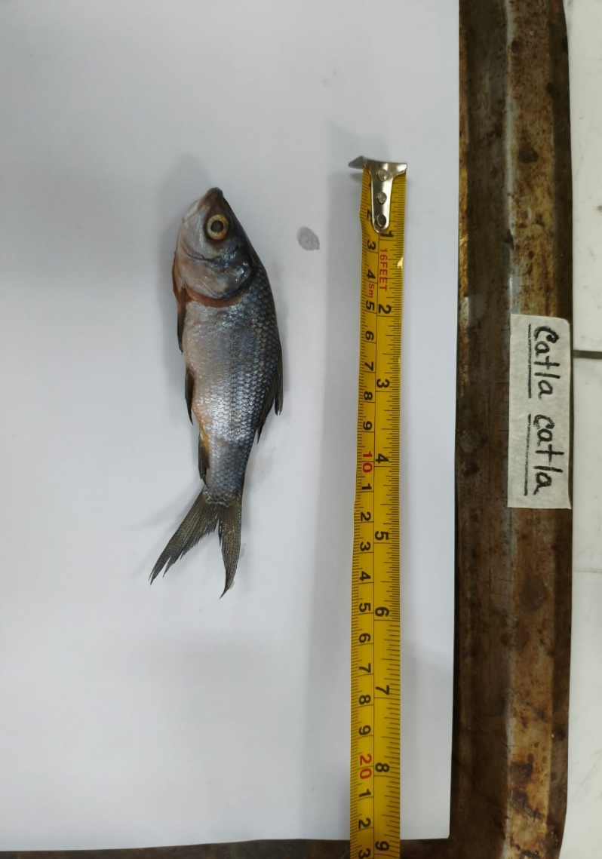
Figure 2.5: Catla catla (Hamilton, 1822)
Key characteristics:
- Deep-bodied and laterally compressed, with a disproportionately large, broad head compared with the other carps.
- Mouth large, wide and distinctly upturned, with a protruding lower jaw a morphological adaptation for surface and near-surface feeding.
- Predominantly a surface/near-surface feeder, filtering zooplankton and phytoplankton from the upper water column.
- Body silvery, with dark edges to the scales giving a faintly reticulated appearance; dorsal fin relatively high and falcate.
- Fast-growing and generally attains the largest individual size among the three species; an ecologically and economically important natural spawner of the Halda River.

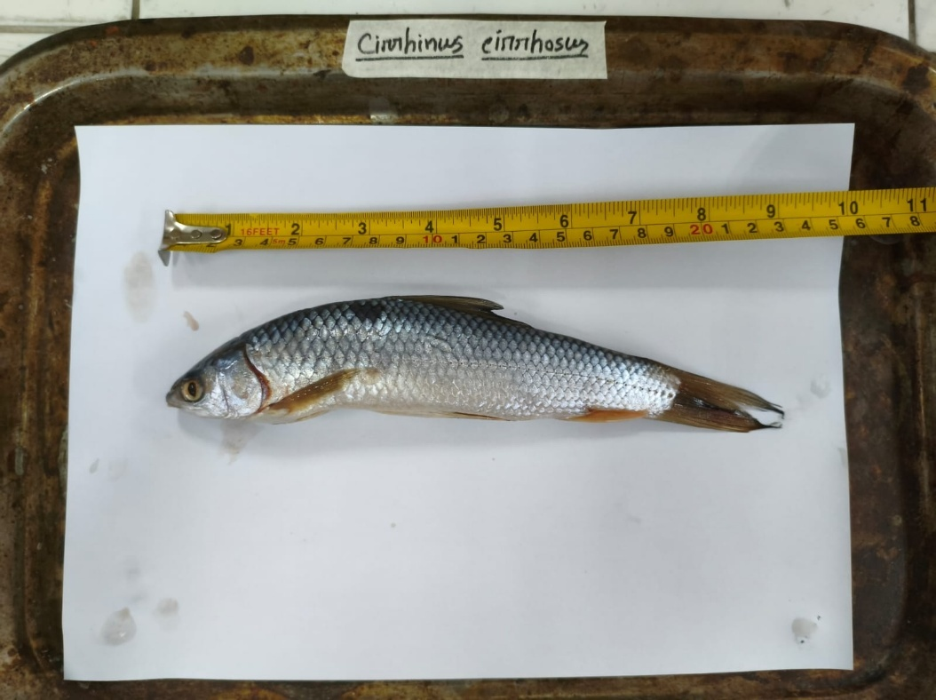
2.4.1.3 Mrigal (Cirrhinus cirrhosus)
Figure 2.6: Cirrhinus cirrhosus (Hamilton, 1822)
Rank | Taxon
Kingdom | Animalia
Phylum | Chordata
Class | Actinopterygii
Order | Cypriniformes
Family | Cyprinidae
Genus | Cirrhinus
Species | Cirrhinus cirrhosus (Hamilton, 1822)
Key characteristics:
- Body elongated and more slender/cylindrical than Rui or Catla, silvery in colour with a slightly darker dorsal surface.
- Head small and pointed, with a terminal-to-slightly-subterminal mouth and thin, non-fringed lips; barbels are minute or absent.
- A bottom-dwelling, detritivorous species that forages directly on the river bed and associated sediment, ingesting organic detritus, algae and associated benthic material.
- Because it feeds directly at the sediment-water interface, it is expected to show comparatively higher accumulation of sediment-associated, hydrophobic contaminants such as OCPs than the column or surface-feeding species.
- Fins comparatively small; anal fin short-based; a widely cultured and consumed Indian Major Carp species in Bangladesh.

2.5 Sample Preservation and Transportation
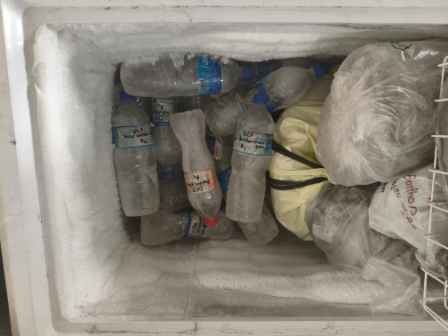
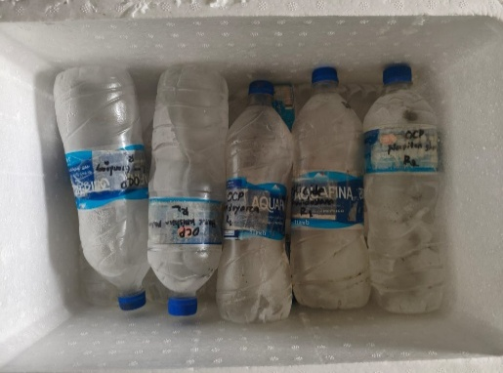
All water, sediment, and fish samples were immediately placed in an insulated ice box containing ice after collection and maintained under chilled conditions during transportation to the laboratory. The samples were transported to the laboratory within approximately 6–8 hours of collection to minimize potential microbial activity, chemical transformation, and losses of target organochlorine pesticide residues during handling and transportation, following established practices for the collection and analysis of pesticide residues in environmental matrices (APHA, 2017; (Kuranchie-Mensah et al., 2012). Upon arrival at the laboratory, all samples were immediately transferred to a −20 °C deep freezer and stored under frozen conditions until sample preparation and extraction. This freezing condition was maintained to minimize potential degradation or alteration of pesticide residues prior to chemical analysis, consistent with procedures reported for organochlorine pesticide residue investigations (Chowdhury et al., 2024).
Figure 2.7: Transportation and preservation.

2.6 Reagents and Materials
n-Hexane of HPLC grade (≥97%, Sigma-Aldrich, Germany) was used as the extraction solvent for all three matrices (water, sediment and fish). Anhydrous sodium sulphate (Na₂SO₄, 99% purity, Alfa Aesar) was used as a bed loaded onto the filter paper during filtration to remove residual moisture from the extract. Whatman No. 1 filter paper (240 mm) was used for gravity filtration of the crude extract, and a nylon syringe filter (25 mm diameter, 0.22 µm pore size), fitted onto a 5 mL syringe (Safeject), was used for final, particulate-free filtration of the extract into 2 mL GC vials prior to instrumental analysis. A certified multi-component organochlorine pesticide reference standard mixture containing all fifteen target congeners listed in Section 1.4
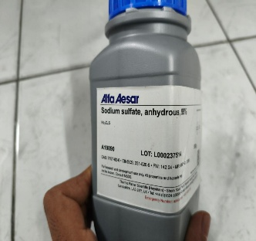
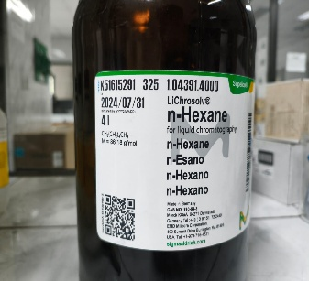
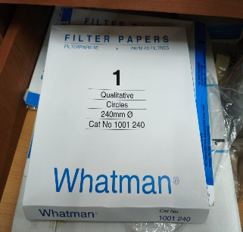
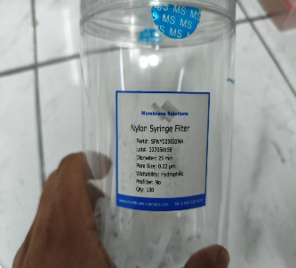
of Chapter One, covering the DDT group, the HCH group, the cyclodiene group, and theheptachlor group, was obtained from Sigma-Aldrich and used for GC-ECD calibration. Stock standard solutions were prepared in n-hexane and stored at −20 °C in the dark; working calibration standards were prepared by serial dilution immediately before use.
Figure 2.8: Reagents and materials

2.7 Sample Preparation and Extraction of OCPs
A liquid-extraction procedure using n-hexane, combined with mechanical shaking, filtration through sodium-sulphate-loaded filter paper, and final syringe filtration, was used for all three matrices. Vials were stored at −80 °C in the dark until GC-ECD analysis, to minimise analyte degradation or volatilisation prior to instrumental run. The procedure for each matrix is described below and summarised in Figures 2.1–2.3.
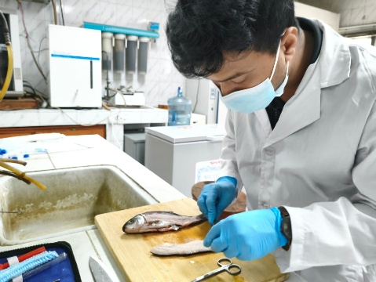
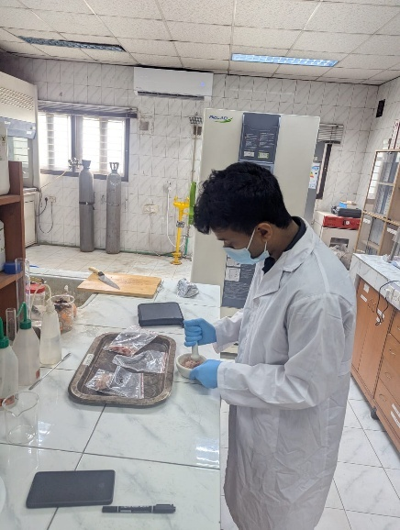
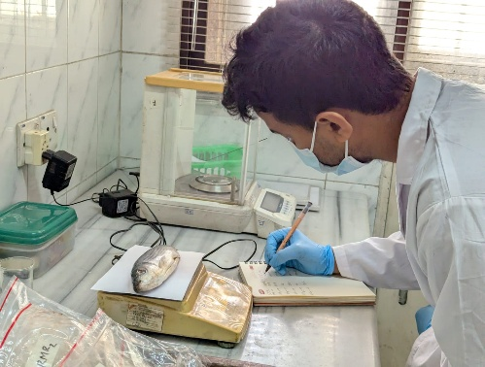
Figure 2.9: Fish sample preparation

2.7.1 Extraction of Fish Samples

Ten grams of homogenised fish muscle tissue was weighed into a falcon tube, to which 30 mL of n-hexane was added, and the mixture was shaken by hand for 5 minutes. The mixture was then transferred into a conical flask and shaken for 30 minutes on a reciprocal mechanical shaker to ensure thorough extraction. The resulting solution was filtered into a second conical flask through Whatman No. 1 filter paper (240 mm), onto which 5 g of anhydrous sodium sulphate had been loaded prior to the transfer, in order to bind residual moisture and retain particulate matter. The filtrate was subsequently passed through a 0.22 µm syringe filter into a 2 mL GC vial, and the resulting extract was analysed by GC-ECD.
Figure 2.10: Fish sample extraction flowchart

2.7.2 Extraction of Sediment Samples

Ten grams of homogenised sediment was weighed directly into a conical flask, to which 30 mL of n-hexane was added, and the mixture was shaken by hand for 5 minutes. The flask was then shaken for 30 minutes on the reciprocal mechanical shaker, exactly as described for the fish samples. The resulting solution was filtered into a second conical flask through Whatman No. 1 filter paper (240 mm), pre-loaded with 5 g of anhydrous sodium sulphate, to bind residual moisture and retain particulate matter. The filtrate was subsequently passed through a 0.22 µm syringe filter into a 2 mL GC vial, and the resulting extract was analysed by GC-ECD.
Figure 2.11: Sediment sample extraction flowchart

2.7.1 Extraction of Water Samples

Ten millilitres of the water sample was combined with n-hexane and shaken by hand for 5 minutes, followed by 30 minutes on the reciprocal mechanical shaker, following the same initial steps used for the sediment samples. The resulting mixture was transferred into a 50 mL falcon tube and left to stand to allow separation of the aqueous and organic (n-hexane) layers. The upper n-hexane layer was carefully transferred into a conical flask and filtered into a second conical flask through Whatman No. 1 filter paper (240 mm), pre-loaded with 5 g of anhydrous sodium sulphate, in the same manner as for the fish and sediment extracts. The filtrate was subsequently passed through a 0.22 µm syringe filter into a 2 mL GC vial, and the resulting extract was analysed by GC-ECD.
Figure 2.12: Water sample extraction flowchart

Figure 0.1: Shaking and VortexingFigure 0.2: Water sample extraction flowchart

Figure 0.3: Shaking and Vortexing

Figure 0.4: Transferring the mixture into a conical flaskFigure 0.5: Shaking and VortexingFigure 0.6: Water sample extraction flowchart

Figure 0.7: Shaking and VortexingFigure 0.8: Water sample extraction flowchart
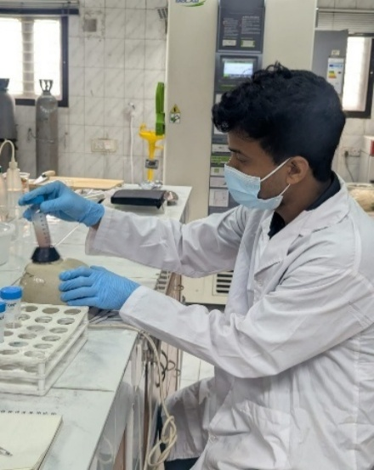
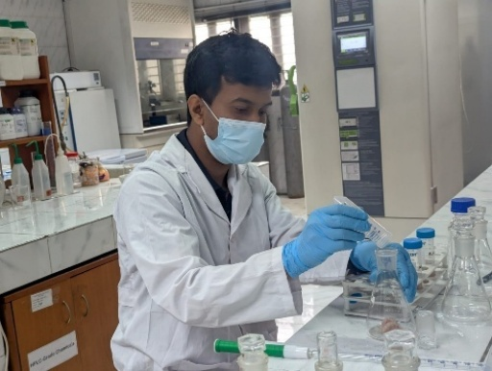
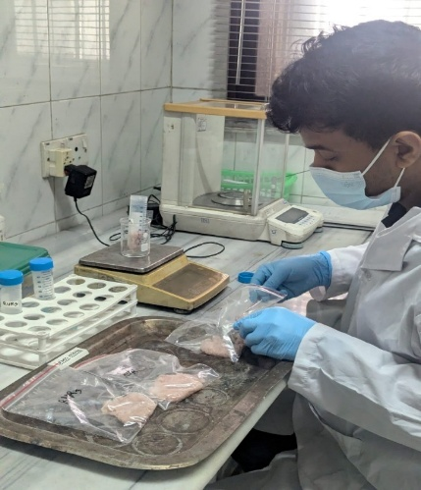
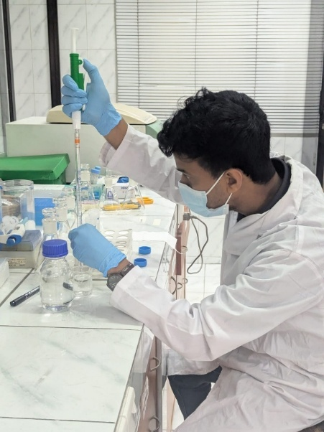
Figure 2.15: Shaking and Vortexing

Figure 0.9: Transferring the mixture into a conical flaskFigure 0.10: Shaking and Vortexing

Figure 0.11: Transferring the mixture into a conical flask

Figure 0.12: Weighing of 10g homoginized sampleFigure 0.13: Transferring the mixture into a conical flaskFigure 0.14: Shaking and Vortexing

Figure 0.15: Transferring the mixture into a conical flaskFigure 0.16: Shaking and Vortexing
Figure 2.16: Transferring the mixture into a conical flask

Figure 0.9: Weighing of 10g homoginized sampleFigure 0.10: Transferring the mixture into a conical flask

Figure 0.11: Weighing of 10g homoginized sample

Figure 0.12: Adding 30 mL n-hexane to the sampleFigure 0.13: Weighing of 10g homoginized sampleFigure 0.14: Transferring the mixture into a conical flask

Figure 0.15: Weighing of 10g homoginized sampleFigure 0.16: Transferring the mixture into a conical flask
Figure 2.13: Weighing of 10g homoginized sample

Figure 0.25: Adding 30 mL n-hexane to the sampleFigure 0.26: Weighing of 10g homoginized sample

Figure 0.27: Adding 30 mL n-hexane to the sample

Figure 0.28: Setting conical flasks on a reciprocal mechanical shakerFigure 0.29: Adding 30 mL n-hexane to the sampleFigure 0.30: Weighing of 10g homoginized sample

Figure 0.31: Adding 30 mL n-hexane to the sampleFigure 0.32: Weighing of 10g homoginized sample
Figure 2.14: Adding 30 mL n-hexane to the sample

Figure 0.25: Setting conical flasks on a reciprocal mechanical shakerFigure 0.26: Adding 30 mL n-hexane to the sample

Figure 0.27: Setting conical flasks on a reciprocal mechanical shaker

Figure 0.28: Adding 5g of anhydrous sodium sulfate on the filter paperFigure 0.29: Setting conical flasks on a reciprocal mechanical shakerFigure 0.30: Adding 30 mL n-hexane to the sample

Figure 0.31: Setting conical flasks on a reciprocal mechanical shakerFigure 0.32: Adding 30 mL n-hexane to the sample

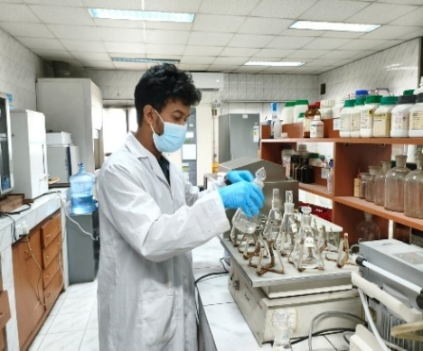
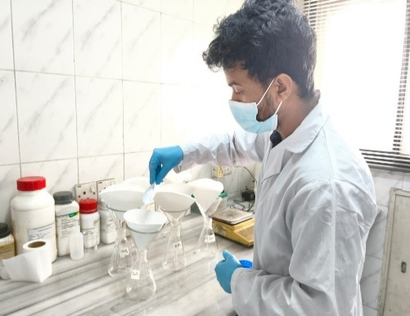
Figure 2.18: Setting conical flasks on a reciprocal mechanical shaker

Figure 0.9: Adding 5g of anhydrous sodium sulfate on the filter paperFigure 0.10: Setting conical flasks on a reciprocal mechanical shaker

Figure 0.11: Adding 5g of anhydrous sodium sulfate on the filter paper

Figure 0.12: Extract filtering through the Whatman filter paperFigure 0.13: Adding 5g of anhydrous sodium sulfate on the filter paperFigure 0.14: Setting conical flasks on a reciprocal mechanical shaker

Figure 0.15: Adding 5g of anhydrous sodium sulfate on the filter paperFigure 0.16: Setting conical flasks on a reciprocal mechanical shaker
Figure 2.17: Adding 5g of anhydrous sodium sulfate on the filter paper

Figure 0.9: Extract filtering through the Whatman filter paperFigure 0.10: Adding 5g of anhydrous sodium sulfate on the filter paper

Figure 0.11: Extract filtering through the Whatman filter paper

Figure 0.12: Drawing the filtered extract into the syringeFigure 0.13: Extract filtering through the Whatman filter paperFigure 0.14: Adding 5g of anhydrous sodium sulfate on the filter paper

Figure 0.15: Extract filtering through the Whatman filter paperFigure 0.16: Adding 5g of anhydrous sodium sulfate on the filter paper
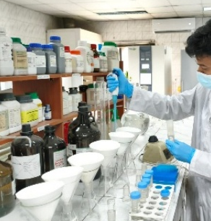
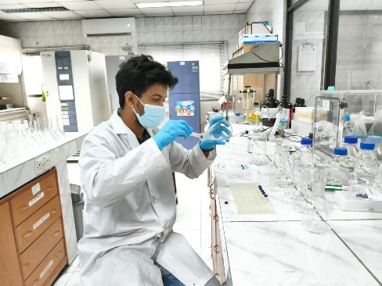
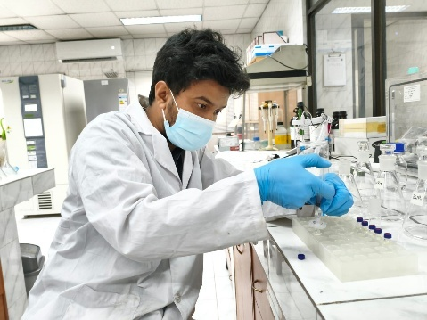
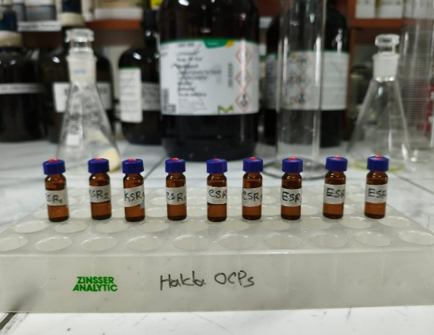
Figure 2.19: Extract filtering through the Whatman filter paper

Figure 0.25: Drawing the filtered extract into the syringeFigure 0.26: Extract filtering through the Whatman filter paper

Figure 0.27: Drawing the filtered extract into the syringe

Figure 0.28: Passing the filtrate through a 0.22 µm syringe filter into a 2mL GC vialFigure 0.29: Drawing the filtered extract into the syringeFigure 0.30: Extract filtering through the Whatman filter paper

Figure 0.31: Drawing the filtered extract into the syringeFigure 0.32: Extract filtering through the Whatman filter paper
Figure 2.20: Drawing the filtered extract into the syringe

Figure 0.25: Passing the filtrate through a 0.22 µm syringe filter into a 2mL GC vialFigure 0.26: Drawing the filtered extract into the syringe

Figure 0.27: Passing the filtrate through a 0.22 µm syringe filter into a 2mL GC vial

Figure 0.28: Ready water sample vial for GC analysisFigure 0.29: Passing the filtrate through a 0.22 µm syringe filter into a 2mL GC vialFigure 0.30: Drawing the filtered extract into the syringe

Figure 0.31: Passing the filtrate through a 0.22 µm syringe filter into a 2mL GC vialFigure 0.32: Drawing the filtered extract into the syringe
Figure 2.21: Passing the filtrate through a 0.22 µm syringe filter into a 2mL GC vial

Figure 0.25: Ready water sample vial for GC analysisFigure 0.26: Passing the filtrate through a 0.22 µm syringe filter into a 2mL GC vial

Figure 0.27: Ready water sample vial for GC analysis

Figure 0.28: Instrumental analysisFigure 0.29: Ready water sample vial for GC analysisFigure 0.30: Passing the filtrate through a 0.22 µm syringe filter into a 2mL GC vial

Figure 0.31: Ready water sample vial for GC analysisFigure 0.32: Passing the filtrate through a 0.22 µm syringe filter into a 2mL GC vial
Figure 2.22: Ready water sample vial for GC analysis

Figure 0.25: Instrumental analysisFigure 0.26: Ready water sample vial for GC analysis

Figure 0.27: Instrumental analysis

Figure 0.28:: Mean concentration (+1 SD) (a) and detection frequency (b) of the 14 target OCPs in fish muscle, pooled across zones and species (n = 27). Bars in (a) are coloured by chemical class; p,p′-DDT, heptachlor and α-HCH were the dominant residues. BDL = below detection limit in all samples.Figure 0.29: Instrumental analysisFigure 0.30: Ready water sample vial for GC analysis

Figure 0.31: Instrumental analysisFigure 0.32: Ready water sample vial for GC analysis

2.8 Extract Clean-up

Because co-extracted lipids, humic substances and other matrix components can interfere with gas-chromatographic detection of OCPs, an extract clean-up step was initially trialled prior to instrumental analysis, consistent with clean-up protocols reported for OCP determination in fish and sediment matrices (Chowdhury et al., 2018; Kuranchie-Mensah et al., 2012). This involved passing the concentrated extract through a glass column packed with activated Florisil, eluting with an appropriate solvent, and concentrating the eluate under a gentle stream of nitrogen before transferring it to a GC vial for analysis. However, this clean-up step resulted in a substantial loss of target analyte signal, with the corresponding OCP peaks absent in both the calibration standard and the spiked sample passed through the Florisil column, indicating irreversible sorption or degradation of the analytes on the adsorbent under the conditions used. Consequently, the Florisil clean-up step was not retained in the final analytical procedure, and all water, sediment and fish extracts were instead filtered (as described in Section 2.7) and analysed directly by GC-ECD without an additional adsorbent-based clean-up stage.

2.9 Instrumental Analysis

The concentrations of the target OCPs in the extracts were determined using a Shimadzu GC-2010 gas chromatograph equipped with an Electron Capture Detector (GC-ECD, ⁶³Ni source, 370 MBq) and an AOC-20S autosampler, the instrumentation most widely used and validated for OCP residue quantification in water, sediment and fish matrices in Bangladesh (Chowdhury et al., 2024; Hasan, 2021; Islam et al., 2026). Chromatographic separation was achieved using an Rtx-CLP capillary pesticide-residue column (30 m length, 0.32 mm internal diameter, 0.50 µm film thickness), with nitrogen used as the carrier and make-up gas. A 1.0 µL aliquot of each sample extract and calibration standard was injected via the autosampler in splitless mode to enhance sensitivity for trace-level pesticide residues. The injector (SPL1) temperature was maintained at 200 °C, with a total flow of 10 mL/min and a column flow of 0.64 mL/min. The initial column oven temperature was set at 120 °C. The oven temperature programme began at 50 °C (held for 1 min), increased at 15 °C/min to 200 °C (held for 1 min), and then increased at 5 °C/min to a final temperature of 300 °C (held for 10 min), giving a total programme run time of 42 min. The ECD detector (EX1) temperature was maintained at 300 °C, with a standing current of 0.35 nA and a detector gas flow of 15 mL/min. Individual OCPs were identified by comparing the retention times of chromatographic peaks in the sample extracts with those of the corresponding certified reference standards. Quantification was performed using an external multi-point calibration curve prepared from the same OCP standard mixture. The concentration of each target OCP in the sample extracts was subsequently calculated from its respective calibration curve and expressed according to the original sample volume or mass and final extract volume, as appropriate. Analytical quality was monitored using calibration standards, procedural blanks, and appropriate quality-control samples throughout the instrumental analysis.

2.9.1 GC Calibration Standards

Quantification of individual OCPs was performed using the external standard calibration method, selected for its simplicity and compatibility with the high sensitivity of the electron capture detector (ECD) (USEPA Method 8081B). Certified reference stock standards of the target OCPs (98–99% purity) were used to prepare the working calibration standards. The stock standards were stored in amber (brown) bottles under light-protected conditions until use. A five-point working calibration curve was prepared at concentrations of 5, 10, 20, 50, and 100 µg/L (equivalent to 5, 10, 20, 50, and 100 ppb) by appropriate dilution of the stock standards. Each calibration level was analysed under the same GC-ECD conditions as the samples, and the corresponding peak responses were plotted against the standard concentrations to construct calibration curves for each target OCP. The linearity of each calibration curve was evaluated using the coefficient of determination (R²), and the resulting calibration equations were used to quantify the OCP concentrations in the sample extracts.

2.9.2 Calibration Factor and Sample Quantification
For each analyte, the sample peak area (or height) was compared against the peak area (or height) of the calibration standards using a calibration-factor approach. The calibration factor (CF) for each analyte at each calibration level was calculated as:
CF=$\frac{\text{Peak Area }\left(\text{orHeight}\right)\text{of the Compound in the Standard}}{\text{Mass of the Compound }\text{Injected}\text{(in microgram)}}$
The mean calibration factor across all n calibration standards was then calculated as:
Mean CF= $\frac{\sum_{i=1}^{n}{CF_{i}}}{n}$
and the standard deviation (SD) and relative standard deviation (RSD) of the calibration factors were calculated as:
$SD=\frac{\sqrt{\sum_{i=1}^{n}{(CF_{i}-CF)}}}{n-1}$
$RSD=\frac{SD}{CF}×100$
An RSD below 20% for a given analyte was taken to indicate a sufficiently linear instrument response, in which case the mean calibration factor was applied for quantification of that analyte in all samples. Throughout each 12-hour analytical run, continuing calibration standards were re-analysed at regular intervals, and every target analyte was required to remain within its assigned retention-time window to confirm stable instrument performance; standards were re-run after every 20 samples, and any batch for which the continuing standards fell outside the QC acceptance limits was flagged for re-injection rather than being quantified against a drifted calibration. The concentration of each OCP in a sample extract was then calculated as:
$Concentration (μg/kg)=\frac{A_{X}×V_{t}×D}{CF×V_{i}×W_{S}}$
where Aₓ is the peak area (or height) of the analyte in the sample; Vₜ is the total volume of the concentrated extract (µL); D is the dilution factor (D = 1, as no dilution was applied in this study); CF is the mean calibration factor for the analyte (area/ng); Vᵢ is the volume of extract injected (µL, identical for samples and standards); and Wₛ is the mass of sample extracted (g; dry weight for sediment, wet weight for fish muscle, as applicable). Each OCP was identified by matching its retention time to that of the corresponding standard, and quantified by comparing peak areas as described above. Calibration standards were re-analysed after every 20 samples as an ongoing quality-control check, so that any samples run against a calibration that had drifted outside acceptance limits could be identified and re-injected rather than reported.
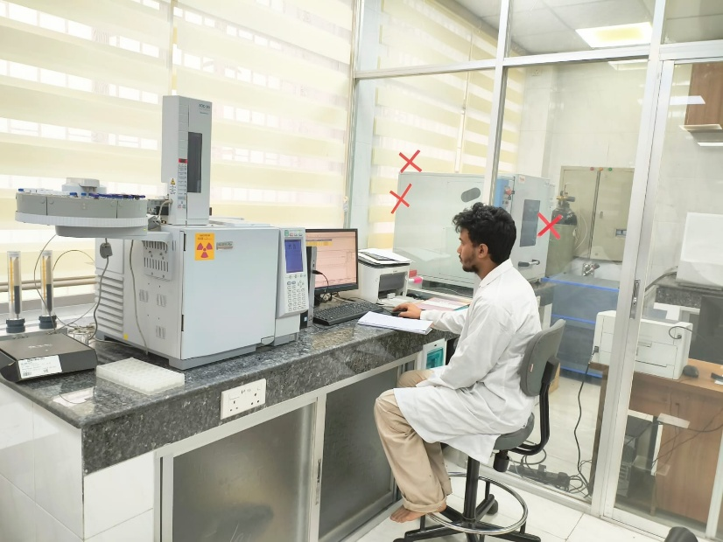
Figure 2.23: Instrumental analysis

2.10 Quality Assurance and Quality Control (QA/QC)
A rigorous QA/QC protocol was followed throughout sample collection, extraction and analysis. Field blanks, procedural (reagent) blanks and solvent blanks were processed alongside every batch of samples to check for background contamination. Recovery experiments were performed by spiking blank/control matrices (e.g., pesticide-free water and cultured fish tissue) with known concentrations of the target OCPs, with acceptable recoveries generally falling within 70–120%, consistent with recovery ranges reported for validated OCP methods applied to Bangladeshi environmental matrices (Haider et al., 2025; Hasan, 2021). Method detection limits (MDL) and limits of quantification (LOQ) were established from the calibration curve and blank variability, and calibration curves were required to achieve a coefficient of determination (R²) ≥ 0.99. Triplicate analysis of samples was performed at each station/tissue type to assess analytical precision, and results are reported as mean ± standard deviation.

2.11 Data Analysis and Risk Assessment Approach
OCP concentrations were compiled in a database according to sampling station, stream segment, matrix (water/sediment/fish) and species, and were analysed using appropriate descriptive and inferential statistics (e.g., mean, standard deviation, one-way ANOVA, Pearson correlation and/or principal component analysis) to compare spatial (upstream–midstream–downstream) and species-level variation, following the analytical approaches used in comparable Halda River contamination studies (M. S. Islam et al., 2023; Kamal et al., 2024b). To characterise the human health risk associated with OCP residues in Halda River fish, standard risk-assessment indices including the Estimated Daily Intake (EDI), Target Hazard Quotient (THQ), Hazard Index (HI), and where relevant, Carcinogenic Risk (CR) were calculated following USEPA risk-assessment guidance, as applied in prior OCP dietary-exposure studies on Bangladeshi fish (Hasan, 2021).

2.11.1 Health Risk Assessment for Fish
Non-carcinogenic and carcinogenic risk from fish consumption were estimated using the standard USEPA deterministic exposure framework (USEPA, 1989, 2000), widely applied in OCP dietary-exposure studies:
EDI = (C × IR × EF × ED) / (BW × AT)
THQ = EDI / RfD HI = ΣTHQ CR = EDI^{carcinogenic} × CSF
where C is the mean OCP concentration in fish muscle (mg/kg ww); IR is the fish ingestion rate; EF is the exposure frequency; ED is the exposure duration; BW is body weight; AT is the averaging time (ED × 365 days for non-carcinogens; 70 years × 365 days for carcinogens); RfD is the oral chronic reference dose; and CSF is the oral cancer slope factor. An HI (or THQ) below 1 indicates no appreciable non-carcinogenic hazard; a CR between 10⁻⁶ and 10⁻⁴ is the USEPA-defined range of "acceptable" incremental lifetime cancer risk.
Table 2.3: Exposure parameters used in the risk calculation.
Parameter | Adult | Child | Source / basis
Body weight, BW (kg) | 70 | 15 | USEPA Exposure Factors Handbook (2011) default
Fish ingestion rate, IR (g/day) | 74 | 37 | Bangladesh national per-capita fish consumption, ≈27 kg/capita/yr (FAO/DoF statistics, 2023); child assumed 50% of adult portion in the absence of an age-disaggregated national survey
Exposure frequency, EF (days/yr) | 365 | 365 | USEPA (1989) default
Exposure duration, ED (yr) | 70 | 6 | USEPA (1989) default lifetime / childhood exposure duration
Averaging time, AT, non-carcinogenic (days) | ED × 365 | ED × 365 | USEPA (1989)
Averaging time, AT, carcinogenic (days) | 70 × 365 | 70 × 365 | USEPA (1989), lifetime

Table 2.4: Oral reference doses (RfD) and cancer slope factors (CSF) applied.
Compound | RfD (mg/kg-day) | CSF (mg/kg-day)⁻¹ | Basis
o,p'-DDT / p,p'-DDT | 5 × 10⁻⁴ | 0.34 | USEPA IRIS (DDT)
o,p'-DDD / p,p'-DDD | 5 × 10⁻⁴* | 0.24 | Surrogate: DDT (IRIS)
o,p'-DDE / p,p'-DDE | 5 × 10⁻⁴* | 0.34* | Surrogate: DDT (IRIS)
α-HCH | 3 × 10⁻⁴* | 6.3 | RfD surrogate: γ-HCH (IRIS); CSF: IRIS/Cal-EPA
β-HCH | 3 × 10⁻⁴* | 1.8 | RfD surrogate: γ-HCH (IRIS); CSF: Cal-EPA
γ-HCH (lindane) | 3 × 10⁻⁴ | 1.3 | USEPA IRIS
δ-HCH | 3 × 10⁻⁴* | not classified | Surrogate: γ-HCH (IRIS)
Aldrin | 3 × 10⁻⁵ | 17 | USEPA IRIS
Dieldrin | 5 × 10⁻⁵ | 16 | USEPA IRIS
Heptachlor | 5 × 10⁻⁴ | 4.5 | USEPA IRIS
Heptachlor epoxide | 1.3 × 10⁻⁵ | 9.1 | USEPA IRIS
* Compound-specific chronic RfD not listed on IRIS; the value of the closest structural congener was applied as a conservative surrogate, following standard practice in the OCP risk-assessment literature.

2.11.2 Health risk assessment for surface water
Because the Halda is used by riverside communities for bathing, washing and, in places, untreated domestic use, and because it serves as a raw-water source for the Chattogram municipal supply (Mohra intake, adjacent to the Kalurghat site), non-carcinogenic and carcinogenic risk from direct contact with river water were estimated with the USEPA deterministic exposure framework (USEPA, 1989, 2004) for two pathways — oral ingestion and dermal absorption during bathing/washing:
CDI_{ingestion} = (C × IR × EF × ED) / (BW × AT)
DAD_{dermal} = (C × SA × Kp × ET × EF × ED × CF) / (BW × AT)
THQ = CDI / RfD HI = ΣTHQ CR = LADD × CSF
where C is the mean OCP concentration in water (mg/L); IR is the daily water ingestion rate; SA is the exposed skin surface area; Kp is the dermal permeability coefficient of the compound in water; ET is the daily exposure (bathing) time; CF is a unit conversion factor (10⁻³ L/cm³); EF, ED, BW and AT are the exposure frequency, exposure duration, body weight and averaging time (ED × 365 days for non-carcinogens; 70 years × 365 days for carcinogens, giving the lifetime average daily dose, LADD); RfD is the oral chronic reference dose and CSF the oral cancer slope factor. The THQ of the two pathways were summed per compound and over all compounds to give the HI. An HI (or THQ) below 1 indicates no appreciable non-carcinogenic hazard; a CR between 10⁻⁶ and 10⁻⁴ is the USEPA-defined range of "acceptable" incremental lifetime cancer risk. Compound-specific Kp values were derived from log Kow and molecular weight with the Potts–Guy relationship recommended in USEPA RAGS Part E (log Kp = −2.80 + 0.66 log Kow − 0.0056 MW).
Table 2.5: Exposure parameters used in the water-exposure risk calculation.
Parameter | Adult | Child | Source / basis
Body weight, BW (kg) | 70 | 15 | USEPA Exposure Factors Handbook (2011) default
Water ingestion rate, IR (L/day) | 2.0 | 1.0 | USEPA (1989, 2011) default drinking-water intake
Exposed skin surface area, SA (cm²) | 18,000 | 6,600 | USEPA RAGS Part E (2004), whole-body bathing
Exposure time, ET (h/day) | 0.58 | 1.0 | USEPA RAGS Part E (2004) bathing/showering default
Exposure frequency, EF (days/yr) | 365 | 365 | USEPA (1989) default
Exposure duration, ED (yr) | 70 | 6 | USEPA (1989) lifetime / childhood exposure duration
Conversion factor, CF (L/cm³) | 10⁻³ | 10⁻³ | Unit conversion
Averaging time, AT, non-carcinogenic (days) | ED × 365 | ED × 365 | USEPA (1989)
Averaging time, AT, carcinogenic (days) | 70 × 365 | 70 × 365 | USEPA (1989), lifetime

Table 2.6: Oral reference doses (RfD), cancer slope factors (CSF) and dermal permeability coefficients (Kp) applied.
Compound | RfD (mg/kg-day) | CSF (mg/kg-day)⁻¹ | Kp (cm/h) | Basis
o,p'-DDT | 5.0 × 10⁻⁴ | 0.34 | 0.497 | USEPA IRIS (DDT)
p,p'-DDT | 5.0 × 10⁻⁴ | 0.34 | 0.596 | USEPA IRIS (DDT)
o,p'-DDD | 5.0 × 10⁻⁴ | 0.34 | 0.191 | Surrogate: DDT (IRIS)*
p,p'-DDD | 5.0 × 10⁻⁴ | 0.34 | 0.240 | Surrogate: DDT (IRIS)*
o,p'-DDE | 5.0 × 10⁻⁴ | 0.34 | 0.239 | Surrogate: DDT (IRIS)*
p,p'-DDE | 5.0 × 10⁻⁴ | 0.34 | 0.520 | Surrogate: DDT (IRIS)*
α-HCH | 3.0 × 10⁻⁴ | 6.3 | 0.012 | RfD surrogate: γ-HCH*; CSF: IRIS
β-HCH | 3.0 × 10⁻⁴ | 1.8 | 0.012 | RfD surrogate: γ-HCH*; CSF: IRIS
γ-HCH (Lindane) | 3.0 × 10⁻⁴ | 1.3 | 0.011 | USEPA IRIS
δ-HCH | 3.0 × 10⁻⁴ | not classified | 0.020 | Surrogate: γ-HCH*; CSF not classified
Aldrin | 3.0 × 10⁻⁵ | 17 | 0.280 | USEPA IRIS
Dieldrin | 5.0 × 10⁻⁵ | 16 | 0.043 | USEPA IRIS
Heptachlor | 5.0 × 10⁻⁴ | 4.5 | 0.137 | USEPA IRIS
Heptachlor epoxide | 1.30 × 10⁻⁵ | 9.1 | 0.020 | USEPA IRIS
* Compound-specific chronic RfD not listed on IRIS; the value of the closest structural congener was applied as a conservative surrogate, following standard practice in the OCP risk-assessment literature.

2.11.3 Health risk assessment for sediment
Non-carcinogenic and carcinogenic risk from direct exposure to river-bank and bed sediment — a relevant pathway for fishers, sand and soil collectors, bathers and children playing along the Halda — was estimated with the USEPA deterministic framework for soil/sediment (USEPA, 1989, 2004), considering two pathways: incidental ingestion and dermal absorption. The chronic daily intake (CDI, mg/kg-day) for each pathway was calculated as:
CDI_ingestion = (C × IngR × EF × ED × CF) / (BW × AT)
CDI_dermal = (C × SA × AF × ABS × EF × ED × CF) / (BW × AT)
THQ = (CDI_ing + CDI_derm) / RfD HI = Σ THQ CR = Σ (CDI_ing + CDI_derm)carc × CSF
where C is the mean OCP concentration in sediment (mg/kg); IngR is the sediment ingestion rate; SA is the exposed skin surface area; AF is the sediment-to-skin adherence factor; ABS is the compound-specific dermal absorption fraction; EF is the exposure frequency; ED is the exposure duration; CF is the unit conversion factor (10⁻⁶ kg/mg); BW is body weight; AT is the averaging time (ED × 365 days for non-carcinogens; 70 years × 365 days for carcinogens); RfD is the oral chronic reference dose; and CSF is the oral cancer slope factor. In line with common practice in the sediment risk literature, oral RfD and CSF values were applied to the dermal pathway without gastrointestinal-absorption adjustment. An HI (or THQ) below 1 indicates no appreciable non-carcinogenic hazard; a CR between 10⁻⁶ and 10⁻⁴ is the USEPA-defined range of "acceptable" incremental lifetime cancer risk. The body weights, exposure durations, RfD and CSF values are identical to those used in the fish chapter so that the two exposure routes are directly comparable.
Table 2.7: Exposure parameters used in the sediment human-health risk calculation.
Parameter | Adult | Child | Source / basis
Body weight, BW (kg) | 70 | 15 | USEPA Exposure Factors Handbook (2011) default; as in fish chapter
Sediment ingestion rate, IngR (mg/day) | 100 | 200 | USEPA (1989, 2011) default soil/sediment incidental ingestion
Exposed skin surface area, SA (cm²) | 5,700 | 2,800 | USEPA RAGS Part E (2004) default (head, hands, forearms, lower legs)
Adherence factor, AF (mg/cm²) | 0.07 | 0.2 | USEPA RAGS Part E (2004) default
Dermal absorption fraction, ABS (–) | compound-specific | compound-specific | USEPA RAGS Part E (2004): DDT/DDD/DDE 0.03; HCH isomers 0.04 (lindane value); other semi-volatile OCPs 0.10 (default) — see Table 5.2
Exposure frequency, EF (days/yr) | 350 | 350 | USEPA (1989) default residential frequency
Exposure duration, ED (yr) | 70 | 6 | Lifetime / childhood duration, as in fish chapter
Conversion factor, CF (kg/mg) | 10⁻⁶ | 10⁻⁶ | —
Averaging time, AT, non-carcinogenic (days) | ED × 365 | ED × 365 | USEPA (1989)
Averaging time, AT, carcinogenic (days) | 70 × 365 | 70 × 365 | USEPA (1989), lifetime

Table 2.8: Oral reference doses (RfD), cancer slope factors (CSF) and dermal absorption fractions (ABS) applied.
Compound | RfD (mg/kg-day) | CSF (mg/kg-day)⁻¹ | ABS (–) | Basis
o,p'-DDT / p,p'-DDT | 5 × 10⁻⁴ | 0.34 | 0.03 | USEPA IRIS (DDT); ABS: RAGS-E
o,p'-DDD / p,p'-DDD | 5 × 10⁻⁴* | 0.34* | 0.03 | Surrogate: DDT (IRIS)
o,p'-DDE / p,p'-DDE | 5 × 10⁻⁴* | 0.34* | 0.03 | Surrogate: DDT (IRIS)
α-HCH | 3 × 10⁻⁴* | 6.3 | 0.04 | RfD surrogate: γ-HCH (IRIS); CSF: IRIS/Cal-EPA
β-HCH | 3 × 10⁻⁴* | 1.8 | 0.04 | RfD surrogate: γ-HCH (IRIS); CSF: Cal-EPA
γ-HCH (lindane) | 3 × 10⁻⁴ | 1.3 | 0.04 | USEPA IRIS; ABS: RAGS-E
δ-HCH | 3 × 10⁻⁴* | not classified | 0.04 | Surrogate: γ-HCH (IRIS)
Aldrin | 3 × 10⁻⁵ | 17 | 0.10 | USEPA IRIS; ABS: RAGS-E default for SVOCs
Dieldrin | 5 × 10⁻⁵ | 16 | 0.10 | USEPA IRIS
Heptachlor | 5 × 10⁻⁴ | 4.5 | 0.10 | USEPA IRIS
Heptachlor epoxide | 1.3 × 10⁻⁵ | 9.1 | 0.10 | USEPA IRIS
* Compound-specific chronic RfD not listed on IRIS; the value of the closest structural congener was applied as a conservative surrogate.

Table 2.9: Sediment quality guidelines (µg/kg dry weight) used for the ecological risk screening.
Compound | Threshold-effect value (TEL / ISQG / LEL / TEC) | Probable-effect value (PEL / SEL / PEC) | Source
o,p'-DDT† | 1.19 | 4.77 | Surrogate: CCME DDT
p,p'-DDT | 1.19 | 4.77 | CCME (2001) freshwater ISQG/PEL (DDT)
o,p'-DDD† | 3.54 | 8.51 | Surrogate: CCME DDD
p,p'-DDD | 3.54 | 8.51 | CCME (2001) freshwater ISQG/PEL (DDD)
o,p'-DDE† | 1.42 | 6.75 | Surrogate: CCME DDE
p,p'-DDE | 1.42 | 6.75 | CCME (2001) freshwater ISQG/PEL (DDE)
α-HCH | 6.00 | 100.00 | Ontario MOE LEL/SEL (Persaud et al., 1993)
β-HCH | 5.00 | 210.00 | Ontario MOE LEL/SEL (Persaud et al., 1993)
γ-HCH (Lindane) | 0.94 | 1.38 | CCME (2001) freshwater ISQG/PEL (lindane)
δ-HCH† | 3.00 | 120.00 | Surrogate: Ontario MOE LEL/SEL for total HCH
Aldrin | 2.00 | 80.00 | Ontario MOE LEL/SEL (Persaud et al., 1993)
Dieldrin | 2.85 | 6.67 | CCME (2001) freshwater ISQG/PEL
Heptachlor† | 0.60 | 2.74 | Surrogate: CCME heptachlor epoxide ISQG/PEL
Heptachlor epoxide | 0.60 | 2.74 | CCME (2001) freshwater ISQG/PEL
ΣDDT (sum of six DDT-group compounds) | 5.28 | 572.0 | MacDonald et al. (2000) consensus TEC/PEC (total DDT)
ΣHCH (sum of four isomers) | 3.00 | 120.0 | Ontario MOE LEL/SEL (total HCH; Persaud et al., 1993)

2.11.4 Ecological risk assessment
The potential ecological risks associated with organochlorine pesticide (OCP) contamination in the Halda River were assessed separately for surface water and sediment because these environmental compartments differ in their contaminant dynamics, exposure pathways, and ecological receptors. For sediment, measured concentrations of individual OCPs were compared with established sediment quality guidelines (SQGs), including the threshold effect level (TEL), probable effect level (PEL), lowest effect level (LEL), severe effect level (SEL), effect range-low (ERL), effect range-median (ERM), and consensus-based threshold and probable effect concentrations (TEC and PEC), where guideline values were available. These SQGs have been developed from chemical–biological effects data and are widely used as screening tools for evaluating the potential biological significance of contaminated sediments (Long and Morgan, 1991; Persaud et al., 1993; Smith et al., 1996; MacDonald et al., 2000). In particular, the consensus-based SQGs of MacDonald et al. (2000) provide TEC and PEC values for freshwater sediments and were developed by integrating multiple published sediment-quality guidelines. Concentrations below a TEC generally indicate a low probability of adverse biological effects, whereas concentrations exceeding a PEC are associated with an increased likelihood of sediment toxicity. Concentrations between the TEC and PEC represent an intermediate range in which biological effects cannot be reliably predicted solely from chemical concentration data. Therefore, these guideline comparisons were interpreted as screening-level indicators of potential ecological risk rather than direct evidence of toxicity in the Halda River.
For sediment-associated OCPs, the degree of contamination was further evaluated by calculating the risk quotient (RQ) for individual compounds as the ratio between the measured sediment concentration and the corresponding sediment-quality benchmark. An RQ value greater than 1 was considered indicative of a potential ecological concern because the measured concentration exceeded the selected screening benchmark. Where appropriate guideline values were unavailable for a specific OCP, the nearest scientifically defensible benchmark or surrogate value was considered, and such comparisons were interpreted cautiously because differences in chemical toxicity and guideline derivation may introduce uncertainty. The combined contamination and potential toxicity of multiple OCPs were also evaluated using cumulative sediment-quality metrics, such as the mean PEC quotient (mPEC-Q or mPEL-Q), where applicable. Consensus-based sediment guidelines have demonstrated that the probability of sediment toxicity increases with increasing mean PEC quotients; therefore, these indices were used to provide an integrated assessment of mixture-related ecological concern rather than to infer effects from individual compounds alone (MacDonald et al., 2000; Ingersoll et al., 2001).
For surface water, the ecological risk posed by individual OCPs was assessed using a risk quotient (RQ) approach by comparing the measured concentration of each pesticide with an appropriate aquatic-life protection benchmark or environmental quality criterion. The RQ was calculated as the ratio of the measured environmental concentration to the corresponding benchmark concentration. An RQ below 0.1 was interpreted as indicating a relatively low potential for ecological effects, values between 0.1 and 1 as indicating a moderate level of concern, and values greater than 1 as indicating a potential for adverse ecological effects. Where compound-specific water-quality criteria were unavailable, the most appropriate available chronic or long-term aquatic toxicity benchmark was considered, with the source and applicability of the benchmark documented. Because water-column RQs represent exposure concentrations rather than measured biological responses, values exceeding unity were interpreted as indicating potential ecological risk and not as confirmation of actual toxicity or population-level effects.
The ecological assessment of water and sediment was interpreted in relation to the spatial distribution of OCP contamination across the upstream, midstream, and downstream zones of the Halda River. Particular attention was given to compounds and locations where concentrations exceeded relevant ecological screening benchmarks, as these exceedances may indicate areas requiring greater environmental monitoring and source-control attention. The combined interpretation of water-column RQs and sediment-quality exceedances was used to characterize the potential ecological significance of OCP contamination throughout the river system. Nevertheless, the assessment was considered a screening-level evaluation because SQGs and RQ thresholds are derived from experimental or empirical toxicity relationships and do not account for all site-specific factors, including sediment organic carbon content, grain size, contaminant bioavailability, hydrological conditions, mixture interactions, and the sensitivity of local aquatic species. Accordingly, exceedance of an ecological benchmark was interpreted as evidence of potential ecological concern rather than direct proof of adverse effects on fish, benthic organisms, or the broader Halda River ecosystem.

Chapter-3: Results

3.1 Concentration and Distribution of OCPs in Fish
Total OCP burden (ΣOCP, the sum of all 14 congeners) in fish muscle averaged 23.59 ± 13.17 µg/kg ww across the 27 samples (range: Below detection level–48.29 µg/kg ww). Seven of the fourteen target compounds; o,p'-DDT, o,p'-DDD, o,p'-DDE, p,p'-DDE, γ-HCH (lindane), dieldrin and heptachlor epoxide were below detection level in all sample. The remaining seven compounds were detected at frequencies ranging from 7.4% (β-HCH) to 77.8% (p,p'-DDT and α-HCH), indicating current or historical, intermittent, non-uniform pesticide input to the river system rather than a continuous point source.
Table 3.1: Descriptive statistics for individual OCPs in fish muscle (µg/kg ww, n = 27).
Compound | Mean ± SD | Range | Detection frequency (%)
o,p'-DDT | 4.25 ± 1.80 | BDL-6.65 | 62.96
p,p'-DDT | 5.01 ± 1.72 | BDL-7.09 | 77.78
o,p'-DDD | BDL | BDL | 0
p,p'-DDD | 5.37 ± 1.67 | BDL-8.32 | 85.19
o,p'-DDE | 5.09 ± 1.62 | BDL-7.44 | 81.48
p,p'-DDE | 6.30 ± 1.70 | BDL-8.84 | 88.89
α-HCH | 4.70 ± 1.52 | BDL-6.69 | 77.78
β-HCH | 5.22 ± 1.45 | BDL-7.09 | 85.19
γ-HCH (Lindane) | BDL | BDL | 0
δ-HCH | 4.41 ± 1.79 | BDL-6.88 | 66.67
Aldrin | 3.26 ± 1.69 | BDL-6.07 | 37.04
Dieldrin | 4.32 ± 2.17 | BDL-7.84 | 55.56
Heptachlor | 3.54 ± 1.77 | BDL-6.12 | 44.44
Heptachlor epoxide | 4.95 ± 2.20 | BDL-7.69 | 66.67
ΣDDTs | 28.02 ± 8.51 | BDL- 8.84 | 66.05
ΣHCHs | 16.33 ± 4.77 | BDL-7.09 | 57.41
ΣDRNs | 7.58 ± 3.86 | BDL-7.84 | 46.3
ΣHPTs | 8.49 ± 3.97 | BDL-7.69 | 55.56
ΣOCP (sum of all 14 congeners) | 60.33 ± 16.74 | BDL- 8.84 | 59.26
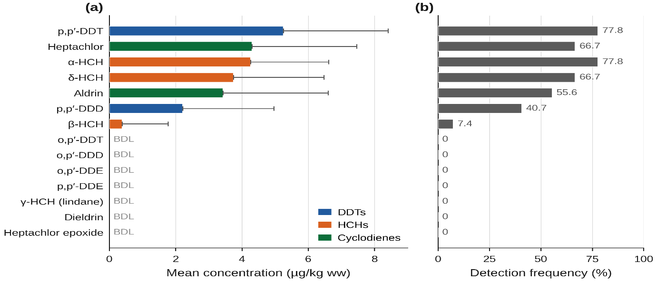
Figure 3.1: Mean concentration (± SD) (a) and detection frequency (b) of the 14 target OCPs in fish muscle, pooled across zones and species (n = 27)
Grouped by chemical class, the ΣOCP burden was contributed almost equally by HCH isomers (35.5%), cyclodienes/heptachlors (32.8%) and DDT-group compounds (31.6%) (Figure 29), suggesting mixed historical usage of technical HCH, aldrin/heptachlor-based termiticides and DDT-based agricultural pesticides in the catchment, rather than dominance of a single formulation.
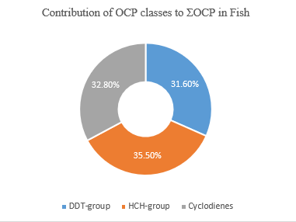
Figure 3.2: Relative contribution (%) of the three OCP chemical classes to the total ΣOCP burden in fish muscle.

Figure 0.2: Mean ± SD total OCP concentration (ΣOCP, µg/kg ww) in fish muscle by zone and species.Figure 0.3: Relative contribution (%) of the three OCP chemical classes to the total ΣOCP burden in fish muscle.

Figure 0.4: Mean ± SD total OCP concentration (ΣOCP, µg/kg ww) in fish muscle by zone and species.

Figure 0.5: Heat map of mean OCP concentration (µg/kg ww) across the nine zone × species combinations, showing which compounds and locations drive the overall contamination pattern (darker cells = higher concentration).Figure 0.6: Mean ± SD total OCP concentration (ΣOCP, µg/kg ww) in fish muscle by zone and species.Figure 0.7: Relative contribution (%) of the three OCP chemical classes to the total ΣOCP burden in fish muscle.

Figure 0.8: Mean ± SD total OCP concentration (ΣOCP, µg/kg ww) in fish muscle by zone and species.Figure 0.9: Relative contribution (%) of the three OCP chemical classes to the total ΣOCP burden in fish muscle.

3.1.1 Spatial (Zone-wise) and Species-wise Variation
Mean ΣOCP concentration increased significantly from the up-stream to the down-stream zone: 13.40 ± 10.26 µg/kg ww (up-stream) < 20.86 ± 9.03 µg/kg ww (mid-stream) < 36.53 ± 7.97 µg/kg ww (down-stream). This longitudinal enrichment a roughly 2.7-fold increase from up-stream to down-stream, is consistent with cumulative loading from agricultural runoff, domestic and industrial discharge, and sediment resuspension accumulating along the flow path, and matches the pattern typically reported for pesticide contamination in tidally influenced, human-impacted river reaches.
Two-way ANOVA showed that river zone significantly affected ΣOCP concentrations in fish muscle (F(2,18) = 175.1, p < 0.001, n = 9 per zone). Fish species also had a significant effect (F(2,18) = 101.6, p < 0.001, n = 9 per species). Moreover, the Zone × Species interaction was significant (F(4,18) = 14.53, p<0.001), indicating that the effect of fish species on OCP accumulation varied among river zones. Among species, mean ΣOCP burden was highest in Mrigal (33.09 ± 10.33 µg/kg ww), intermediate in Rui (22.48 ± 9.11 µg/kg ww) and lowest in Catla (15.20 ± 13.87 µg/kg ww). The higher burden in Mrigal and Rui, both benthic/column feeders with closer contact with contaminated bottom sediment, relative to the more planktivorous, water-column-feeding Catla is consistent with feeding-habit and lipid-content-driven differences in OCP bioaccumulation reported for other lowland rivers.
Table 3.2: Two-way analysis of variance of ΣOCP concentration (µg/kg ww) in fish muscle by zone and species (fixed effects, balanced design, n = 3 per cell, N = 27).
Source of variation | SS | df | MS | F | p
Zone | 2509.96 | 2 | 1254.98 | 175.08 | < 0.001
Species | 1456.83 | 2 | 728.42 | 101.62 | < 0.001
Zone × Species | 416.64 | 4 | 104.16 | 14.53 | < 0.001
Error | 129.03 | 18 | 7.17
Total | 4512.45 | 26
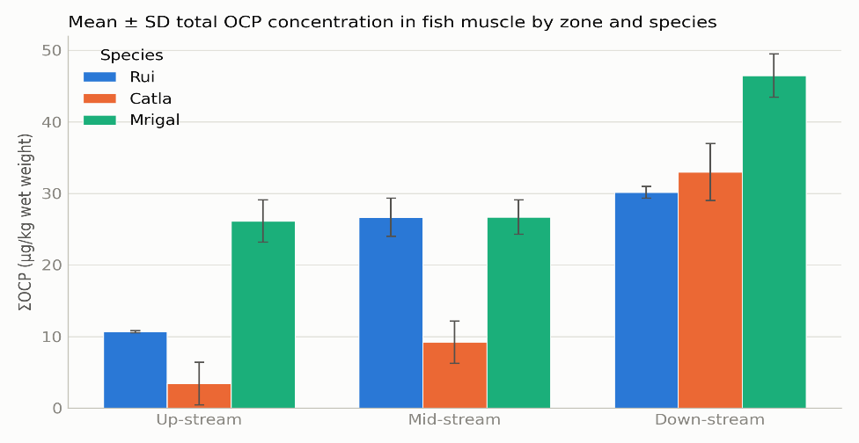
Figure 3.3: Mean ± SD total OCP concentration (ΣOCP, µg/kg ww) in fish muscle by zone and species

Figure 0.10: Heat map of mean OCP concentration (µg/kg ww) across the nine zone × species combinations, showing which compounds and locations drive the overall contamination pattern (darker cells = higher concentration).Figure 0.11: Mean ± SD total OCP concentration (ΣOCP, µg/kg ww) in fish muscle by zone and species.

Figure 0.12: Heat map of mean OCP concentration (µg/kg ww) across the nine zone × species combinations, showing which compounds and locations drive the overall contamination pattern (darker cells = higher concentration).

Figure 0.13: Non-carcinogenic Hazard Index (HI = ΣTHQ) for adult and child fish consumers (a) by zone and (b) by species. The dashed line marks the HI = 1 threshold (USEPA); numbers above the bars are HI values.Figure 0.14: Heat map of mean OCP concentration (µg/kg ww) across the nine zone × species combinations, showing which compounds and locations drive the overall contamination pattern (darker cells = higher concentration).Figure 0.15: Mean ± SD total OCP concentration (ΣOCP, µg/kg ww) in fish muscle by zone and species.

Figure 0.16: Heat map of mean OCP concentration (µg/kg ww) across the nine zone × species combinations, showing which compounds and locations drive the overall contamination pattern (darker cells = higher concentration).Figure 0.17: Mean ± SD total OCP concentration (ΣOCP, µg/kg ww) in fish muscle by zone and species.
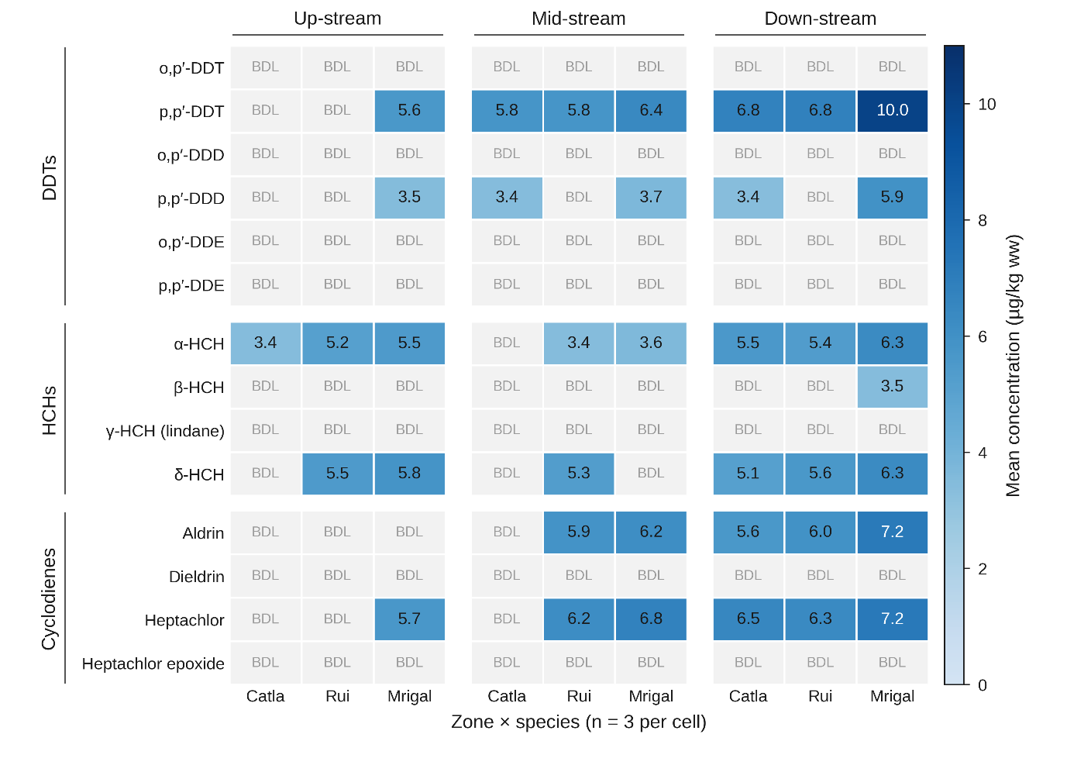
The heat map (Figure 4.4) shows that p,p'-DDT, aldrin and heptachlor reach their highest concentrations in down-stream Mrigal (10.0, 7.2 and 7.2 µg/kg ww, respectively), confirming that the down-stream zone and the benthic-feeding Mrigal jointly represent the combination of highest OCP exposure in the river.
Figure 3.4: Heat map of mean OCP concentration (µg/kg ww) across the nine zone × species combinations, showing which compounds and locations drive the overall contamination pattern

3.1.2 Human Health Risk from Fish Consumption
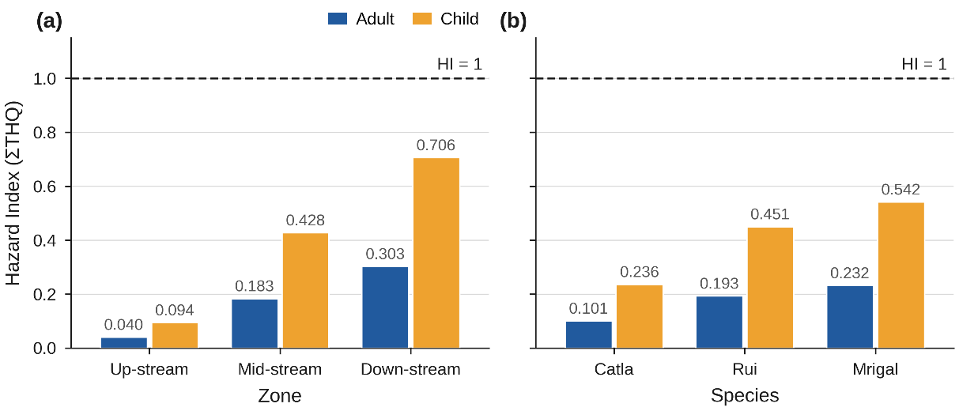
Applying the exposure parameters of Table 4 to the mean OCP concentrations, the overall (all-sample) Hazard Index was 0.175 for adults and 0.409 for children; both below the safety threshold of 1, indicating no appreciable non-carcinogenic hazard from fish consumption at present average contamination levels. However, HI in children was consistently 2.2–2.5-fold higher than in adults across all zones and species, reflecting children's higher fish-intake-to-body-weight ratio, and HI rose sharply along the river: from 0.040 (adult) / 0.094 (child) up-stream to 0.303 (adult) / 0.706 (child) down-stream, a ~7.5-fold increase that tracks the spatial concentration gradient described above (Figure 4.5). At the current down-stream contamination level, child HI (0.706) is approaching the threshold of concern and would merit continued monitoring.
Figure 3.5: Non-carcinogenic Hazard Index (HI = ΣTHQ) for adult and child fish consumers (a) by zone and (b) by species

Table 3.3: Hazard Index (HI) and incremental lifetime Cancer Risk (CR) by zone and species, for adult and child consumers.
Grouping | Consumer | HI (ΣTHQ) | Cancer Risk (CR)
Up-stream | Adult | 0.040 | 4.1 × 10⁻⁵
Up-stream | Child | 0.094 | 8.0 × 10⁻⁶
Mid-stream | Adult | 0.183 | 1.12 × 10⁻⁴
Mid-stream | Child | 0.428 | 2.2 × 10⁻⁵
Down-stream | Adult | 0.303 | 1.89 × 10⁻⁴
Down-stream | Child | 0.706 | 3.8 × 10⁻⁵
Catla | Adult | 0.101 | 6.6 × 10⁻⁵
Catla | Child | 0.236 | 1.3 × 10⁻⁵
Rui | Adult | 0.193 | 1.24 × 10⁻⁴
Rui | Child | 0.451 | 2.5 × 10⁻⁵
Mrigal | Adult | 0.232 | 1.52 × 10⁻⁴
Mrigal | Child | 0.542 | 3.0 × 10⁻⁵
Overall | Adult | 0.175 | 1.14 × 10⁻⁴
Overall | Child | 0.409 | 2.3 × 10⁻⁵

For carcinogenic risk, USEPA regards CR values within 10⁻⁶-10⁻⁴ as an acceptable range. Adult CR fell within or slightly above this range at every location (4.1 × 10⁻⁵ up-stream to 1.89 × 10⁻⁴ down-stream); mid-stream (1.12 × 10⁻⁴) and down-stream (1.89 × 10⁻⁴) adult values exceed the 10⁻⁴ upper bound, indicating a potentially non-negligible lifetime cancer risk for regular adult consumers of fish from these two zones. Species-wise, Mrigal and Rui carried the highest adult CR (1.52 × 10⁻⁴ and 1.24 × 10⁻⁴). Child CR remained within the acceptable range at all locations, because the shorter assumed childhood exposure duration (6 years vs 70 years lifetime) offsets the higher child ingestion-rate-to-body-weight ratio in the carcinogenic-risk formula. Compound-wise decomposition of the adult THQ (Figure 33) shows that aldrin alone accounted for ~69% of the overall adult HI (THQ = 0.121 of 0.175), driven by its low oral RfD (3 × 10⁻⁵ mg/kg-day) rather than its absolute concentration. α-HCH, δ-HCH, p,p'-DDT and heptachlor contributed smaller, comparable shares (THQ ≈ 0.009–0.015 each). This pattern — a low-RfD compound dominating risk despite not being the most abundant residue — is a common and important finding in OCP risk assessments and should be highlighted in the discussion: aldrin contamination, even at moderate concentrations, is the principal driver of fish-consumption risk in the Halda river.
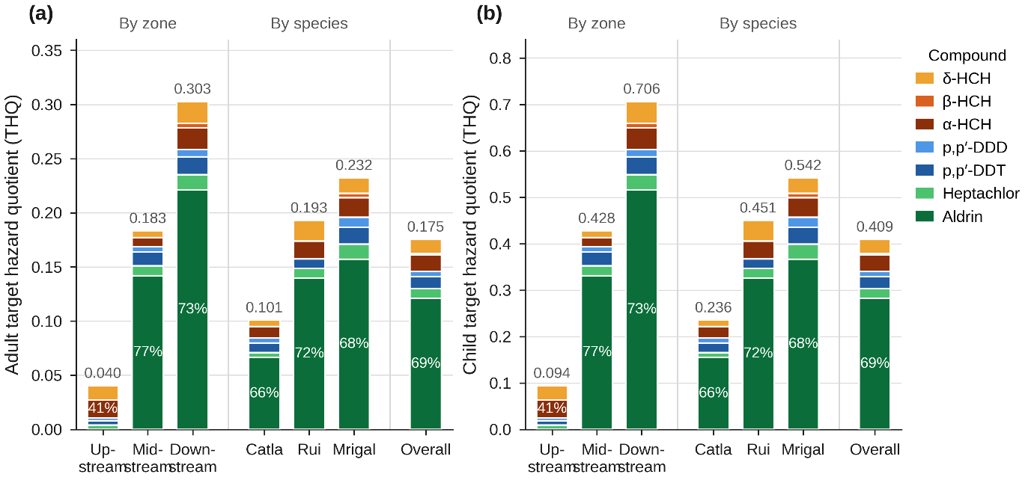
Figure 3.6: Compound-wise contribution to the target hazard quotient (THQ) for (a) adult and (b) child consumers, by zone, by species and overall

3.2 Concentration and Distribution of OCPs in Water
Total OCP concentration (ΣOCP, the sum of all 14 congeners) in Halda River water averaged 63.20 ± 24.60 µg/L across the 33 samples (range 22.11–108.76 µg/L). Seven of the fourteen target compounds; o,p'-DDT, o,p'-DDD, o,p'-DDE, p,p'-DDE, γ-HCH (Lindane), Dieldrin, Heptachlor epoxide were below detection level in all sample. Of the seven detected compounds, p,p'-DDT and p,p'-DDD were present in every sample (detection frequency 100%) and were by far the most abundant residues (mean 19.54 ± 4.67 and 17.50 ± 4.28 µg/L, respectively), followed by δ-HCH, α-HCH, heptachlor, β-HCH and aldrin (means 3.1–6.8 µg/L; detection frequency 45.5–81.8%) (Table 14; Figure 34). The ubiquitous presence of the DDT group at every site, contrasted with the patchier occurrence of the HCH isomers and cyclodienes, indicates a river-wide, diffuse DDT signal superimposed on more localised HCH/aldrin/heptachlor inputs.
Table 3.4: Descriptive statistics for individual OCPs in Halda River water (µg/L, n = 33).
Compound | Mean ± SD | Range | Detection frequency (%)
p,p'-DDT | 19.54 ± 4.67 | 12.17–31.30 | 100.0
p,p'-DDD | 17.50 ± 4.28 | 9.36–27.88 | 100.0
δ-HCH | 6.82 ± 3.63 | BDL –12.16 | 81.8
α-HCH | 5.98 ± 3.61 | BDL –13.36 | 78.8
Heptachlor | 5.82 ± 4.86 | BDL –14.74 | 63.6
β-HCH | 4.47 ± 3.08 | BDL –8.07 | 69.7
Aldrin | 3.08 ± 3.47 | BDL –8.40 | 45.5
o,p'-DDE | BDL | BDL | 0.0
o,p'-DDD | BDL | BDL | 0.0
o,p'-DDT | BDL | BDL | 0.0
p,p'-DDE | BDL | BDL | 0.0
γ-HCH (Lindane) | BDL | BDL | 0.0
Dieldrin | BDL | BDL | 0.0
Heptachlor epoxide | BDL | BDL | 0.0
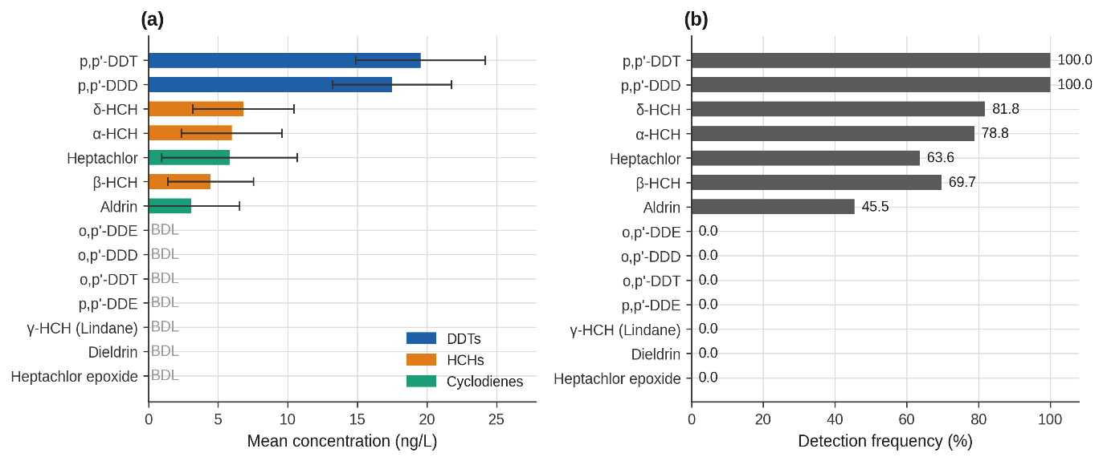
BDL =.Below detection limit
Figure 3.7: Mean (± SD) concentration of individual OCPs in Halda River water, pooled across all sites

Grouped by chemical class, the ΣOCP burden in water was dominated by DDT-group compounds (58.6%), followed by HCH isomers (27.3%) and cyclodiene group (14.1%) (Figure 4.2). This composition differs markedly from that of fish muscle from the same river, in which the three classes contributed almost equally; the stronger DDT dominance in the dissolved phase reflects both the greater historical usage of DDT in the catchment and the comparatively lower bioconcentration of the DDT group in the fish tissue analysed relative to the more bioaccumulative cyclodienes.
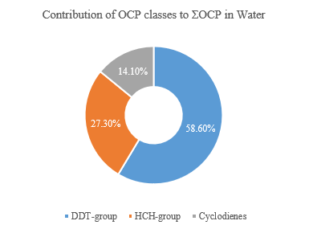
Figure 3.8: Relative contribution (%) of the three OCP chemical classes to the total ΣOCP concentration in water

Figure 0.18: Figure 36: Mean ± SD total OCP concentration (ΣOCP, ng/L) in water at the eleven sampling sites, arranged from up-stream to down-stream and coloured by zone.Figure 0.19: Relative contribution (%) of the three OCP chemical classes to the total ΣOCP concentration in water.

Figure 0.20: Figure 36: Mean ± SD total OCP concentration (ΣOCP, ng/L) in water at the eleven sampling sites, arranged from up-stream to down-stream and coloured by zone.

Figure 0.21: Heat map of the mean concentration (µg/L, n = 3 per site) of the seven detected OCPs at the eleven sampling sites, arranged up-stream to down-stream. BDL = below detection limit in all three samples at that site.Figure 0.22: Figure 36: Mean ± SD total OCP concentration (ΣOCP, ng/L) in water at the eleven sampling sites, arranged from up-stream to down-stream and coloured by zone.Figure 0.23: Relative contribution (%) of the three OCP chemical classes to the total ΣOCP concentration in water.

Figure 0.24: Figure 36: Mean ± SD total OCP concentration (ΣOCP, ng/L) in water at the eleven sampling sites, arranged from up-stream to down-stream and coloured by zone.Figure 0.25: Relative contribution (%) of the three OCP chemical classes to the total ΣOCP concentration in water.

3.2.1 Spatial (Zone-wise and Site-wise) Variation
Mean ΣOCP concentration increased from the up-stream to the down-stream zone: 43.95 ± 28.80 µg/L (up-stream) < 54.91 ± 11.17 µg/L (mid-stream) < 79.73 ± 16.20 µg/L (down-stream), and the difference among zones was statistically significant. A two-way fixed-effects ANOVA of the zone × compound-class design (Table 4.4, Figure 4.3) confirmed a significant zone main effect (F(2,90) = 27.85, p < 0.001), a much larger compound-class main effect (F(2,90) = 142.93, p < 0.001), and a significant zone × class interaction (F(4,90) = 2.74, p = 0.034): the down-stream increase was proportionally steepest for the cyclodiene and HCH classes, whose down-stream means were 2–3-fold their up-stream means, whereas the already-dominant DDT-group increased only ~1.4-fold. This longitudinal enrichment, a roughly 1.8-fold increase in ΣOCP from up-stream to down-stream; is consistent with cumulative loading from agricultural run-off, domestic and industrial discharge, and tidal resuspension of contaminated bed sediment accumulating along the flow path, and matches the spatial gradient reported for OCPs in fish muscle from the same zones.The overall longitudinal enrichment, a ~1.8-fold increase in the zone mean and a ~4.3-fold increase between the least (Bhujpur Dam, 24.10 µg/L) and most (Kalurghat, 103.46 µg/L) contaminated sites.
A notable exception to the smooth gradient is Nazirhat (82.15 ± 4.46 ng/L), which despite lying in the up-stream zone carried a ΣOCP burden ~3.3 times higher than the two other up-stream sites (Bhujpur Dam 24.10 and Ekkhuliya 25.62 µg/L) and was the only up-stream site at which HCH isomers, aldrin and heptachlor were detected (Figure 4.5). Nazirhat is a major market town and agricultural trading centre, and this local hotspot most plausibly reflects direct pesticide handling, run-off from intensively cultivated land and municipal drainage; it also inflates the up-stream mean and its standard deviation (up-stream median = 27.8 µg/L).
Table 3.5: Mean ± SD ΣOCP concentration (µg/L) by zone and by sampling site.
Grouping | Zone | n | Mean ± SD | Range
Bhujpur Dam | Up-stream | 3 | 24.10 ± 3.17 | 22.11–27.75
Ekkhuliya | Up-stream | 3 | 25.62 ± 2.27 | 23.69–28.12
Nazirhat | Up-stream | 3 | 82.15 ± 4.46 | 78.18–86.98
Sekandar Para | Mid-stream | 3 | 47.24 ± 1.71 | 45.62–49.03
Nichintapur | Mid-stream | 3 | 48.48 ± 6.56 | 40.99–53.21
Nadimpur | Mid-stream | 3 | 68.99 ± 2.34 | 66.45–71.06
West Binajuri | Down-stream | 3 | 58.13 ± 1.80 | 56.29–59.88
Napiter Ghona | Down-stream | 3 | 68.81 ± 2.67 | 65.75–70.70
Horekrishno Mohajoner Tek | Down-stream | 3 | 83.19 ± 3.12 | 80.12–86.36
Chayar Char | Down-stream | 3 | 85.08 ± 1.95 | 83.21–87.10
Kalurghat | Down-stream | 3 | 103.46 ± 5.31 | 98.13–108.76
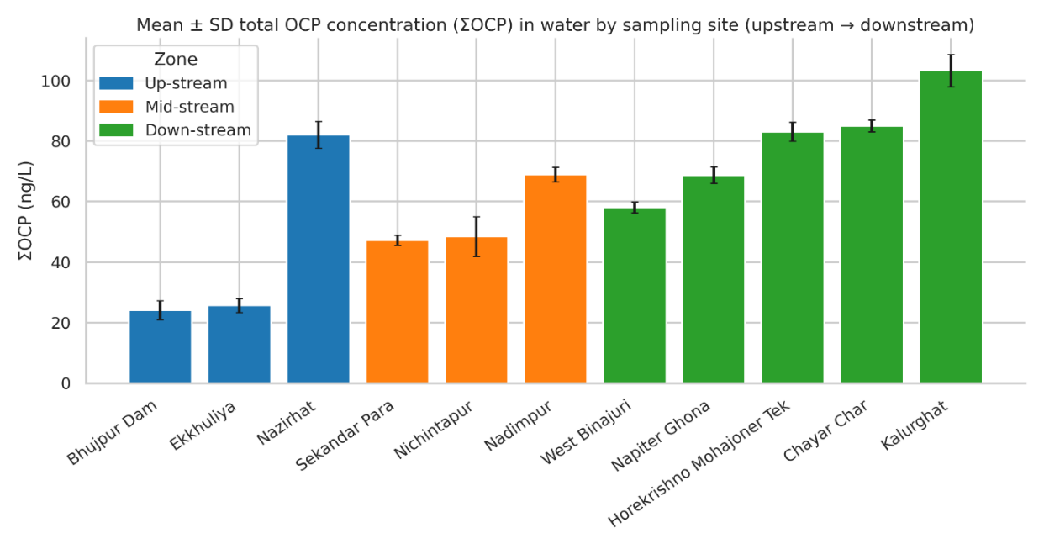
Figure 3.9: Figure 36: Mean ± SD total OCP concentration (ΣOCP, µg/L) in water at the eleven sampling sites, arranged from up-stream to down-stream and coloured by zone

Figure 0.26: Heat map of the mean concentration (µg/L, n = 3 per site) of the seven detected OCPs at the eleven sampling sites, arranged up-stream to down-stream. BDL = below detection limit in all three samples at that site.Figure 0.27: Figure 36: Mean ± SD total OCP concentration (ΣOCP, ng/L) in water at the eleven sampling sites, arranged from up-stream to down-stream and coloured by zone.

Figure 0.28: Heat map of the mean concentration (µg/L, n = 3 per site) of the seven detected OCPs at the eleven sampling sites, arranged up-stream to down-stream. BDL = below detection limit in all three samples at that site.

Figure 0.29: Non-carcinogenic Hazard Index (HI = ΣTHQ, ingestion + dermal) for adult and child receptors exposed to Halda River water, by zone. Numbers above the bars are HI values; the safety threshold (HI = 1) lies far above the plotted range at present contamination levels.Figure 0.30: Heat map of the mean concentration (µg/L, n = 3 per site) of the seven detected OCPs at the eleven sampling sites, arranged up-stream to down-stream. BDL = below detection limit in all three samples at that site.Figure 0.31: Figure 36: Mean ± SD total OCP concentration (ΣOCP, ng/L) in water at the eleven sampling sites, arranged from up-stream to down-stream and coloured by zone.

Figure 0.32: Heat map of the mean concentration (µg/L, n = 3 per site) of the seven detected OCPs at the eleven sampling sites, arranged up-stream to down-stream. BDL = below detection limit in all three samples at that site.Figure 0.33: Figure 36: Mean ± SD total OCP concentration (ΣOCP, ng/L) in water at the eleven sampling sites, arranged from up-stream to down-stream and coloured by zone.
Table 3.6: Two-way analysis of variance of water OCP concentration (µg/L) by zone and compound class (fixed effects, proportional design, N = 99 class-sum observations).
Source of variation | SS | df | MS | F | p
Zone | 2684.53 | 2 | 1342.27 | 27.85 | < 0.001
Compound class | 13777.71 | 2 | 6888.86 | 142.93 | < 0.001
Zone × Class | 527.59 | 4 | 131.90 | 2.74 | 0.034
Error | 4337.83 | 90 | 48.20
Total | 21327.65 | 98
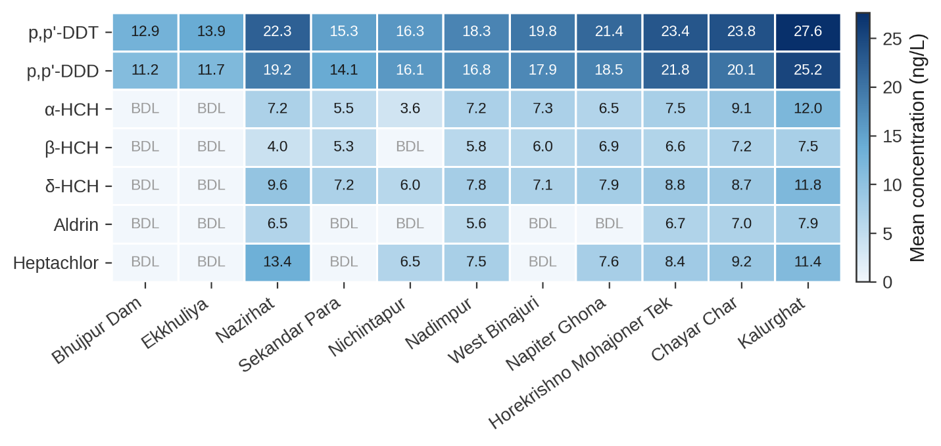
Figure 3.10: Heat map of the mean concentration (µg/L, n = 3 per site) of the seven detected OCPs at the eleven sampling sites, arranged up-stream to down-stream

The heat map (Figure 4.4) shows that every detected compound reached its maximum at Kalurghat (p,p′-DDT 27.6, p,p′-DDD 25.2, δ-HCH 11.8 µg/L) or at the Nazirhat hotspot (heptachlor 13.4 µg/L), confirming that the lower reach between Horekrishno Mohajoner Tek and Kalurghat, together with Nazirhat, represents the combination of highest OCP exposure in the river.

3.3.2 Human Health Risk from Exposure to River Water
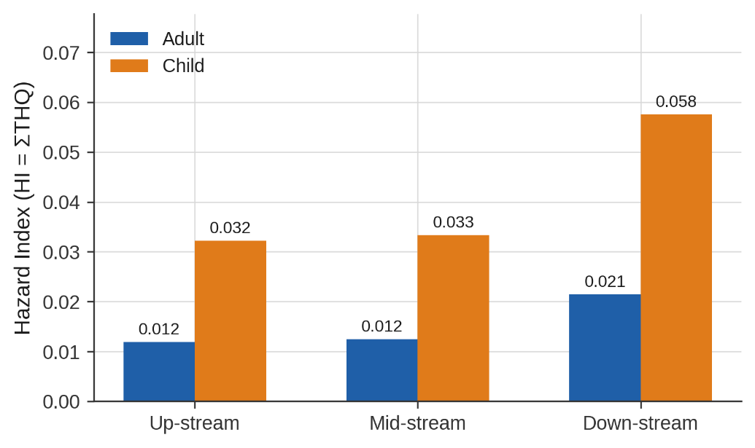
Applying the exposure parameters of Table 6 to the mean OCP concentrations, the overall (all-sample) Hazard Index for combined ingestion and dermal exposure was 0.016 for adults and 0.044 for children; both one to two orders of magnitude below the safety threshold of 1, indicating no appreciable non-carcinogenic hazard from direct contact with Halda River water at present contamination levels (Figure 38; Table 17). As in the fish-consumption assessment, HI in children was consistently ~2.7-fold higher than in adults, reflecting children's higher intake- and skin-area-to-body-weight ratios, and HI increased along the river, from 0.012 (adult) / 0.032 (child) up-stream to 0.021 / 0.058 down-stream; the highest site-specific values occurred at Kalurghat (0.033 / 0.088). The dermal pathway contributed 57% (adult) and 63% (child) of the total HI, a consequence of the very high dermal permeability of the lipophilic DDT-group compounds; because the Potts–Guy Kp is an upper-bound estimate for such compounds, the dermal contribution should be interpreted as conservative
Figure 3.11: Non-carcinogenic Hazard Index (HI = ΣTHQ, ingestion + dermal) for adult and child receptors exposed to Halda River water, by zone

Figure 0.34: Incremental lifetime cancer risk (CR, ingestion + dermal) for adult and child receptors by zone (log scale). Dashed and dotted lines mark the 10⁻⁴ and 10⁻⁶ bounds of the USEPA acceptable range.Figure 0.35: Non-carcinogenic Hazard Index (HI = ΣTHQ, ingestion + dermal) for adult and child receptors exposed to Halda River water, by zone. Numbers above the bars are HI values; the safety threshold (HI = 1) lies far above the plotted range at present contamination levels.

Figure 0.36: Incremental lifetime cancer risk (CR, ingestion + dermal) for adult and child receptors by zone (log scale). Dashed and dotted lines mark the 10⁻⁴ and 10⁻⁶ bounds of the USEPA acceptable range.

Figure 0.37: Compound-wise contribution to the adult Target Hazard Quotient (THQ, ingestion + dermal), by zone. Aldrin and the DDT group dominate the non-carcinogenic hazard at every zone.Figure 0.38: Incremental lifetime cancer risk (CR, ingestion + dermal) for adult and child receptors by zone (log scale). Dashed and dotted lines mark the 10⁻⁴ and 10⁻⁶ bounds of the USEPA acceptable range.Figure 0.39: Non-carcinogenic Hazard Index (HI = ΣTHQ, ingestion + dermal) for adult and child receptors exposed to Halda River water, by zone. Numbers above the bars are HI values; the safety threshold (HI = 1) lies far above the plotted range at present contamination levels.

Figure 0.40: Incremental lifetime cancer risk (CR, ingestion + dermal) for adult and child receptors by zone (log scale). Dashed and dotted lines mark the 10⁻⁴ and 10⁻⁶ bounds of the USEPA acceptable range.Figure 0.41: Non-carcinogenic Hazard Index (HI = ΣTHQ, ingestion + dermal) for adult and child receptors exposed to Halda River water, by zone. Numbers above the bars are HI values; the safety threshold (HI = 1) lies far above the plotted range at present contamination levels.
Table 3.7: Hazard Index (HI) and incremental lifetime Cancer Risk (CR) from water exposure by zone and site, for adult and child receptors (ingestion + dermal pathways).
Grouping | Receptor | THQ ingestion | THQ dermal | HI (total) | CR (total)
Bhujpur Dam | Adult | 0.0014 | 0.0031 | 0.0045 | 7.6 × 10⁻⁷
Bhujpur Dam | Child | 0.0032 | 0.0091 | 0.0124 | 1.80 × 10⁻⁷
Ekkhuliya | Adult | 0.0015 | 0.0033 | 0.0048 | 8.1 × 10⁻⁷
Ekkhuliya | Child | 0.0034 | 0.0098 | 0.0132 | 1.92 × 10⁻⁷
Nazirhat | Adult | 0.0113 | 0.0151 | 0.0265 | 1.37 × 10⁻⁵
Nazirhat | Child | 0.0265 | 0.0447 | 0.0711 | 3.1 × 10⁻⁶
Sekandar Para | Adult | 0.0034 | 0.0039 | 0.0072 | 2.2 × 10⁻⁶
Sekandar Para | Child | 0.0079 | 0.0114 | 0.0193 | 4.9 × 10⁻⁷
Nichintapur | Adult | 0.0031 | 0.0044 | 0.0075 | 3.1 × 10⁻⁶
Nichintapur | Child | 0.0073 | 0.0130 | 0.0203 | 6.9 × 10⁻⁷
Nadimpur | Adult | 0.0098 | 0.0128 | 0.0225 | 1.12 × 10⁻⁵
Nadimpur | Child | 0.0228 | 0.0376 | 0.0605 | 2.5 × 10⁻⁶
West Binajuri | Adult | 0.0041 | 0.0050 | 0.0091 | 2.9 × 10⁻⁶
West Binajuri | Child | 0.0096 | 0.0146 | 0.0242 | 6.3 × 10⁻⁷
Napiter Ghona | Adult | 0.0047 | 0.0056 | 0.0103 | 4.6 × 10⁻⁶
Napiter Ghona | Child | 0.0111 | 0.0165 | 0.0276 | 10 × 10⁻⁷
Horekrishno Mohajoner Tek | Adult | 0.0116 | 0.0156 | 0.0272 | 1.31 × 10⁻⁵
Horekrishno Mohajoner Tek | Child | 0.0271 | 0.0459 | 0.0731 | 3.0 × 10⁻⁶
Chayar Char | Adult | 0.0121 | 0.0159 | 0.0280 | 1.39 × 10⁻⁵
Chayar Char | Child | 0.0282 | 0.0470 | 0.0752 | 3.1 × 10⁻⁶
Kalurghat | Adult | 0.0142 | 0.0185 | 0.0327 | 1.63 × 10⁻⁵
Kalurghat | Child | 0.0332 | 0.0544 | 0.0876 | 3.7 × 10⁻⁶
Up-stream | Adult | 0.0047 | 0.0072 | 0.0119 | 5.1 × 10⁻⁶
 | Child | 0.0110 | 0.0212 | 0.0322 | 1.16 × 10⁻⁶
Mid-stream | Adult | 0.0054 | 0.0070 | 0.0124 | 5.5 × 10⁻⁶
 | Child | 0.0127 | 0.0207 | 0.0333 | 1.24 × 10⁻⁶
Down-stream | Adult | 0.0094 | 0.0121 | 0.0215 | 1.02 × 10⁻⁵
 | Child | 0.0218 | 0.0357 | 0.0575 | 2.3 × 10⁻⁶
Overall | Adult | 0.0070 | 0.0094 | 0.0164 | 7.5 × 10⁻⁶
Overall | Child | 0.0164 | 0.0276 | 0.0440 | 1.69 × 10⁻⁶

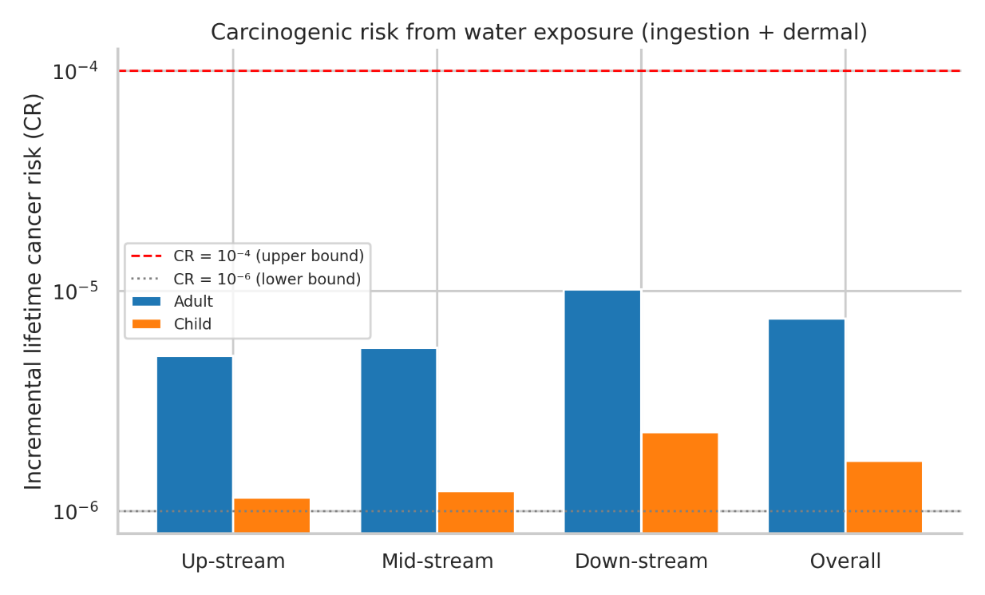
For carcinogenic risk, the overall CR was 7.5 × 10⁻⁶ for adults and 1.69 × 10⁻⁶ for children, i.e. within the USEPA "acceptable" range of 10⁻⁶–10⁻⁴ (Figure 4.7). Adult CR ranged from 7.6 × 10⁻⁷ (Bhujpur Dam) to 1.63 × 10⁻⁵ (Kalurghat) and remained below the 10⁻⁴ upper bound at every site; child CR stayed close to the 10⁻⁶ lower bound (1.80 × 10⁻⁷–3.7 × 10⁻⁶), because the shorter assumed childhood exposure duration (6 years vs 70 years) offsets the higher child dose per unit body weight in the lifetime-averaged carcinogenic formula. At Nazirhat, Nadimpur and the four lowest down-stream sites adult CR exceeded 10⁻⁵, the level at which USEPA generally recommends that risk management be considered, so that long-term direct use of untreated river water from these reaches carries a small but non-negligible incremental cancer risk.
Figure 3.12: Incremental lifetime cancer risk (CR, ingestion + dermal) for adult and child receptors by zone (log scale)

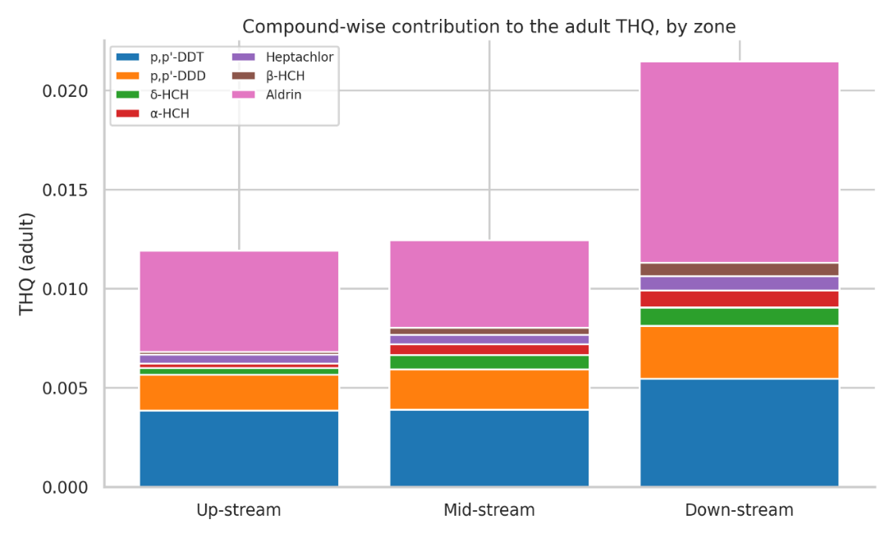
Compound-wise decomposition of the adult THQ (Figure 4.8) shows that aldrin alone accounted for ~44% of the overall adult HI (THQ = 0.0072 of 0.0164) and ~49% of the CR, despite contributing only 4.9% of the ΣOCP concentration — a consequence of its very low oral RfD (3 × 10⁻⁵ mg/kg-day) and high CSF (17 (mg/kg-day)⁻¹). p,p'-DDT and p,p'-DDD together contributed a further ~42% of the HI, while the HCH isomers and heptachlor contributed smaller, comparable shares. This is the same pattern identified in the fish-consumption assessment: aldrin, although not the most abundant residue, is the principal driver of human-health risk from OCPs in the Halda system, and its sources should be prioritised in any mitigation programme.
Figure 3.13: Compound-wise contribution to the adult Target Hazard Quotient (THQ, ingestion + dermal), by zone

3.2.3 Ecological Risk of OCPs in Water
In contrast to the low human-health risk, the ecological risk quotients indicate that OCP concentrations in Halda water are of serious concern for aquatic biota (Table 19; Figures 41–43). Based on river-wide mean concentrations, p,p'-DDT (RQ = 19.5), p,p'-DDD (RQ = 17.5) and heptachlor (RQ = 1.53) fell in the high-risk category (RQ ≥ 1), aldrin (RQ = 0.77) and the three HCH isomers (RQ = 0.22–0.34) in the medium-risk category, and no detected compound was of low or negligible risk. Under the worst-case (maximum-concentration) scenario, aldrin also entered the high-risk category (RQ = 2.1), heptachlor rose to 3.9, and the HCH isomers approached the high-risk boundary (RQ = 0.40–0.67). The DDT group, which exceeded its chronic aquatic-life criterion by more than an order of magnitude at every one of the eleven sites, is the overwhelming driver of ecological risk (92% of ΣRQ).
Table 3.8: Ecological risk quotients (RQ = MEC/PNEC) of detected OCPs in Halda River water based on river-wide mean and maximum concentrations, with risk classification.
Compound | Mean MEC (µg/L) | Max MEC (µg/L) | PNEC (µg/L) | RQ (mean) | RQ (max) | Risk class (mean) | Risk class (max)
p,p'-DDT | 0.0195 | 0.0313 | 0.001 | 19.54 | 31.30 | High | High
p,p'-DDD | 0.0175 | 0.0279 | 0.001 | 17.50 | 27.88 | High | High
δ-HCH | 0.0068 | 0.0122 | 0.02 | 0.34 | 0.61 | Medium | Medium
α-HCH | 0.0060 | 0.0134 | 0.02 | 0.30 | 0.67 | Medium | Medium
Heptachlor | 0.0058 | 0.0147 | 0.0038 | 1.53 | 3.88 | High | High
β-HCH | 0.0045 | 0.0081 | 0.02 | 0.22 | 0.40 | Medium | Medium
Aldrin | 0.0031 | 0.0084 | 0.004 | 0.77 | 2.10 | Medium | High
Risk classes after Hernando et al. (2006): low, RQ < 0.1; medium, 0.1 ≤ RQ < 1; high, RQ ≥ 1.
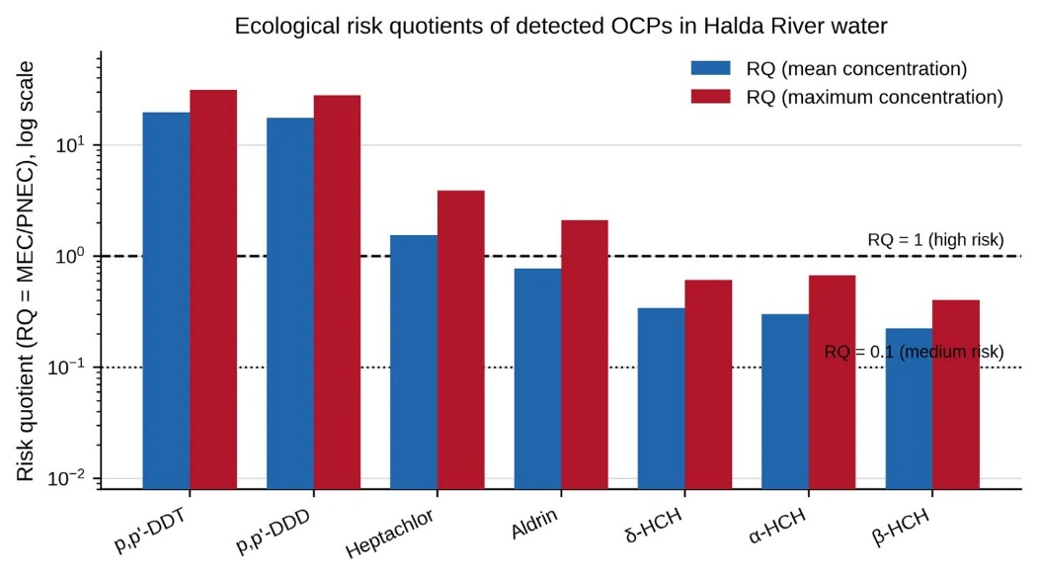
Figure 3.14: Ecological risk quotients of the seven detected OCPs based on river-wide mean and maximum concentrations (log scale)
Spatially (Figure 42; Table 19), high DDT-related risk was present at all sites, with RQ for p,p'-DDT rising from 12.9 at Bhujpur Dam to 27.6 at Kalurghat. Heptachlor posed a high risk at every site where it was detected (RQ 1.72–3.53, maximum at Nazirhat), and aldrin posed a high risk at Nazirhat, Nadimpur and the four lowest down-stream sites (RQ 1.41–1.99). The cumulative mixture risk, ΣRQ, increased from 32.4 (up-stream) through 34.8 (mid-stream) to 48.1 (down-stream) (Figure 4.11), and from 24.1 at Bhujpur Dam to 59.4 at Kalurghat i.e. the OCP mixture exceeded the no-effect level for sensitive aquatic organisms by a factor of ~25–60 throughout the river.
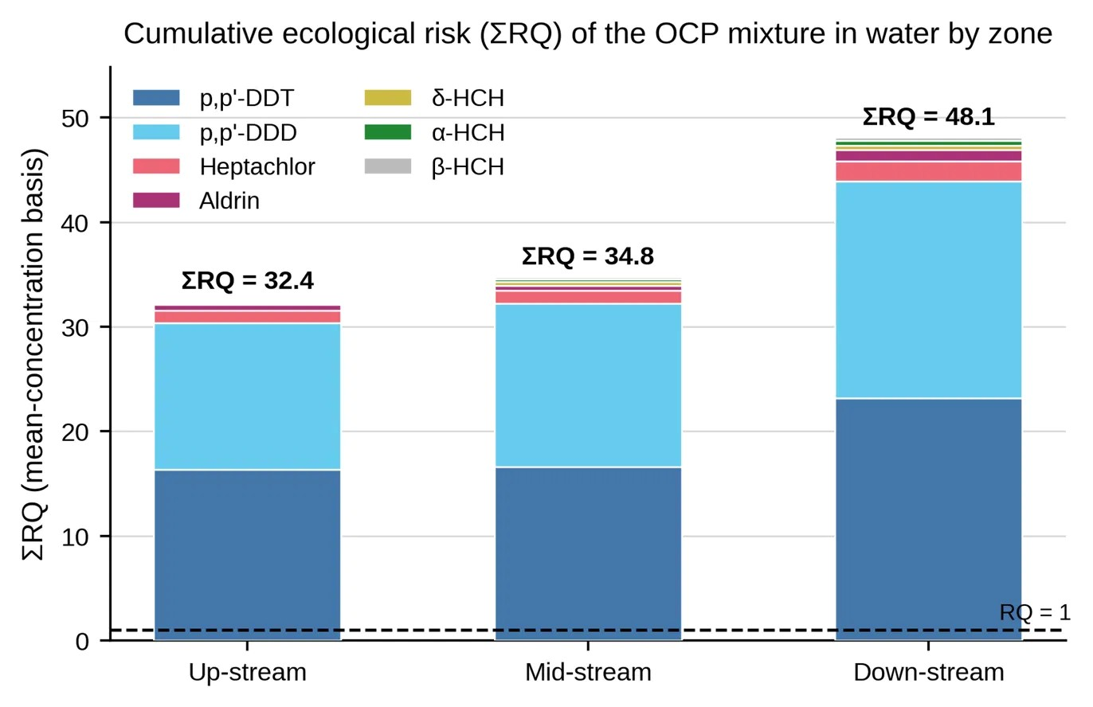
Figure 3.15: Cumulative ecological risk (ΣRQ, mean-concentration basis) of the OCP mixture by zone, decomposed by compound

Figure 0.42: Figure 5.1 — Mean concentration (+1 SD) (a) and detection frequency (b) of the 14 target OCPs in Halda River surface sediment, pooled across all sites and zones (n = 33). Bars in (a) are coloured by chemical class; p,p′-DDT and p,p′-DDD were the dominant residues. BDL = below detection limit in all samples.Figure 0.43: Cumulative ecological risk (ΣRQ, mean-concentration basis) of the OCP mixture by zone, decomposed by compound. The dashed line marks ΣRQ = 1.

Figure 0.44: Figure 5.1 — Mean concentration (+1 SD) (a) and detection frequency (b) of the 14 target OCPs in Halda River surface sediment, pooled across all sites and zones (n = 33). Bars in (a) are coloured by chemical class; p,p′-DDT and p,p′-DDD were the dominant residues. BDL = below detection limit in all samples.

Figure 0.45: Relative contribution (%) of the three OCP chemical classes to the total ΣOCP burden in sediment.Figure 0.46: Figure 5.1 — Mean concentration (+1 SD) (a) and detection frequency (b) of the 14 target OCPs in Halda River surface sediment, pooled across all sites and zones (n = 33). Bars in (a) are coloured by chemical class; p,p′-DDT and p,p′-DDD were the dominant residues. BDL = below detection limit in all samples.Figure 0.47: Cumulative ecological risk (ΣRQ, mean-concentration basis) of the OCP mixture by zone, decomposed by compound. The dashed line marks ΣRQ = 1.

Figure 0.48: Figure 5.1 — Mean concentration (+1 SD) (a) and detection frequency (b) of the 14 target OCPs in Halda River surface sediment, pooled across all sites and zones (n = 33). Bars in (a) are coloured by chemical class; p,p′-DDT and p,p′-DDD were the dominant residues. BDL = below detection limit in all samples.Figure 0.49: Cumulative ecological risk (ΣRQ, mean-concentration basis) of the OCP mixture by zone, decomposed by compound. The dashed line marks ΣRQ = 1.
Table 3.9: Site-wise ecological risk quotients (mean-concentration basis) and cumulative mixture risk (ΣRQ) for detected OCPs in Halda River water.
Site | Zone | p,p'-DDT | p,p'-DDD | δ-HCH | α-HCH | Heptachlor | β-HCH | Aldrin | ΣRQ (mean) | ΣRQ (max)
Bhujpur Dam | Up-stream | 12.90 | 11.20 | BDL | BDL | BDL | BDL | BDL | 24.1 | 27.8
Ekkhuliya | Up-stream | 13.93 | 11.69 | BDL | BDL | BDL | BDL | BDL | 25.6 | 28.2
Nazirhat | Up-stream | 22.25 | 19.18 | 0.48 | 0.36 | 3.53 | 0.20 | 1.64 | 47.6 | 50.4
Sekandar Para | Mid-stream | 15.27 | 14.06 | 0.36 | 0.27 | BDL | 0.26 | BDL | 30.2 | 31.9
Nichintapur | Mid-stream | 16.26 | 16.11 | 0.30 | 0.18 | 1.72 | BDL | BDL | 34.6 | 37.8
Nadimpur | Mid-stream | 18.27 | 16.79 | 0.39 | 0.36 | 1.97 | 0.29 | 1.41 | 39.5 | 41.8
West Binajuri | Down-stream | 19.83 | 17.86 | 0.36 | 0.36 | BDL | 0.30 | BDL | 38.7 | 40.2
Napiter Ghona | Down-stream | 21.37 | 18.55 | 0.39 | 0.32 | 2.01 | 0.34 | BDL | 43.0 | 45.1
Horekrishno Mohajoner Tek | Down-stream | 23.39 | 21.78 | 0.44 | 0.38 | 2.21 | 0.33 | 1.68 | 50.2 | 51.6
Chayar Char | Down-stream | 23.83 | 20.08 | 0.44 | 0.45 | 2.43 | 0.36 | 1.75 | 49.3 | 52.2
Kalurghat | Down-stream | 27.60 | 25.22 | 0.59 | 0.60 | 2.99 | 0.38 | 1.99 | 59.4 | 66.0
Up-stream (zone) |  | 16.36 | 14.02 | 0.16 | 0.12 | 1.18 | 0.07 | 0.55 | 32.4 | 50.4
Mid-stream (zone) |  | 16.60 | 15.65 | 0.35 | 0.27 | 1.23 | 0.18 | 0.47 | 34.8 | 41.8
Down-stream (zone) |  | 23.20 | 20.70 | 0.44 | 0.42 | 1.93 | 0.34 | 1.08 | 48.1 | 66.0
Overall |  | 19.54 | 17.50 | 0.34 | 0.30 | 1.53 | 0.22 | 0.77 | 40.2 | 66.8
The ecological significance of these findings is heightened by the unique status of the Halda as the only natural spawning ground of Indian major carps in Bangladesh. The PNEC values used here are chronic criteria intended to protect sensitive life stages, and fish embryos and larvae; the very life stages on which the Halda fishery depends, are among the most DDT- and cyclodiene-sensitive aquatic organisms known. Sustained DDT and heptachlor concentrations of one to two orders of magnitude above these criteria, together with the medium-to-high risk from aldrin and HCH, therefore imply a realistic potential for chronic sub-lethal effects (reduced hatching success, larval deformity and impaired growth) on carp spawn in the river, and for continued bioaccumulation in the food web, as evidenced by the OCP burden measured in fish from the same reaches. The gradient of ecological risk closely follows the gradient in concentration, so that the lower reach from Horekrishno Mohajoner Tek to Kalurghat and the Nazirhat hotspot should be prioritised for source control and monitoring.

3.3 Concentration and Distribution of OCPs in Sediment
Total OCP burden (ΣOCP, the sum of all 14 congeners) in surface sediment averaged 121.90 ± 57.20 µg/kg across the 33 samples (median 130.4; range 38.7-257.5 µg/kg), i.e. roughly 5.2-fold higher than the corresponding mean burden in fish muscle (23.59 µg/kg ww) and 1.93-fold higher than the corresponding mean burden in water (63.20 µg/kg ww), confirming that the bed sediment is the principal reservoir of OCPs in the Halda system. Exactly the same seven compounds that were below detection limit from fish and water; o,p'-DDT, o,p'-DDD, o,p'-DDE, p,p'-DDE, γ-HCH (Lindane), Dieldrin, Heptachlor epoxide, were also below detection limit in all sediment sample, which strongly supports the analytical consistency of the three datasets and indicates that these compounds are not part of the contaminant signature of the catchment.
The remaining seven compounds were detected at frequencies ranging from 27.3 % (β-HCH) to 100 % (p,p'-DDT and p,p'-DDD) (Table 5.4). p,p'-DDT (43.26 ± 12.42 µg/kg) and p,p'-DDD (39.91 ± 12.99 µg/kg) were present in every sample and together accounted for 68.2 % of ΣOCP; α-HCH (11.20 ± 6.56 µg/kg), heptachlor, δ-HCH, aldrin and β-HCH were detected less regularly and at markedly lower levels (Figure 5.1). The ubiquity of the two DDT-group compounds, contrasted with the patchy occurrence of the HCH isomers and cyclodienes, points to a diffuse, basin-wide legacy of DDT superimposed on more localised inputs of technical HCH and aldrin/heptachlor-based formulations.
Table 3.10: Descriptive statistics for individual OCPs in surface sediment (µg/kg, n = 33).
Compound | Mean ± SD | Median | Range | Detection frequency (%)
p,p'-DDT | 43.26 ± 12.42 | 45.08 | 21.78–71.45 | 100.0
p,p'-DDD | 39.91 ± 12.99 | 41.49 | 16.87–69.73 | 100.0
α-HCH | 11.20 ± 6.56 | 11.32 | BDL–22.01 | 81.8
Heptachlor | 8.69 ± 8.58 | 9.76 | BDL –23.57 | 54.5
δ-HCH | 8.50 ± 8.35 | 6.64 | BDL –31.91 | 72.7
Aldrin | 6.25 ± 8.03 | 0.00 | BDL –27.83 | 42.4
β-HCH | 4.09 ± 7.10 | 0.00 | BDL –22.76 | 27.3
o,p'-DDT | BDL | BDL | BDL | 0.0
o,p'-DDD | BDL | BDL | BDL | 0.0
o,p'-DDE | BDL | BDL | BDL | 0.0
p,p'-DDE | BDL | BDL | BDL | 0.0
γ-HCH (Lindane) | BDL | BDL | BDL | 0.0
Dieldrin | BDL | BDL | BDL | 0.0
Heptachlor epoxide | BDL | BDL | BDL | 0.0
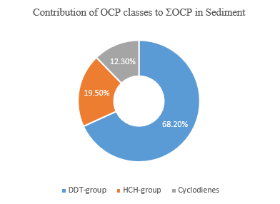
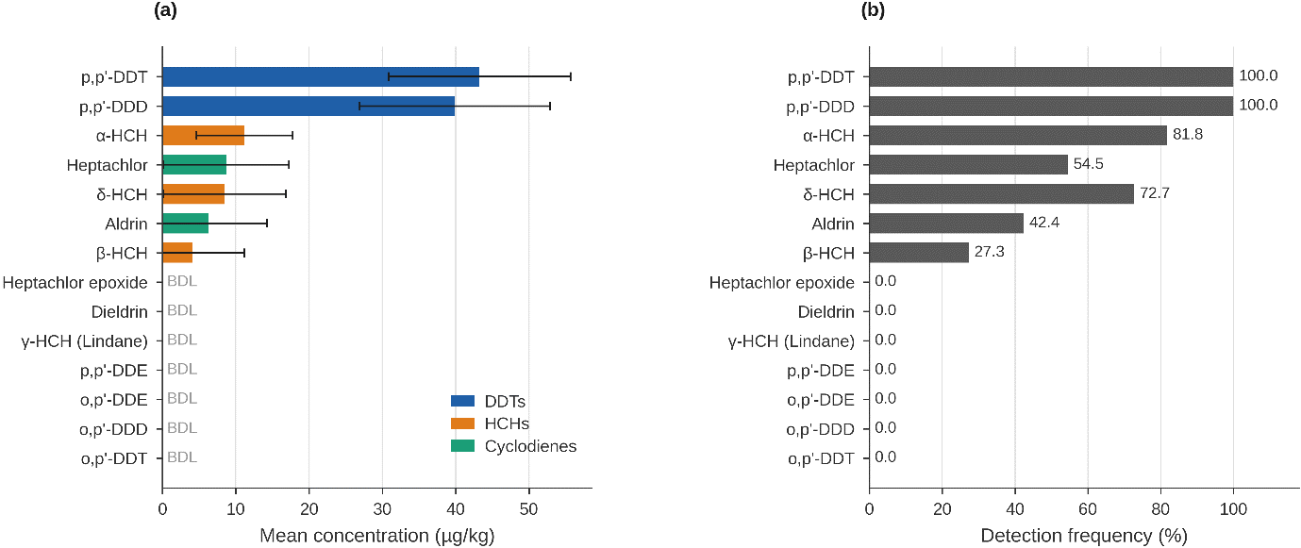
Grouped by chemical class (Figure 45), the ΣOCP burden was dominated by the DDT group (68.2 %), followed by the HCH isomers (19.5 %) and the cyclodienes/heptachlors (12.3 %). This differs from the almost equal three-way split observed in fish muscle (≈ 32–36 % per class), and is consistent with the very high hydrophobicity and sediment-binding affinity of the DDT compounds (log K₀w ≈ 6–6.9) relative to the HCH isomers (log K₀w ≈ 3.7–3.9), which partition preferentially into the dissolved phase and biota. The class composition also shifted along the river: the ΣHCH share increased from 13.0 % up-stream to 21.6 % down-stream, and the cyclodiene share from 11.8 % to 14.6 % (Figure 5.5), indicating additional HCH and aldrin/heptachlor sources in the lower reach.
Figure 3.17: Relative contribution (%) of the three OCP chemical classes to the total ΣOCP burden in sediment
Figure 3.16: Mean concentration (+1 SD) (a) and detection frequency (b) of the 14 target OCPs in Halda River surface sediment, pooled across all sites and zones

3.3.1 Spatial (Zone-wise and Site-wise) Variation
Mean ΣOCP concentration increased significantly from the up-stream to the down-stream zone: 78.72 ± 48.92 µg/kg (up-stream, n = 9) < 99.38 ± 29.23 µg/kg (mid-stream, n = 9) < 161.32 ± 49.32 µg/kg (down-stream, n = 15). A two-way fixed-effects ANOVA of the zone × compound-class design (Tables 5.6 and 5.7, Figure 5.4) confirmed a highly significant zone main effect (F(2,90) = 30.51, p < 0.001), a much larger compound-class main effect (F(2,90) = 186.20, p < 0.001), and a significant zone × class interaction (F(4,90) = 2.69, p = 0.036): the down-stream increase was proportionally steepest for the HCH and cyclodiene classes, whose down-stream means were 3.4- and 2.6-fold their up-stream means, whereas the already-dominant DDT group increased only 1.7-fold. The longitudinal trend was equally clear at the site level: ΣOCP correlated strongly with the up- to down-stream order of the eleven sites.
At the site level (Table 3.11, Figure 3.16), ΣOCP ranged from 41.7 µg/kg at Ekkhuliya to 244.9 µg/kg at Kalurghat, the most down-stream site adjacent to the urban-industrial fringe of Chattogram city near the Halda-Karnaphuli confluence. The two most up-stream sites, Bhujpur Dam (50.8 µg/kg) and Ekkhuliya (41.7 µg/kg), carried only p,p'-DDT and p,p'-DDD and no HCH or cyclodiene residues at all, and may be regarded as the background DDT signature of the upper catchment. Nazirhat (143.7 µg/kg) is a clear exception within the up-stream zone: it contained all seven detected compounds, including β-HCH, aldrin and the highest up-stream heptachlor level, which points to a discrete local source (e.g. run-off from intensively cultivated land or a market/settlement area) rather than the diffuse background. Within the down-stream zone, concentrations rose monotonically from West Binajuri to Kalurghat.
Table 3.11: Mean ± SD concentration (µg/kg, n = 3) of OCP classes and ΣOCP at each sampling site.
Site | Zone | n | ΣOCP | Range
Bhujpur Dam | Up-stream | 3 | 50.78 ± 3.26 | 19.47–27.68
Ekkhuliya | Up-stream | 3 | 41.73 ± 2.66 | 16.87–21.78
Nazirhat | Up-stream | 3 | 143.66 ± 2.61 | 7.909–47.59
Sekandar Para | Mid-stream | 3 | 66.67 ± 7.79 | 8.12–35.76
Nichintapur | Mid-stream | 3 | 98.33 ± 4.32 | 5.66–41.98
Nadimpur | Mid-stream | 3 | 133.14 ± 4.70 | 5.95–44.70
West Binajuri | Down-stream | 3 | 106.68 ± 3.24 | 5.92–48.97
Napiter Ghona | Down-stream | 3 | 131.04 ± 7.16 | 9.77–53.84
Horekrishno Mohajoner Tek | Down-stream | 3 | 150.28 ± 6.68 | 10.08–56.50
Chayar Char | Down-stream | 3 | 173.75 ± 5.20 | 14.13–59.49
Kalurghat | Down-stream | 3 | 244.86 ± 12.60 | 15.86–71.45
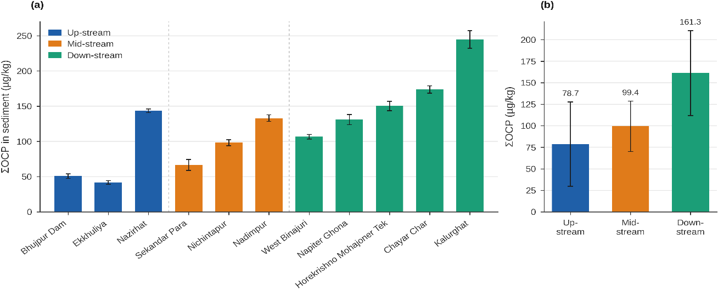
Figure 3.18: Mean ± SD total OCP concentration (ΣOCP, µg/kg) in sediment at the eleven sampling sites (a) and by zone (b)

Figure 0.50:Compound-wise contribution to the adult Target Hazard Quotient (THQ) from sediment contact, by zone. Aldrin is the dominant contributor at every zone.Figure 0.51: Mean ± SD total OCP concentration (ΣOCP, µg/kg) in sediment at the eleven sampling sites (a; bars coloured by zone, dashed lines separate the zones) and by zone (b; n = 9, 9 and 15 samples).

Figure 0.52:Compound-wise contribution to the adult Target Hazard Quotient (THQ) from sediment contact, by zone. Aldrin is the dominant contributor at every zone.

Figure 0.53: Non-carcinogenic Hazard Index (left) and incremental lifetime Cancer Risk (right) from combined incidental ingestion and dermal contact with sediment, for adult and child receptors by zone (logarithmic axes). The dashed line marks HI = 1; the shaded band marks the USEPA acceptable cancer-risk range of 10⁻⁶–10⁻⁴.Figure 0.54:Compound-wise contribution to the adult Target Hazard Quotient (THQ) from sediment contact, by zone. Aldrin is the dominant contributor at every zone.Figure 0.55: Mean ± SD total OCP concentration (ΣOCP, µg/kg) in sediment at the eleven sampling sites (a; bars coloured by zone, dashed lines separate the zones) and by zone (b; n = 9, 9 and 15 samples).

Figure 0.56:Compound-wise contribution to the adult Target Hazard Quotient (THQ) from sediment contact, by zone. Aldrin is the dominant contributor at every zone.Figure 0.57: Mean ± SD total OCP concentration (ΣOCP, µg/kg) in sediment at the eleven sampling sites (a; bars coloured by zone, dashed lines separate the zones) and by zone (b; n = 9, 9 and 15 samples).

Table 3.12: Two-way analysis of variance of sediment OCP concentration (µg/kg) by zone and compound class (fixed effects, proportional design, N = 99 class-sum observations).
Source of variation | SS | df | MS | F | p-value
Zone (main effect) | 14885.966 | 2 | 7442.983 | 30.512 | <0.001
Compound Class (main effect) | 90843.719 | 2 | 45421.860 | 186.201 | <0.001
Zone × Class (interaction) | 2625.113 | 4 | 656.278 | 2.690 | 0.0360
Error | 21954.552 | 90 | 243.939
Total | 130309.349 | 98
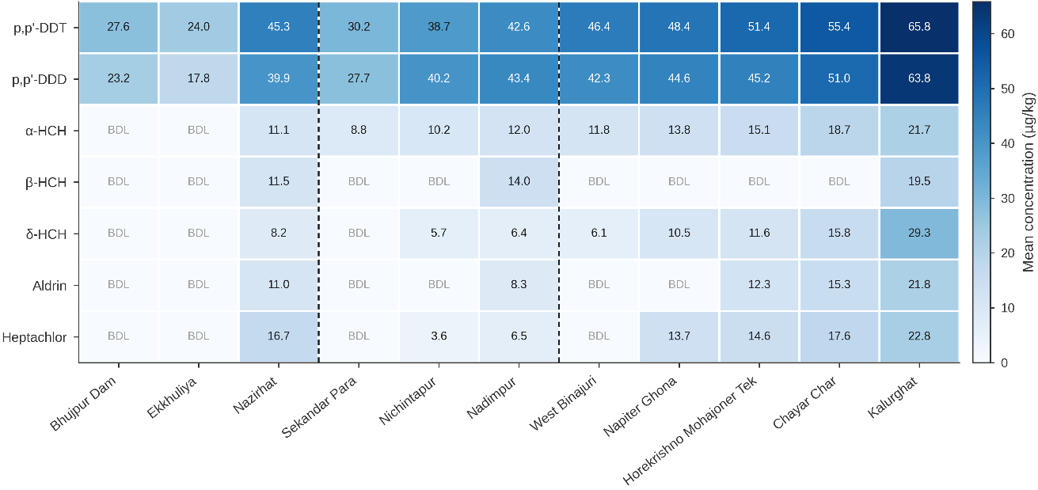
The compound-by-site heat map (Figure 47) shows that the spatial gradient is driven by all detected compounds simultaneously rather than by any single one: p,p'-DDT, p,p'-DDD, α-HCH, δ-HCH, aldrin and heptachlor all reach their maxima at Kalurghat (65.8, 63.8, 21.7, 29.3, 21.8 and 22.8 µg/kg, respectively), while β-HCH occurs only at Nazirhat, Nadimpur and Kalurghat. The two-way ANOVA using the seven detected compounds in place of the three class sums (zone × compound, N = 231) confirms significant down-stream enrichment: zone F(2,210) = 60.85, p < 0.001; compound F(6,210) = 175.22, p < 0.001; zone × compound interaction F(12,210) = 4.12, p < 0.001.
Figure 3.19: Heat map of mean OCP concentration (µg/kg, n = 3 per site) at each of the eleven sampling sites, arranged up-stream to down-stream

Figure 0.58: Mean ± SD total OCP concentration (ΣOCP, µg/kg) in sediment at the eleven sampling sites (a; bars coloured by zone, dashed lines separate the zones) and by zone (b; n = 9, 9 and 15 samples).Figure 0.59: Heat map of mean OCP concentration (µg/kg, n = 3 per site) at each of the eleven sampling sites, arranged up-stream to down-stream (dashed lines separate the zones; darker cells = higher concentration). BDL = below detection limit in all three samples at that site.

Figure 0.60: Mean ± SD total OCP concentration (ΣOCP, µg/kg) in sediment at the eleven sampling sites (a; bars coloured by zone, dashed lines separate the zones) and by zone (b; n = 9, 9 and 15 samples).

Figure 0.61:Compound-wise contribution to the adult Target Hazard Quotient (THQ) from sediment contact, by zone. Aldrin is the dominant contributor at every zone.Figure 0.62: Mean ± SD total OCP concentration (ΣOCP, µg/kg) in sediment at the eleven sampling sites (a; bars coloured by zone, dashed lines separate the zones) and by zone (b; n = 9, 9 and 15 samples).Figure 0.63: Heat map of mean OCP concentration (µg/kg, n = 3 per site) at each of the eleven sampling sites, arranged up-stream to down-stream (dashed lines separate the zones; darker cells = higher concentration). BDL = below detection limit in all three samples at that site.

Figure 0.64: Mean ± SD total OCP concentration (ΣOCP, µg/kg) in sediment at the eleven sampling sites (a; bars coloured by zone, dashed lines separate the zones) and by zone (b; n = 9, 9 and 15 samples).Figure 0.65: Heat map of mean OCP concentration (µg/kg, n = 3 per site) at each of the eleven sampling sites, arranged up-stream to down-stream (dashed lines separate the zones; darker cells = higher concentration). BDL = below detection limit in all three samples at that site.

3.3.2 Human Health Risk from Direct Sediment Contact
Applying the exposure parameters of Table 8 to the mean OCP concentrations, the overall Hazard Index for combined incidental ingestion and dermal contact with Halda sediment was 8.14 × 10⁻⁴ for adults and 7.13 × 10⁻³ for children, three to four orders of magnitude below the safety threshold of 1 (Table 5.22, Figure 48). Even at the most contaminated site, Kalurghat, HI reached only 2.25 × 10⁻³ (adult) and 1.96 × 10⁻² (child). As in the fish pathway, children carried a consistently higher hazard than adults (≈ 8.8-fold), reflecting their higher sediment ingestion rate, higher soil-to-skin adherence and lower body weight, and HI followed the spatial gradient of contamination, rising ≈ 2.4-fold from the up-stream to the down-stream zone. Incidental ingestion contributed ≈ 79 % of the HI and dermal absorption the remaining ≈ 21 %.
The incremental lifetime cancer risk from sediment contact was likewise very low: 4.46 × 10⁻⁷ for adults and 3.33 × 10⁻⁷ for children overall, and below the 10⁻⁶ lower bound of the USEPA acceptable range at every zone and at ten of the eleven sites; only at Kalurghat did adult CR (1.25 × 10⁻⁶) marginally enter the 10⁻⁶–10⁻⁴ "acceptable" range. Direct contact with sediment therefore does not, at present contamination levels, constitute a meaningful non-carcinogenic or carcinogenic health hazard to river users, in sharp contrast to the fish-consumption pathway, for which adult CR exceeded 10⁻⁴ in the mid- and down-stream zones (fish chapter). The comparison highlights that the human-health significance of the sediment OCP burden lies not in direct contact but in its role as the source from which residues are remobilised and bioaccumulated through the aquatic food chain.
Table 3.13: Hazard Index (HI, ingestion + dermal) and incremental lifetime Cancer Risk (CR) from sediment contact by site, zone and overall, for adult and child receptors.
Site / zone | Receptor | HI ingestion | HI dermal | HI total (ΣTHQ) | Cancer Risk (CR)
Bhujpur Dam | Adult | 1.39 × 10⁻⁴ | 1.67 × 10⁻⁵ | 1.56 × 10⁻⁴ | 2.65 × 10⁻⁸
 | Child | 1.30 × 10⁻³ | 1.09 × 10⁻⁴ | 1.41 × 10⁻³ | 2.05 × 10⁻⁸
Ekkhuliya | Adult | 1.14 × 10⁻⁴ | 1.37 × 10⁻⁵ | 1.28 × 10⁻⁴ | 2.18 × 10⁻⁸
 | Child | 1.07 × 10⁻³ | 8.96 × 10⁻⁵ | 1.16 × 10⁻³ | 1.69 × 10⁻⁸
Nazirhat | Adult | 9.23 × 10⁻⁴ | 2.70 × 10⁻⁴ | 1.19 × 10⁻³ | 6.92 × 10⁻⁷
 | Child | 8.62 × 10⁻³ | 1.77 × 10⁻³ | 1.04 × 10⁻² | 5.13 × 10⁻⁷
Sekandar Para | Adult | 1.99 × 10⁻⁴ | 2.54 × 10⁻⁵ | 2.24 × 10⁻⁴ | 1.18 × 10⁻⁷
 | Child | 1.85 × 10⁻³ | 1.66 × 10⁻⁴ | 2.02 × 10⁻³ | 9.07 × 10⁻⁸
Nichintapur | Adult | 2.98 × 10⁻⁴ | 4.13 × 10⁻⁵ | 3.40 × 10⁻⁴ | 1.74 × 10⁻⁷
 | Child | 2.78 × 10⁻³ | 2.71 × 10⁻⁴ | 3.06 × 10⁻³ | 1.33 × 10⁻⁷
Nadimpur | Adult | 7.82 × 10⁻⁴ | 2.11 × 10⁻⁴ | 9.92 × 10⁻⁴ | 5.32 × 10⁻⁷
 | Child | 7.30 × 10⁻³ | 1.38 × 10⁻³ | 8.68 × 10⁻³ | 3.97 × 10⁻⁷
West Binajuri | Adult | 3.25 × 10⁻⁴ | 4.22 × 10⁻⁵ | 3.67 × 10⁻⁴ | 1.64 × 10⁻⁷
 | Child | 3.03 × 10⁻³ | 2.76 × 10⁻⁴ | 3.31 × 10⁻³ | 1.26 × 10⁻⁷
Napiter Ghona | Adult | 4.03 × 10⁻⁴ | 6.32 × 10⁻⁵ | 4.67 × 10⁻⁴ | 3.05 × 10⁻⁷
 | Child | 3.77 × 10⁻³ | 4.14 × 10⁻⁴ | 4.18 × 10⁻³ | 2.30 × 10⁻⁷
Horekrishno Mohajoner Tek | Adult | 9.89 × 10⁻⁴ | 2.91 × 10⁻⁴ | 1.28 × 10⁻³ | 7.29 × 10⁻⁷
 | Child | 9.23 × 10⁻³ | 1.91 × 10⁻³ | 1.11 × 10⁻² | 5.41 × 10⁻⁷
Chayar Char | Adult | 1.20 × 10⁻³ | 3.58 × 10⁻⁴ | 1.55 × 10⁻³ | 8.93 × 10⁻⁷
 | Child | 1.12 × 10⁻² | 2.35 × 10⁻³ | 1.35 × 10⁻² | 6.63 × 10⁻⁷
Kalurghat | Adult | 1.74 × 10⁻³ | 5.16 × 10⁻⁴ | 2.25 × 10⁻³ | 1.25 × 10⁻⁶
 | Child | 1.62 × 10⁻² | 3.38 × 10⁻³ | 1.96 × 10⁻² | 9.26 × 10⁻⁷
Up-stream | Adult | 3.92 × 10⁻⁴ | 10.00 × 10⁻⁵ | 4.92 × 10⁻⁴ | 2.47 × 10⁻⁷
 | Child | 3.66 × 10⁻³ | 6.55 × 10⁻⁴ | 4.32 × 10⁻³ | 1.84 × 10⁻⁷
Mid-stream | Adult | 4.26 × 10⁻⁴ | 9.25 × 10⁻⁵ | 5.19 × 10⁻⁴ | 2.75 × 10⁻⁷
 | Child | 3.98 × 10⁻³ | 6.06 × 10⁻⁴ | 4.58 × 10⁻³ | 2.07 × 10⁻⁷
Down-stream | Adult | 9.30 × 10⁻⁴ | 2.54 × 10⁻⁴ | 1.18 × 10⁻³ | 6.68 × 10⁻⁷
 | Child | 8.68 × 10⁻³ | 1.67 × 10⁻³ | 1.03 × 10⁻² | 4.97 × 10⁻⁷
Overall | Adult | 6.46 × 10⁻⁴ | 1.68 × 10⁻⁴ | 8.14 × 10⁻⁴ | 4.46 × 10⁻⁷
 | Child | 6.03 × 10⁻³ | 1.10 × 10⁻³ | 7.13 × 10⁻³ | 3.33 × 10⁻⁷
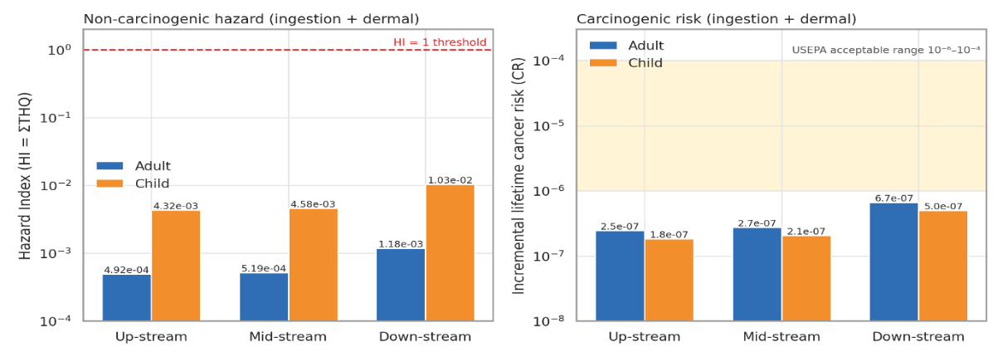
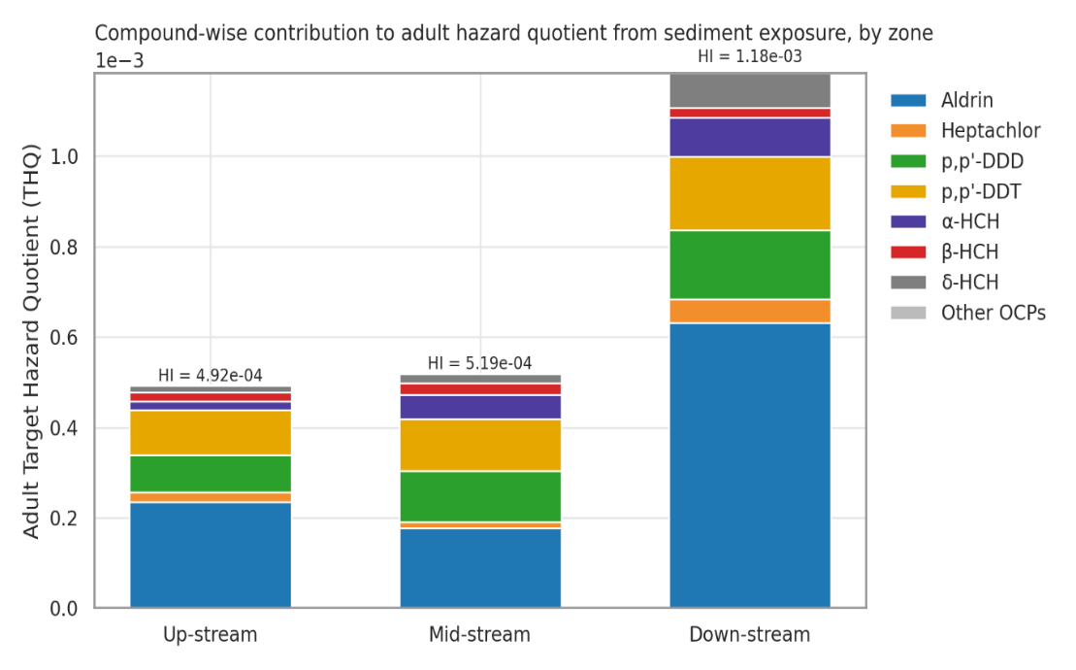
Compound-wise decomposition of the adult THQ (Figure 49) shows that, exactly as in the fish pathway, aldrin dominated the non-carcinogenic hazard (≈ 49 % of the overall adult HI) despite being only the sixth most abundant residue, because of its very low oral reference dose (3 × 10⁻⁵ mg/kg-day). p,p'-DDT and p,p'-DDD contributed the next largest shares (THQ ≈ 1.3 × 10⁻⁴ each), followed by the HCH isomers and heptachlor. Aldrin (≈ 46 %) and α-HCH (≈ 25 %) together accounted for most of the cancer risk, owing to their high cancer slope factors (17 and 6.3 (mg/kg-day)⁻¹). Although absolute risks are negligible for the sediment-contact pathway, the consistent identification of aldrin as the principal risk driver across the fish, the water and the sediment compartments reinforces the recommendation of the fish chapter that aldrin together with DDT should be prioritised in source tracking and mitigation.
Figure 3.20: Non-carcinogenic Hazard Index (left) and incremental lifetime Cancer Risk (right) from combined incidental ingestion and dermal contact with sediment, for adult and child receptors by zone (logarithmic axes)
Figure 3.21: Compound-wise contribution to the adult Target Hazard Quotient (THQ) from sediment contact, by zone. Aldrin is the dominant contributor at every zone

3.3.3 Ecological Risk of OCPs in Sediment
Comparison with sediment quality guidelines (Table 10) shows that the ecological risk in the Halda River is dominated by the two DDT-group compounds. The overall mean p,p'-DDT concentration (43.26 µg/kg) exceeded its TEL (1.19 µg/kg) by 36-fold and its PEL (4.77 µg/kg) by 9.1-fold; p,p'-DDD (39.91 µg/kg) exceeded its TEL and PEL by 11- and 4.7-fold. Critically, every one of the 33 samples including those from the least contaminated up-stream sites exceeded the PEL for both compounds (exceedance frequency 100 %), placing the entire river in the "frequently adverse effects" category for DDT and DDD. ΣDDT (83.2 µg/kg) likewise exceeded the consensus TEC (5.28 µg/kg) 16-fold, though it remained well below the very high consensus PEC (572 µg/kg). α-HCH, δ-HCH and aldrin fell between their threshold- and probable-effect values (RQ = 1.9, 2.8 and 3.1, respectively; "occasionally adverse"), with TEL exceedance in 82 %, 73 % and 42 % of samples, while β-HCH posed medium risk (RQ = 0.82). Heptachlor, screened against the heptachlor-epoxide guideline as a surrogate, exceeded the surrogate PEL in 55 % of samples (RQ = 14.5); this result is indicative only, but heptachlor is at least as toxic to aquatic invertebrates as its epoxide, so a high-risk classification is not unreasonable.

Table 3.14: Ecological risk quotients (RQ = C/TEL; RQ-PEL = C/PEL), risk class and guideline tier for each detected compound, by zone and overall.
Compound | RQ Up | RQ Mid | RQ Down | RQ Overall | RQ-PEL Overall | % samples > TEL / > PEL | Risk class | Guideline tier (overall)
p,p'-DDT | 27.14 | 31.22 | 44.96 | 36.35 | 9.07 | 100 / 100 | High | Frequently adverse (> PEL)
p,p'-DDD | 7.61 | 10.48 | 13.95 | 11.27 | 4.69 | 100 / 100 | High | Frequently adverse (> PEL)
α-HCH | 0.62 | 1.72 | 2.71 | 1.87 | 0.11 | 82 / 0 | High | Occasionally adverse (TEL–PEL)
β-HCH | 0.77 | 0.93 | 0.78 | 0.82 | 0.02 | 27 / 0 | Medium | Rarely adverse (< TEL)
δ-HCH† | 0.91 | 1.34 | 4.88 | 2.83 | 0.07 | 73 / 0 | High | Occasionally adverse (TEL–PEL)
Aldrin | 1.84 | 1.39 | 4.94 | 3.13 | 0.08 | 42 / 0 | High | Occasionally adverse (TEL–PEL)
Heptachlor | 9.29 | 5.60 | 22.91 | 14.48 | 3.17 | 55 / 55 | High | Frequently adverse (> PEL)
ΣDDT | 11.22 | 14.06 | 19.49 | 15.75 | 0.15 | — | High | Occasionally adverse (TEL–PEL)
ΣHCH | 3.42 | 6.33 | 11.60 | 7.93 | 0.20 | — | High | Occasionally adverse (TEL–PEL)
Risk class after Hernando et al. (2006): Low (RQ < 0.1), Medium (0.1 ≤ RQ < 1), High (RQ ≥ 1).

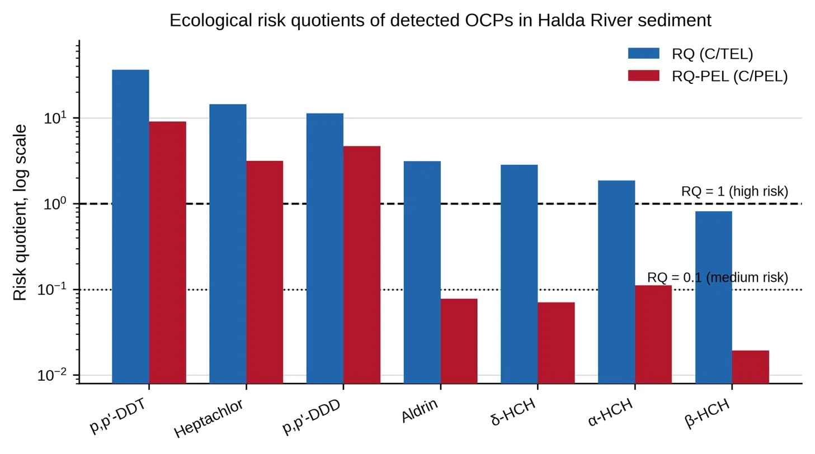
Figure 3.22: Ecological risk quotients of the seven detected OCPs based on river-wide mean and maximum concentrations (log scale)
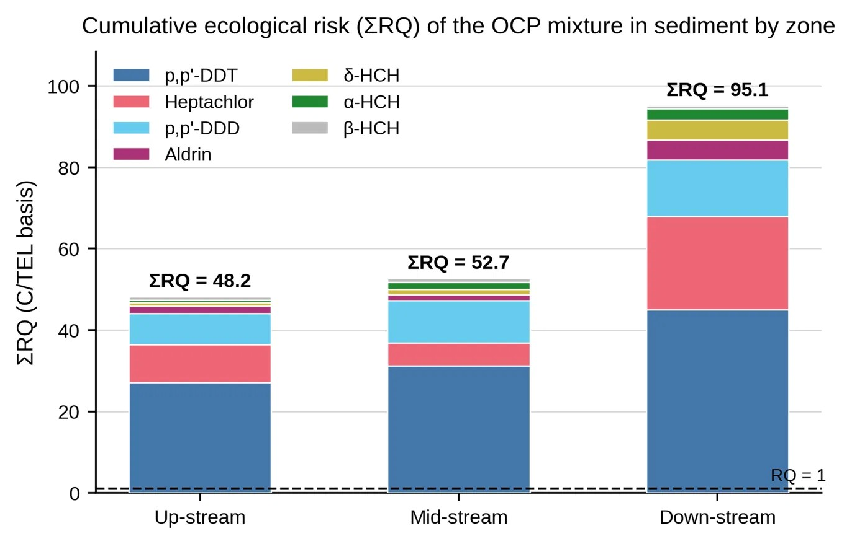
The total RQ in zones (Figure 50) shows that the high-risk classification for p,p'-DDT and p,p'-DDD applies to all eleven sites (RQ = 20–55 and 5–18, respectively), whereas the HCH and cyclodiene risk is confined to Nazirhat and the mid- and down-stream sites. The number of compounds exceeding their TEL rose from 4 in the up-stream zone to 6 in the down-stream zone, and the summed RQ (ΣRQ, a simple index of cumulative mixture pressure) doubled from 48.2 to 95.1.
Figure 3.23: Cumulative ecological risk (ΣRQ, mean-concentration basis) of the OCP mixture by zone, decomposed by compound
The mean PEL-quotient integrates these individual exceedances into a single probabilistic index (Table 24, Figure 51). mPEL-Q averaged 1.23 over the whole river (0.47–2.21 for individual samples) and increased from 0.86 up-stream to 0.97 mid-stream and 1.60 down-stream. Site values ranged from 0.51 (Ekkhuliya) to 2.18 (Kalurghat). Against the empirical calibration of Long et al. (1998), 70 % of the samples (all samples from Bhujpur Dam, Ekkhuliya, the three mid-stream sites and West Binajuri, and most of those from Nazirhat, Napiter Ghona and Horekrishno Mohajoner Tek) fall in the 0.11–1.5 band, corresponding to an approximately 21 % probability of acute toxicity to sensitive benthic organisms, and 30 % of the samples (all samples from Chayar Char and Kalurghat, two of three from Horekrishno Mohajoner Tek and one each from Nazirhat and Napiter Ghona) fall in the 1.51–2.3 band, corresponding to an approximately 49 % probability of toxicity. No sample exceeded 2.3, but Kalurghat (mPEL-Q = 2.18) is close to that upper boundary. When the surrogate-screened compounds are excluded from the average, mPEL-Q is higher still (1.55 overall; 1.92 down-stream), because the excluded compounds are mostly non-detects that dilute the mean; the conclusion is therefore robust to the choice of guideline set. Considering additionally that the guidelines are dry-weight based while the data are wet-weight, the true level of exceedance is, if anything, greater than reported here. Taken together, the sediment of the lower Halda, the principal spawning ground of the Indian major carps and a designated Ecologically Critical Area, presents a moderate-to-high ecological risk to benthic biota, arising overwhelmingly from DDT and DDD.
Table 3.15: Mean PEL-quotient (mPEL-Q), number of compounds exceeding TEL and PEL, and the corresponding empirical probability of sediment toxicity each site and zone.
Site / zone | ΣOCP (µg/kg) | mPEL-Q (all 14) | mPEL-Q (excl. surrogates) | No. > TEL | No. > PEL | ΣRQ (C/TEL) | mPEL-Q band (toxicity probability)
Bhujpur Dam | 50.8 | 0.61 | 0.95 | 2 | 2 | 29.7 | 0.11–1.5 (≈ 21 %)
Ekkhuliya | 41.7 | 0.51 | 0.79 | 2 | 2 | 25.2 | 0.11–1.5 (≈ 21 %)
Nazirhat | 143.7 | 1.48 | 1.61 | 7 | 3 | 89.6 | 0.11–1.5 (≈ 21 %)
Sekandar Para | 66.7 | 0.69 | 1.08 | 3 | 2 | 34.7 | 0.11–1.5 (≈ 21 %)
Nichintapur | 98.3 | 1.02 | 1.44 | 5 | 3 | 53.4 | 0.11–1.5 (≈ 21 %)
Nadimpur | 133.1 | 1.20 | 1.59 | 7 | 3 | 70.0 | 0.11–1.5 (≈ 21 %)
West Binajuri | 106.7 | 1.06 | 1.65 | 4 | 2 | 55.0 | 0.11–1.5 (≈ 21 %)
Napiter Ghona | 131.0 | 1.47 | 1.73 | 5 | 3 | 81.9 | 0.11–1.5 (≈ 21 %)
Horekrishno Mohajoner Tek | 150.3 | 1.56 | 1.82 | 6 | 3 | 92.9 | 1.51–2.3 (≈ 49 %)
Chayar Char | 173.8 | 1.75 | 2.00 | 6 | 3 | 106.3 | 1.51–2.3 (≈ 49 %)
Kalurghat | 244.9 | 2.18 | 2.43 | 7 | 3 | 139.6 | 1.51–2.3 (≈ 49 %)
Up-stream | 78.7 | 0.86 | 1.12 | 4 | 3 | 48.2 | 0.11–1.5 (≈ 21 %)
Mid-stream | 99.4 | 0.97 | 1.37 | 6 | 3 | 52.7 | 0.11–1.5 (≈ 21 %)
Down-stream | 161.3 | 1.60 | 1.92 | 6 | 3 | 95.1 | 1.51–2.3 (≈ 49 %)
Overall | 121.9 | 1.23 | 1.55 | 6 | 3 | 70.7 | 0.11–1.5 (≈ 21 %)

Chapter-4: Discussion

4.1 Overview
This study characterised the occurrence, spatial distribution, and ecological and human-health risk of fourteen organochlorine pesticide (OCP) congeners in water, surface sediment, and fish muscle from the Halda River, addressing the aim stated in Section 1.12. The results (Chapter Three) show that legacy OCPs dominated by the DDT group (p,p'-DDT, p,p'-DDD) with additional contributions from HCH isomers and cyclodiene compounds remain measurable in all three compartments more than four decades after these compounds were formally restricted in Bangladesh. This chapter interprets these findings against the six study objectives, compares them with the regional literature, and considers their mechanistic, ecological, and public-health significance.

4.2 Congener Profile and Implied Contamination History
Only seven of the fourteen target congeners (p,p'-DDT, p,p'-DDD, α-, β- and δ-HCH, aldrin and heptachlor) were quantifiable; the remaining seven, including both DDT metabolites (p,p'-DDE, o,p'-DDE), lindane (γ-HCH) and dieldrin, were below detection in all 93 samples across all three matrices. This consistent, matrix-independent non-detection pattern is informative rather than incidental. In particular, the near-total absence of p,p'-DDE , normally the dominant aerobic degradation product of DDT and commonly used as a chronological marker of "aged" contamination (Jayaraj et al., 2016); alongside readily detectable parent p,p'-DDT and its reductive metabolite p,p'-DDD, points to a predominantly anaerobic degradation regime, consistent with the fine-grained, organically enriched, frequently anoxic sediments typical of the Halda channel, and/or a degree of ongoing low-level input rather than a purely historical residue. The same reasoning applies to the detection of aldrin without its aerobic oxidation product dieldrin. Together, the congener pattern indicates a mixed contamination signature: a diffuse, basin-wide legacy of technical DDT and HCH, most plausibly linked to historical agricultural use in the catchment, superimposed on a more spatially restricted, comparatively recent input of aldrin/heptachlor-type termiticide formulations at specific locations. This satisfies Objective 1 (Section 1.12).

4.3 Inter-Compartmental Partitioning
A central finding, addressing Objective 2, is the divergent class composition of ΣOCP across compartments (Table 4.1). DDT-group compounds dominated sediment (68.2%) and water (58.6%), whereas the three classes contributed almost equally in fish muscle (31.6–35.5%). This is consistent with the differing hydrophobicity of the two classes: DDT-group log K_ow (≈ 6.0–6.9) is roughly three orders of magnitude higher than that of the HCH isomers (≈ 3.7–3.9), favouring strong DDT sorption to sediment organic carbon and to the dissolved-organic-matter–bound fraction in water, but not proportionally greater bioavailability for uptake across the gill and gut epithelium. In fish tissue, where bioaccumulation reflects the balance of uptake, metabolism and elimination rather than ambient abundance alone, the more bioavailable HCH and cyclodiene compounds therefore achieve a share of body burden disproportionate to their environmental concentration. The same logic explains why aldrin, a minor fraction of ΣOCP by mass in every compartment was nevertheless the leading driver of calculated toxicological risk throughout (Section 4.5), owing to its very low reference dose rather than its abundance, a pattern widely reported in OCP risk-assessment literature (Chowdhury et al., 2018; Hasan, 2021).
Table 4.1: Relative contribution (%) of OCP compound classes to ΣOCP in the three environmental compartments of the Halda River.
Compound class | Water (%) | Sediment (%) | Fish muscle (%)
DDT group | 58.6 | 68.2 | 31.6
HCH isomers | 27.3 | 19.5 | 35.5
Cyclodienes | 14.1 | 12.3 | 32.8

Sediment ΣOCP (121.90 ± 57.20 µg/kg) exceeded the fish burden by ~5.2-fold and the water burden by ~1.9-fold, confirming bed sediment as the principal long-term OCP reservoir in the Halda system. Because sediment can act as a secondary diffuse source through resuspension and porewater diffusion long after primary loading has declined (Bayen et al., 2019), the reservoir characterised here is expected to continue releasing OCPs to the water column and food web for an extended period even in the absence of further input, a consideration directly relevant to the management recommendations in Chapter Five.

4.4 Spatial Gradient and Anthropogenic Pressure
A statistically robust upstream-to-downstream enrichment gradient was observed in all three compartments (Objective 5): ~2.7-fold in fish, ~1.8-fold in water, and ~2.0-fold in sediment on a zone-mean basis, with a 4.3-fold range at the individual-site level. Two-way ANOVA confirmed river zone as a highly significant source of variance in every compartment (fish: F(2,18) = 175.1; water: F(2,90) = 27.85; sediment: F(2,90) = 30.51; all p < 0.001), with a significant zone × compound-class (or zone × species) interaction in each case, indicating non-uniform enrichment: the HCH and cyclodiene classes increased proportionally more steeply downstream (2- to 3.4-fold) than the already-dominant DDT group (1.4- to 1.7-fold). This pattern is consistent with the land-use gradient of the catchment, a rural, hill-tract agricultural upstream reach giving way to the urban–industrial fringe of Chattogram near the Halda–Karnaphuli confluence downstream and with cumulative contaminant loading along the flow path, a pattern well documented in comparable tropical river systems under mixed agricultural and urban pressure (Bhuyan & Bakar, 2017; Hossain et al., 2021; Islam et al., 2022). Tidal resuspension of contaminated bed sediment in the lower, tidally influenced reach offers a plausible mechanistic link between the closely corresponding water and sediment gradients.
The Nazirhat site is a notable exception to the smooth gradient, carrying a ΣOCP burden 3- to 3.5-fold higher than the other two upstream sites and the only upstream location at which HCH isomers, aldrin and heptachlor were all detected. As a recognised market and agricultural trading centre, Nazirhat most plausibly represents a localised, point-source-like input from concentrated pesticide handling and adjacent intensive cultivation, rather than evidence against the broader diffuse-loading model. This identifies Nazirhat, together with the lower reach from Horekrishno Mohajoner Tek to Kalurghat, as a priority location for source investigation and monitoring (Objective 6).

4.5 Ecological versus Human-Health Risk
The ecological and human-health risk assessments produced markedly different pictures from the same concentration data (Table 4.2), addressing Objectives 3 and 4. Deterministic human-health hazard indices remained below the threshold of concern (HI = 1) for all three exposure pathways under mean-concentration exposure assumptions, and adult fish-consumption cancer risk exceeded the USEPA upper-bound acceptable value of 10⁻⁴ only in the mid- and downstream zones. In contrast, the ecological risk quotients (RQ = MEC/PNEC) for p,p'-DDT and p,p'-DDD in water exceeded the high-risk threshold (RQ ≥ 1) by more than an order of magnitude at every one of the eleven sites, with cumulative mixture risk (ΣRQ) ranging from 24.1 to 59.4 — indicating that the OCP mixture exceeds the no-effect level for sensitive aquatic organisms by a factor of roughly 25–60 throughout the river. In sediment, p,p'-DDT and p,p'-DDD exceeded the probable-effect level (PEL) in 100% of samples, and the mean PEL-quotient (mPEL-Q = 1.23 river-wide, rising to 1.56–1.75 downstream) corresponds to an empirically calibrated probability of acute sediment toxicity of ~21% river-wide and ~49% in the lower reach (Long et al., 1998).
Table 4.1: Summary comparison of ecological and human-health risk indicators for OCPs in the Halda River (river-wide mean values).
Risk indicator | Water | Sediment | Fish (consumption)
Ecological RQ / mPEL-Q (high-risk threshold) | ΣRQ 40.2  (threshold = 1) | mPEL-Q 1.23 (threshold ≈ 1) | —
Human-health HI, adult (threshold = 1) | 0.016 | 8.14 × 10⁻⁴ | 0.175
Human-health HI, child (threshold = 1) | 0.044 | 7.13 × 10⁻³ | 0.409
Cancer risk range, adult (USEPA acceptable 10⁻⁶–10⁻⁴) | 7.6 × 10⁻⁷–1.63 × 10⁻⁵ | 2.2 × 10⁻⁸–1.25 × 10⁻⁶ | 4.1 × 10⁻⁵–1.89 × 10⁻⁴
Principal risk driver | DDT group (92% ΣRQ) | DDT group | Aldrin (~69% of HI)

This divergence reflects the different toxicological bases of the two frameworks: human-health reference doses incorporate conservative safety margins calibrated to protect human receptors from dietary and incidental exposure, whereas the aquatic PNEC and sediment-quality values reflect chronic toxicity in far more sensitive taxa, including early fish life stages, under continuous, direct ambient exposure. The practical implication is significant given the Halda's unique status as the only natural riverine spawning ground for Indian major carp species in Bangladesh (M. A. Islam et al., 2020; Karim et al., 2026): fish embryos and larvae are amongst the most DDT- and cyclodiene-sensitive aquatic organisms known, susceptible to reduced hatching success, larval deformity and impaired growth at sub-lethal concentrations. The sustained, order-of-magnitude exceedance of protective aquatic thresholds documented here — occurring in the reach and season of peak spawning activity — represents a plausible, though not directly measured, threat to reproductive success in this ecologically and economically important fishery. Overall, current OCP contamination in the Halda does not present an acute threat to the general human population under typical exposure, but already constitutes a pervasive threat to the aquatic ecosystem the river is specifically valued for protecting; a management response calibrated only to human-health thresholds would substantially underestimate the urgency of intervention required.
Across all three human-health pathways, aldrin consistently emerged as the leading contributor to calculated hazard (~69% of adult HI for fish, ~44% for water, ~49% for sediment) despite representing only a minor fraction of ΣOCP mass, owing to its very low oral reference dose (3 × 10⁻⁵ mg/kg-day) and high cancer slope factor (17 (mg/kg-day)⁻¹). This cross-matrix consistency identifies aldrin, together with the ubiquitous DDT-group compounds, as the priority target compounds for future source-tracking and mitigation.

4.6 Comparison with Previous Studies
Prior environmental research on the Halda River has focused predominantly on heavy metals and general water quality, with limited OCP-specific evidence available for direct comparison (Dey et al., 2021; Hossain et al., 2021; Kamal et al., 2024b). Nonetheless, the DDT-dominated legacy signature, pronounced sediment reservoir, and downstream enrichment gradient reported here are broadly consistent with the heavy-metal contamination gradient previously documented for the same river (Hossain et al., 2021; Islam et al., 2020), suggesting a common set of catchment pressures; agricultural intensification, urbanisation, and inadequately managed runoff, driving the co-occurrence of multiple contaminant classes. This strengthens the case, first raised in the research gap (Section 1.11), for integrated multi-contaminant monitoring of the Halda system. Regionally, the magnitude of DDT-group contamination reported here is comparable to, and in some cases higher than, levels reported for other actively used or historically pesticide-impacted South and Southeast Asian rivers (Chowdhury et al., 2018; Chowdhury et al., 2024; Kuranchie-Mensah et al., 2012), consistent with legacy organochlorine contamination remaining a regionally widespread concern despite long-standing regulatory restriction. The recurring dominance of aldrin in risk despite its low environmental abundance also mirrors observations from other tropical freshwater systems (Griboff et al., 2018; Miličić et al., 2026), lending external support to the risk-assessment conclusions of this thesis.

4.7 Limitations
Several methodological considerations, foreshadowed in Section 1.15, bear on interpretation of these results. The Florisil clean-up trial (Section 2.8) produced substantial, apparently irreversible loss of target-analyte signal and was therefore not retained; the resulting filtration-only extraction procedure, while empirically justified, means that some matrix interference in the more complex fish and sediment extracts cannot be entirely excluded. The human-health risk assessment relies on standard default exposure parameters rather than Bangladesh- or Halda-community-specific consumption and contact data, so the risk estimates in Section 4.5 should be regarded as screening-level indicators of relative priority rather than precise measures of realised health outcomes. Similarly, the ecological risk quotients draw on generic PNEC and sediment-quality guidelines derived largely from temperate-system toxicity data, as species-specific sensitivity data for Indian major carps are not available. Finally, the single cross-sectional sampling campaign captures spatial variation robustly but cannot resolve seasonal (e.g., monsoon-driven) variability or temporal trends; repeated, seasonally resolved monitoring, as recommended in Chapter Five, is needed to confirm the temporal stability of the patterns reported here.

4.8 Synthesis
The Halda River retains a measurable, spatially structured legacy of OCP contamination, dominated by DDT-group residues with additional HCH and cyclodienes inputs at specific locations, with bed sediment as the principal long-term reservoir from which contamination is transferred to water and, via bioaccumulation, to fish. The spatial gradient rising from the rural upstream reach to the urban-influenced downstream reach and punctuated by a distinct hotspot at Nazirhat, reflects a combination of diffuse catchment-wide legacy loading and more concentrated, potentially ongoing, local inputs. Although human-health risk under current exposure levels remains within conventionally acceptable bounds on a river-wide average basis, ecological risk to aquatic biota, particularly the sensitive early life stages of the Indian major carp populations that make the Halda uniquely important, is substantial and pervasive throughout the study reach. These findings fulfil the aim and objectives set out in Section 1.12 and provide the evidentiary basis for the conclusions and recommendations developed in Chapter Five.

Chapter-5: Conclusions and Recommendations

5.1 Conclusions
This study provides an integrated assessment of selected OCP residues in water, surface sediment and fish from the Halda River and demonstrates that legacy organochlorine contamination remains detectable across the river system. The results indicate a pronounced spatial gradient, with contaminant burdens generally increasing from the upstream to the downstream reach and with localized enrichment at Nazirhat and the lower river, particularly near Kalurghat. This pattern is consistent with cumulative contaminant loading along the river and with the influence of urban, industrial and other anthropogenic pressures in the lower catchment; however, the present dataset does not by itself establish individual sources.
The water results showed that total OCP concentrations were significantly different among river zones, increasing from 43.95 ± 28.80 µg/L upstream to 79.73 ± 16.20 µg/L downstream. The DDT group represented the largest proportion of the water OCP burden. p,p′-DDT and p,p′-DDD were particularly important contributors to the measured contamination and also accounted for the dominant ecological-risk signal. The significant zone × compound-class interaction indicates that the magnitude of spatial enrichment differed among OCP classes rather than following a uniform pattern. Surface sediment contained substantially greater OCP burdens than the corresponding fish and water measurements reported in the thesis, supporting the interpretation that sediment constitutes an important environmental reservoir for hydrophobic OCPs. Mean sediment ΣOCP increased from 78.72 ± 48.92 µg/kg upstream to 161.32 ± 49.32 µg/kg downstream. p,p′-DDT and p,p′-DDD were detected throughout the sampled sediment dataset and together contributed approximately 68% of the total reported OCP burden. Sediment-quality comparisons further indicated frequent exceedance of guideline values for these DDT-related compounds, particularly in the lower river. OCP residues were also detected in the muscle tissue of Rui, Catla and Mrigal. Mean fish ΣOCP increased from 13.40 ± 10.26 µg/kg wet weight upstream to 36.53 ± 7.97 µg/kg wet weight downstream. Significant effects of both river zone and fish species indicate that contaminant accumulation was not spatially uniform and may also be associated with species-specific ecological characteristics. The comparatively high residue burden in the downstream zone is consistent with the greater environmental contamination observed in water and sediment in the same reach.
The ecological-risk assessment identified a more pronounced concern than the deterministic human-health screening results. In water, p,p′-DDT and p,p′-DDD produced high risk quotients at the river-wide level, while heptachlor and, at some locations, aldrin also contributed substantially to risk. Sediment assessments similarly indicated that DDT-related residues frequently exceeded sediment-quality guideline thresholds. These findings are particularly relevant to a river that supports natural spawning and early life stages of Indian major carps, although direct effects on spawning success, embryo survival or larval development were not measured in this study and therefore should not be inferred solely from the concentration data.
The human-health assessment showed that non-carcinogenic hazard indices remained below unity for fish consumption, direct exposure to river water and direct sediment contact under the exposure assumptions used in the thesis. Nevertheless, fish-consumption cancer-risk estimates increased along the river and exceeded the upper end of the screening range used in the thesis for some adult downstream exposure scenarios. These estimates should be interpreted as screening-level risk indicators rather than measurements of actual disease risk, because they depend on assumptions concerning consumption rate, body weight, exposure duration, contaminant bioavailability and toxicological reference values. Taken together, the results indicate that OCP contamination in the Halda River is characterized by persistent DDT-related residues, additional contributions from HCH and cyclodiene/heptachlor compounds at selected locations, a strong sediment-associated burden, transfer to fish, and a downstream increase in contamination. The study therefore establishes a useful baseline for future OCP surveillance and source-oriented investigations in the Halda River.

5.2 Recommendations
- Establish a long-term OCP monitoring programme covering water, surface sediment and edible fish tissue at the existing eleven stations, with particular attention to Nazirhat and the lower reach from Horekrishno Mohajoner Tek to Kalurghat.
- Repeat sampling across pre-monsoon, monsoon and post-monsoon periods to determine seasonal changes in OCP transport, sediment redistribution and fish bioaccumulation.
- Prioritize source-apportionment investigations for DDT-related residues and for localized aldrin, heptachlor and HCH detections. Land-use mapping, drainage surveys and targeted sampling of agricultural drains, markets, settlements and industrial/municipal outfalls would help distinguish diffuse from point-associated inputs.
- Strengthen surveillance of legacy pesticide storage, disposal sites and potentially contaminated soils in the Halda catchment, while maintaining enforcement of national restrictions on banned or restricted OCPs.
- Use sediment and fish monitoring together with water monitoring because the present results indicate that sediment acts as an important reservoir and fish provide evidence of transfer into biota.
- Develop a fish-consumption monitoring component for locally harvested species, especially in downstream communities. Where future measurements confirm elevated residues, risk communication should be based on measured concentrations and locally representative consumption patterns rather than on generalized assumptions.
- Protect spawning and nursery habitats from additional contaminant inputs, with particular attention to the lower river and other locations where ecological-risk indicators are elevated.
- Future ecological investigations should include toxicity-oriented endpoints, such as fish early-life-stage assays, biomarkers, histopathology and reproductive endpoints, to determine whether the concentration-based ecological concerns translate into measurable biological effects.

5.3 Limitations and Future Research

This study provides a spatially resolved assessment of selected organochlorine pesticides (OCPs) in the Halda River during a limited sampling period; therefore, seasonal and annual variations in pesticide occurrence could not be fully evaluated. The assessment was restricted to selected OCPs and sampling locations, and the deterministic risk estimates are subject to uncertainties associated with exposure assumptions and reference values. Ecological risk quotients indicate potential risk rather than direct evidence of biological effects. Any inconsistencies in reported analytes, units, and sample replication should also be resolved before final interpretation.
Future studies should implement multi-season and long-term monitoring and expand the analytical scope to include currently used pesticides and other emerging contaminants. Source-apportionment approaches integrating pesticide fingerprints with land-use, hydrological, and drainage information are recommended. Measurement of sediment organic carbon, grain size, fish lipid content, and trophic-position indicators would further improve understanding of contaminant partitioning, bioaccumulation, and trophic transfer in the Halda River ecosystem.

Chapter – 6: References
Aislabie, J. M., Richards, N. K., & Boul, H. L. (1997). Microbial degradation of DDT and its residues—A review. New Zealand Journal of Agricultural Research, 40(2), 269–282. https://doi.org/10.1080/00288233.1997.9513247
Akoto, O., Azuure, A. A., & Adotey, K. D. (2016). Pesticide residues in water, sediment and fish from Tono Reservoir and their health risk implications. SpringerPlus, 5(1), 1849. https://doi.org/10.1186/s40064-016-3544-z
Akter, A., & Ali, Md. H. (2012). Environmental flow requirements assessment in the Halda River, Bangladesh. Hydrological Sciences Journal, 57(2), 326–343. https://doi.org/10.1080/02626667.2011.644242
Akter, M., Hosen, Md. A., Tohura, U., & Islam, Md. M. (2026). Apportionment of Organochlorine Pesticides, Appraisal, and Health Implications in the Surface Water of Gazipur, Bangladesh. Journal of Chemistry, 2026(1), 3234529. https://doi.org/10.1155/joch/3234529
Alam, Md. K. (2013). Organochlorine Insecticide Residues are Found in Surface, Irrigated Water Samples from Several Districts in Bangladesh. Bulletin of Environmental Contamination and Toxicology, 90(2), 149–154. https://doi.org/10.1007/s00128-012-0897-z
Alam, Md., Masum, M., & Ruva, I. (2026). Tidal Influence on Physicochemical Characteristics and Heavy Metal Contamination in Feeder Canals of the Halda River, Bangladesh. International Journal For Multidisciplinary Research, 8(2), 75076. https://doi.org/10.36948/ijfmr.2026.v08i02.75076
Antu, Mst. A. R., Ahmed, Md. T., Rojoni, S. A., Shammi, S. S., Suraiya, S., Ali, M. S., & Haq, M. (2026). Exposure of Fish and Shellfish to Organochlorine Pesticides and Associated Consumer Health Risks. Environments, 13(3), 167. https://doi.org/10.3390/environments13030167
Bayen, S., Segovia Estrada, E., Zhang, H., Lee, W. K., Juhel, G., Smedes, F., & Kelly, B. C. (2019). Partitioning and Bioaccumulation of Legacy and Emerging Hydrophobic Organic Chemicals in Mangrove Ecosystems. Environmental Science & Technology, 53(5), 2549–2558. https://doi.org/10.1021/acs.est.8b06122
Bhuyan, M. S., Kibria, Md. M., & Begum, Mst. A. (2018). Livelihood status of egg collector and traditional knowledge of Carps Egg collection in the Halda River: A natural fish spawning heritage in Bangladesh (2018) SDRP Journal of Aquaculture. Fisheries & Fish Science, 2(2). https://www.academia.edu/download/108008497/A-natural-fish-spawning-heritage-in-Bangladesh20181218040134.pdf
Bhuyan, Md. S., & Bakar, M. A. (2017). Seasonal variation of heavy metals in water and sediments in the Halda River, Chittagong, Bangladesh. Environmental Science and Pollution Research, 24(35), 27587–27600. https://doi.org/10.1007/s11356-017-0204-y
Bidleman, T. F. (1988). Atmospheric processes. Environmental Science & Technology, 22(4), 361–367. https://doi.org/10.1021/es00169a002
Birungi, G., Byamugisha, D., Morrison, S., & Bolender, J. (2025). Occurrence and risk assessment of organochlorine pesticides in River Rwizi sediment in Western Uganda. Discover Environment, 3(1), 251. https://doi.org/10.1007/s44274-025-00465-7
Carolin, F., Kamalesh, T., Senthil Kumar, P., & Rangasamy, G. (2023). An insights of organochlorine pesticides categories, properties, eco-toxicity and new developments in bioremediation process. Environmental Pollution, 333, 122114. https://doi.org/10.1016/j.envpol.2023.122114
Chowdhury, F. R., Dewan, G., Verma, V. R., Knipe, D. W., Isha, I. T., Faiz, M. A., Gunnell, D. J., & Eddleston, M. (2018). Bans of WHO Class I Pesticides in Bangladesh—Suicide prevention without hampering agricultural output. International Journal of Epidemiology, 47(1), 175–184. https://doi.org/10.1093/ije/dyx157
Chowdhury, N. J., Akbor, Md. A., Nahar, A., & Ali Shaikh, Md. A. (2024). Techniques for quantification of organochlorine pesticides from a validated method by using gas chromatography-electron capture detector. Heliyon, 10(14), e34548. https://doi.org/10.1016/j.heliyon.2024.e34548
Coat, S., Monti, D., Legendre, P., Bouchon, C., Massat, F., & Lepoint, G. (2011). Organochlorine pollution in tropical rivers (Guadeloupe): Role of ecological factors in food web bioaccumulation. Environmental Pollution, 159(6), 1692–1701. https://doi.org/10.1016/j.envpol.2011.02.036
Dey, M., Akter, A., Islam, S., Chandra Dey, S., Choudhury, T. R., Fatema, K. J., & Begum, B. A. (2021). Assessment of contamination level, pollution risk and source apportionment of heavy metals in the Halda River water, Bangladesh. Heliyon, 7(12), e08625. https://doi.org/10.1016/j.heliyon.2021.e08625
Fenner, K., Canonica, S., Wackett, L. P., & Elsner, M. (2013). Evaluating Pesticide Degradation in the Environment: Blind Spots and Emerging Opportunities. Science, 341(6147), 752–758. https://doi.org/10.1126/science.1236281
Ga, T. (2016). Residues Analysis of Organochlorine Pesticides in Fish, Sediment and Water Samples from Tekeze Dam, Tigray, Ethiopia. Journal of Environmental & Analytical Toxicology, 06(01). https://doi.org/10.4172/2161-0525.1000342
Gardes, T., Portet-Koltalo, F., Debret, M., & Copard, Y. (2021). Historical and post-ban releases of organochlorine pesticides recorded in sediment deposits in an agricultural watershed, France. Environmental Pollution, 288, 117769. https://doi.org/10.1016/j.envpol.2021.117769
Griboff, J., Horacek, M., Wunderlin, D. A., & Monferran, M. V. (2018). Bioaccumulation and trophic transfer of metals, As and Se through a freshwater food web affected by antrophic pollution in Córdoba, Argentina. Ecotoxicology and Environmental Safety, 148, 275–284. https://doi.org/10.1016/j.ecoenv.2017.10.028
Haider, A., Islam, Md. M., & Shoeb, M. (2025). Spatio-environmental surveillance of organochlorine pesticides in the Meghna River by liquid–liquid extraction coupled with GC-ECD. Environmental Monitoring and Assessment, 198(1), 21. https://doi.org/10.1007/s10661-025-14878-7
Harner, T., Bidleman, T. F., Jantunen, L. M. M., & Mackay, D. (2001). Soil—Air exchange model of persistent pesticides in the United States cotton belt. Environmental Toxicology and Chemistry, 20(7), 1612–1621. https://doi.org/10.1002/etc.5620200728
Hasan, G. M. M. A. (2021). Human Health Risk Surveillance of Organochlorine Pesticides in River Water and Fishes from Bangladesh. Bioscience Biotechnology Research Communications, 14(4), 1777–1785. https://doi.org/10.21786/bbrc/14.4.59
Henderson, C., Pickering, Q. H., & Tarzwell, C. M. (1959). Relative Toxicity of Ten Chlorinated Hydrocarbon Insecticides to Four Species of Fish. Transactions of the American Fisheries Society, 88(1), 23–32. https://doi.org/10.1577/1548-8659(1959)88%5B23:RTOTCH%5D2.0.CO;2
Hoque, S. F., Peters, R., Whitehead, P., Hope, R., & Hossain, M. A. (2021). River pollution and social inequalities in Dhaka, Bangladesh. Environmental Research Communications, 3(9), 095003. https://doi.org/10.1088/2515-7620/ac2458
Hossain, M. B., Semme, S. A., Ahmed, A. S. S., Hossain, Md. K., Porag, G. S., Parvin, A., Shanta, T. B., Senapathi, V., & Sekar, S. (2021). Contamination levels and ecological risk of heavy metals in sediments from the tidal river Halda, Bangladesh. Arabian Journal of Geosciences, 14(3), 158. https://doi.org/10.1007/s12517-021-06477-w
Hussein, M. A., Hammad, O. S., Tharwat, A. E., Darwish, W. S., Sayed-Ahmed, A., Zigo, F., Farkašová, Z., & Rehan, I. F. (2022). Health risk assessment of organochlorine pesticide residues in edible tissue of seafood. Frontiers in Veterinary Science, 9, 1042956. https://doi.org/10.3389/fvets.2022.1042956
Islam, M. A., Das, B., Quraishi, S. B., Khan, R., Naher, K., Hossain, S. M., Karmaker, S., Latif, S. A., & Hossen, M. B. (2020). Heavy metal contamination and ecological risk assessment in water and sediments of the Halda river, Bangladesh: A natural fish breeding ground. Marine Pollution Bulletin, 160, 111649. https://doi.org/10.1016/j.marpolbul.2020.111649
Islam, M. S., Nakagawa, K., Abdullah-Al-Mamun, M., Siddique, Md. A. B., & Berndtsson, R. (2023). Toxicity and source identification of pollutants in an urban river in Bangladesh. Environmental Earth Sciences, 82(6), 140. https://doi.org/10.1007/s12665-023-10812-7
Islam, Md. M., Avha, N. J., Ahmed, S., Akbor, Md. A., Islam, Md. S., Mostafiz, F., & Habibullah-Al-Mamun, Md. (2022). Trace metals and organochlorine pesticide residues in imported fishes in Bangladesh and human health risk implications. Environmental Science and Pollution Research, 29(12), 17499–17512. https://doi.org/10.1007/s11356-021-17074-5
Islam, Md. M., Shoeb, M., & Mamun, Md. I. R. (2026). Spatiotemporal Distribution, Risk, and Source Identification of Organochlorine Pesticides in the Surface Water of Shitalakshya River, Bangladesh. Journal of Toxicology, 2026(1), 9611223. https://doi.org/10.1155/jt/9611223
Jayaraj, R., Megha, P., & Sreedev, P. (2016). Review Article. Organochlorine pesticides, their toxic effects on living organisms and their fate in the environment. Interdisciplinary Toxicology, 9(3–4), 90–100. https://doi.org/10.1515/intox-2016-0012
Jorgenson, J. L. (2001). Aldrin and dieldrin: A review of research on their production, environmental deposition and fate, bioaccumulation, toxicology, and epidemiology in the United States. Environmental Health Perspectives, 109(suppl 1), 113–139. https://doi.org/10.1289/ehp.01109s1113
Kabir, M., Kibria, M., & Hossain, M. (2015). Indirect and Non-use Values of Halda River- A Unique Natural Breeding Ground of Indian Carps in Bangladesh. Journal of Environmental Science and Natural Resources, 6(2), 31–36. https://doi.org/10.3329/jesnr.v6i2.22092
Kamal, A., Kibria, Md. M., Hossain, S., Mahmud, C. K., Roy, R., & Resma, N. S. (2024a). Analysis of Heavy Metal Pollution in the Water of the Halda River: A Distinctive Breeding Habitat for Carp Fish in Bangladesh. Veterinary Medicine and Science, 10(6), e70078. https://doi.org/10.1002/vms3.70078
Kamal, A., Kibria, Md. M., Hossain, S., Mahmud, C. K., Roy, R., & Resma, N. S. (2024b). Analysis of Heavy Metal Pollution in the Water of the Halda River: A Distinctive Breeding Habitat for Carp Fish in Bangladesh. Veterinary Medicine and Science, 10(6), e70078. https://doi.org/10.1002/vms3.70078
Karim, A., Moula, M. T., Nath, R. K., Rashel, M. R., Chowdhury, Mh. M., Mansur, A., Rhaman, Md. M., & Khandaker, M. U. (2026). Assessment of water quality of the Halda River using multiple WQI approaches: Implications for Riverine Ecosystem and Sustainable Management. PLOS One, 21(6), e0350672. https://doi.org/10.1371/journal.pone.0350672
Katagi, T. (2010). Bioconcentration, Bioaccumulation, and Metabolism of Pesticides in Aquatic Organisms. In D. M. Whitacre (Ed.), Review of Environmental Contamination and Toxicology Volume 204 (Vol. 204, pp. 1–132). Springer New York. https://doi.org/10.1007/978-1-4419-1440-8_1
Kormoker, T., Islam, Md. S., Siddique, Md. A. B., Kumar, S., Phoungthong, K., Kabir, M. H., Iqubal, K. F., Kumar, R., Ali, M. M., & Islam, A. R. Md. T. (2023). Layer-wise physicochemical and elemental distribution in an urban river water, Bangladesh: Potential pollution, sources, and human health risk assessment. Environmental Science: Advances, 2(10), 1382–1398. https://doi.org/10.1039/D3VA00094J
Kuranchie-Mensah, H., Atiemo, S. M., Palm, L. M. N.-D., Blankson-Arthur, S., Tutu, A. O., & Fosu, P. (2012). Determination of organochlorine pesticide residue in sediment and water from the Densu river basin, Ghana. Chemosphere, 86(3), 286–292. https://doi.org/10.1016/j.chemosphere.2011.10.031
Lal, R., Pandey, G., Sharma, P., Kumari, K., Malhotra, S., Pandey, R., Raina, V., Kohler, H.-P. E., Holliger, C., Jackson, C., & Oakeshott, J. G. (2010). Biochemistry of Microbial Degradation of Hexachlorocyclohexane and Prospects for Bioremediation. Microbiology and Molecular Biology Reviews, 74(1), 58–80. https://doi.org/10.1128/MMBR.00029-09
Matin, M. A., Malek, M. A., Amin, M. R., Rahman, S., Khatoon, J., Rahman, M., Aminuddin, M., & Mian, A. J. (1998). Organochlorine insecticide residues in surface and underground water from different regions of Bangladesh. Agriculture, Ecosystems & Environment, 69(1), 11–15. https://doi.org/10.1016/S0167-8809(98)00094-2
Miličić, L., Herceg Romanić, S., Mijatović, N., Jovanović, G., Jakšić, G., Mendaš, G., Ilić, B., Popović, A., & Milićević, T. (2026). Integrated study of sediments and fish from Croatian rivers: Potentially toxic elements and human health concerns. Environmental Geochemistry and Health, 48(9), 385. https://doi.org/10.1007/s10653-026-03270-0
Mörner, J., Bos, R., Fredrix, M., & Organization, W. H. (2002). Reducing and eliminating the use of persistent organic pesticides: Guidance on alternative strategies for sustainable pest and vector management. https://iris.who.int/bitstreams/270100ec-1a12-4362-9af2-d3c2f4ed57c1/download
Nagata, Y., Prokop, Z., Sato, Y., Jerabek, P., Kumar, A., Ohtsubo, Y., Tsuda, M., & Damborský, J. (2005). Degradation of β-Hexachlorocyclohexane by Haloalkane Dehalogenase LinB from Sphingomonas paucimobilis UT26. Applied and Environmental Microbiology, 71(4), 2183–2185. https://doi.org/10.1128/AEM.71.4.2183-2185.2005
Narahashi, T. (1996). Neuronal Ion Channels as the Target Sites of Insecticides. Pharmacology & Toxicology, 79(1), 1–14. https://doi.org/10.1111/j.1600-0773.1996.tb00234.x
Naseem, S., Tabinda, A. B., Baqar, M., Chohan, K., Aslam, I., Mahmood, A., Yasar, A., Zhao, S., & Zhang, G. (2023). Organochlorines in the riverine ecosystem of Punjab province, Pakistan: Contamination status, seasonal variation, source apportionment, and ecological risk assessment. Environmental Science and Pollution Research, 30(14), 40340–40355. https://doi.org/10.1007/s11356-022-24528-x
National Research Council (U.S.). (1993). Pesticides in the diets of infants and children. National Academy Press.
Nowell, L. H., Capel, P. D., & Dileanis, P. D. (1999). Pesticides in stream sediment and aquatic biota: Distribution, trends, and governing factors. Lewis.
Pang, S., Lin, Z., Li, J., Zhang, Y., Mishra, S., Bhatt, P., & Chen, S. (2022). Microbial Degradation of Aldrin and Dieldrin: Mechanisms and Biochemical Pathways. Frontiers in Microbiology, 13, 713375. https://doi.org/10.3389/fmicb.2022.713375
Rahman, H., Hoque, N., Sarker, P. K., & Safa, A. (2020). Assessment of Hexavalent Chromium Pollution in Buriganga and Dhaleshwari River Waterbodies Adjacent to Tannery Estates in Bangladesh. MIST INTERNATIONAL JOURNAL OF SCIENCE AND TECHNOLOGY, 8, 11–15. https://doi.org/10.47981/j.mijst.08(01)2020.160(11-15)
Rahman, S. (2013). Pesticide consumption and productivity and the potential of IPM in Bangladesh. Science of The Total Environment, 445–446, 48–56. https://doi.org/10.1016/j.scitotenv.2012.12.032
Ray, S., & Shaju, S. T. (2023). Bioaccumulation of pesticides in fish resulting toxicities in humans through food chain and forensic aspects. Environmental Analysis Health and Toxicology, 38(3), e2023017. https://doi.org/10.5620/eaht.2023017
Soloneski, S., & Larramendy, M. (Eds.). (2012). Insecticides: Basic and Other Applications. InTech. https://doi.org/10.5772/2446
Streit, B. (1998). Bioaccumulation of contaminants in fish. In T. Braunbeck, D. E. Hinton, & B. Streit (Eds.), Fish Ecotoxicology (pp. 353–387). Birkhäuser Basel. https://doi.org/10.1007/978-3-0348-8853-0_12
Taiwo, A. M. (2019). A review of environmental and health effects of organochlorine pesticide residues in Africa. Chemosphere, 220, 1126–1140. https://doi.org/10.1016/j.chemosphere.2019.01.001
Tongo, I., Ewere, E., & Ezemonye, L. (2019). Organochlorine pesticide residues in fish (Alestes baremoze and Synodontis bastiani) from Warri River, Nigeria: Levels and human exposure assessment. Sokoto Journal of Veterinary Sciences, 17(2), 1. https://doi.org/10.4314/sokjvs.v17i2.1
Tsai, C., Islam, M. N., Karim, Md. R., & Rahman, K. U. M. S. (1981). Spawning of Major Carps in the Lower Halda River, Bangladesh. Estuaries, 4(2), 127. https://doi.org/10.2307/1351675
Tsiantas, P., Tzanetou, E. N., Karasali, H., & Kasiotis, K. M. (2021). A Dieldrin Case Study: Another Evidence of an Obsolete Substance in the European Soil Environment. Agriculture, 11(4), 314. https://doi.org/10.3390/agriculture11040314
Uddin, Md. J., & Jeong, Y.-K. (2021). Urban river pollution in Bangladesh during last 40 years: Potential public health and ecological risk, present policy, and future prospects toward smart water management. Heliyon, 7(2), e06107. https://doi.org/10.1016/j.heliyon.2021.e06107
United Nations Environment Programme. (2001). The Stockholm Convention on Persistent Organic Pollutants (pp. 692–708) [Convention / Treaty (optional)]. United Nations Environment Programme. https://doi.org/10.2307/2668517
Uotila, M., & Kömives, T. (1996). Effects of herbicide stress on wheat cultivars from organic and conventional cropping systems. Journal of Environmental Science and Health, Part B, 31(3), 585–590. https://doi.org/10.1080/03601239609373022
Wahlang, B. (2018). Exposure to persistent organic pollutants: Impact on women’s health. Reviews on Environmental Health, 33(4), 331–348. https://doi.org/10.1515/reveh-2018-0018
WHO (Ed.). (2006). Heptachlor. World Health Organization.
Willett, K. L., Ulrich, E. M., & Hites, R. A. (1998). Differential Toxicity and Environmental Fates of Hexachlorocyclohexane Isomers. Environmental Science & Technology, 32(15), 2197–2207. https://doi.org/10.1021/es9708530
Zhorov, B. S., & Dong, K. (2017). Elucidation of pyrethroid and DDT receptor sites in the voltage-gated sodium channel. NeuroToxicology, 60, 171–177. https://doi.org/10.1016/j.neuro.2016.08.013
United States Environmental Protection Agency (USEPA). SW-846 Test Methods: Method 3510C (Separatory Funnel Liquid-Liquid Extraction); Method 3540C (Soxhlet Extraction); Method 3620C (Florisil Cleanup); Method 3630C (Silica Gel Cleanup); Method 8081B (Organochlorine Pesticides by Gas Chromatography).
U.S. EPA. (1995). Method 508: Determination of chlorinated pesticides in water by gas chromatography with an electron capture detector. U.S. Environmental Protection Agency.

